Financial compensation for foresters to keep their soil healthy

Swedish Operational Group turns forest residues into a soil and climate solution

July 2025

Financial compensation for foresters to keep their soil healthy

Swedish Operational Group turns forest residues into a soil and climate solution
The Swedish EIP-AGRI Operational Group ‘Carbon Credits with Biochar’ is set to transform a pressing climate challenge into a bioeconomic opportunity.

Project manager Cecilia Hermansson explains: ‘We want to create a functioning market where farmers are financially rewarded for storing carbon in soil using biochar, a stable form of carbon made from - for example - forest residues that can store carbon for centuries’.

The project combines technical, ecological, and market solutions to develop a certified and verifiable carbon credit system. By doing so, it connects forest biomass valorisation with climate restoration and sustainable farming practices.

This EIP-AGRI Operational Group is pioneering a certification scheme for carbon credits using biochar. Cecilia Hermansson explains: ‘We aim to establish a certified and viable national certification standard for biochar-based sinks, allowing for compensation to foresters and farmers for sequestering carbon in soils. At the same time, a verified system allows companies to purchase for these local, transparent, and long-term credits’. This creates a link between forest biomass utilisation, climate mitigation, and sustainable forestry and agriculture.

“We noticed a growing demand for carbon sinks and carbon credits, as a more permanent alternative to traditional carbon offsets. Biochar-based carbon sinks can remain in the soil for thousands of years. We believed there was potential for farmers to sell carbon sink credits to companies looking to lower their climate footprint,” says Cecilia Hermansson.

The EIP-AGRI Operational Group is launching the carbon credit system commercially and continues to refine and develop the certification standard. This establishment of a national certification standard involves the development of a carbon credit calculation tool, initially designed for forest residue biomass but also adaptable to other types of biomass.

Farmers and foresters use a carbon calculation tool to enter data and estimate CO² sinks, which can then become verified carbon credits. According to Cecilia it is important to use the biochar in soil first. This helps to calculate how big the carbon sink became and thereby determine how many carbon credits you can sell. This is essential because at the final stage of using the biochar in soil, you usually emit some CO² from using fossil fuels for transportation or on application.

These carbon credits are checked by an independent third party. Once approved they are registered online using blockchain technology and are digitally tracked. To use the credits, the buyer must make them unavailable to others. A certificate showing the number of retired credits is then issued.

The Operational Group is open to scale the model both across Sweden and internationally, thereby opening up access to emerging climate markets and setting a precedent for climate-smart forestry across Europe. “We want to promote policy alignment and secure funding to support the broader adoption of biocarbon systems in forestry and agriculture. This will ensure more foresters and farmers across Europe getting rewarded for keeping our soils healthy while promoting a valuable climate solution”, concludes Cecilia.

Background information
- The EU CAP Network organised a workshop 'Circular bioeconomy - valorisation of forest by-products' that took place in Kouvola (Finland) on Wednesday 26 and Thursday 27 March 2025.
- The EU CAP Network published a thematic newsletter on the valorisation of forestry by-products
- EIP-AGRI Operational Group Carbon credits by biochar in the EIP-AGRI project database

Project information
✆ EU CAP Network contact

Ina Van Hoye
ina.vanhoye@eucapnetwork.eu
+32 486 90 77 43

Communication manager
‘Support Facility for Innovation &
Knowledge exchange | EIP-AGRI’
✆ Project contact

Cecilia Hermansson
cecilia.hermansson@hushallningssallskapet.se
+46(0)325-618635

Find more information about the project.

Project photos
Click on the pictures to download the high-resolution versions. The pictures are free for use, please mention the copyright.

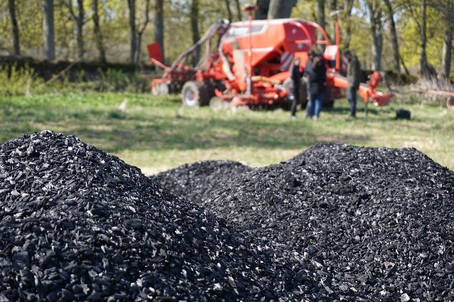 | 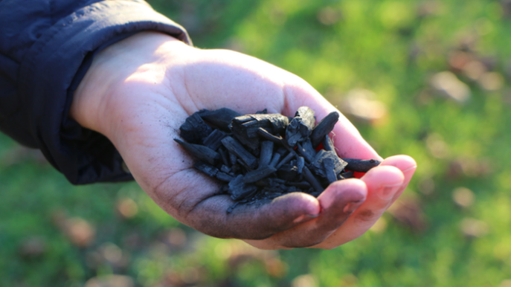
Biochar © Therese Ivarsson | Biochar in hand - © Katarina Johansson
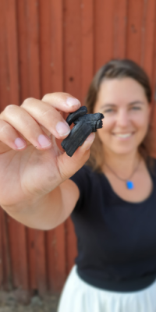 | 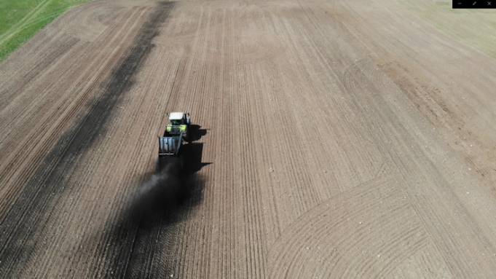
Cecilia with biochar © Helena Falkman | Tractor disseminating biochar on the field © Carbon credits with biochar

Please feel free to use this press article and the pictures in your own publications and to inform your colleagues.
If you would like to receive all EU CAP Network press articles directly, please fill in the subscription form.

More information
The EU CAP Network promotes Innovation, knowledge exchange and EIP-AGRI in the EU CAP Network

The Support Facility for Innovation and Knowledge exchange including EIP-AGRI is part of the EU CAP Network. It connects diverse stakeholders, including farmers, foresters, advisors, researchers, businesses, and NGOs, to foster robust knowledge flows and accelerate innovation.
The activities of the EU CAP Network align with the Common Agricultural Policy (CAP) objectives, including modernising agriculture and rural areas through knowledge exchange, innovation and digitalisation.
By bridging research and practice, the network shares research results, best practices, and innovative solutions with end-users. This approach supports the development of effective Agricultural Knowledge and Innovation Systems (AKIS) across the EU.

EIP-AGRI Operational Groups

EIP-AGRI Operational Groups are small collaborative projects designed to foster grassroots innovation by bringing together partners with complementary expertise. The composition of each group varies based on the project’s theme and specific objectives. Farmers, advisors, scientists, businesses and other relevant partners collaborate to develop practical solutions to specific challenges or opportunities faced by European farmers and foresters. The involvement of farmers and foresters throughout the project ensures that the innovative solutions are practical and readily applicable in the field.

Operational Groups funded under Rural Development Programmes 2014 – 2022

- A total of 98 Rural Development Programmes (RDPs) from 2014 to 2022 provide support for innovative EIP-AGRI Operational Group projects
- 4382 * Operational Group projects have been notified in the common EU data repository, with many currently ongoing or already completed as of May 2023. Member States continue to launch additional Operational Group projects under current transitional rules for EU Rural Development Programmes, with some running until 2025. Information on all of these projects can be found in the EIP-AGRI project database.

*Last update 16 June 2025

Operational Groups funded under CAP Strategic Plans 2023 – 2027

Under the common agricultural policy (CAP) for 2023-2027, the EU Member States have designed national CAP Strategic Plans (CSPs) which combine funding for income support, rural development, and market measures. All CAP Strategic Plans have been adopted, with implementation beginning on 1 January 2023.
A total of 26 CAP Strategic Plans include support for innovative EIP-AGRI Operational Groups. Altogether, 6,600 EIP-AGRI Operational Group projects have been planned.

Horizon Europe Multi-actor projects

Multi-actor projects are research and innovation initiatives where diverse stakeholders with complementary expertise - such as researchers, farmers, and local communities – to work together to co-create solutions to real-world challenges.

Horizon Europe supports Thematic networks - collaborative platforms where individuals, organisations and Operational Groups share existing knowledge and best practices on a specific theme, presenting them in easily accessible formats for end-users such as farmers, foresters and advisors.

EIP-AGRI Operational Groups projects (EIP-AGRI OGs) are encouraged to take part in Horizon Europe multi-actor projects.

EU CAP Network ‘Innovation & knowledge exchange | EIP-AGRI’ activities

Focus Groups

- Sustainable mobilisation of forest biomass
- Moving from source to sink in arable farming
- Forest practices and climate change

Events

- EU CAP Network workshop 'Circular bioeconomy - valorisation of forest by-products'

Publications & videos
- Bridging local solutions and market potential in the forestry bioeconomy
- Go nuts! The sustainable use of by-products from forestry

Inspirational ideas from the network

- Inspirational idea: Sustainable biorefineries based on agricultural residues

Operational Groups working on the valorisation of forestry by-products

31 Operational Groups working on forest residues are available in the EIP-AGRI project database (update June 2025). Carbon credits by biochar is one of the OGs.

- Belgium (4)
- Croatia (1)
- Finland (4)
- France (5)
- Germany (4)
- Greece (1)
- Ireland (2)
- Italy (11)
- Latvia (4)
- Netherlands (1)
- Other (3)
- Poland (1)
- Portugal (6)
- Slovenia (2)
- Spain (11)
- Sweden (1)

Horizon multi-actor projects working on the valorisation of forestry by-products

- MOBILE FLIP - Mobile and Flexible Industrial Processing of Biomass
- PYRAGRAF - Decentralized pyrolytic conversion of agriculture and forestry wastes towards local circular value chains and sustainability
- WOODCELL - Wood residues derived microcrystalline cellulose for sustainable materials
- SuperBark - Safe, sustainable and high performance adhesives and coatings from industrial softwood bark
- BeonNAT - Innovative value chains from tree & shrub species grown in marginal lands as a source of biomass for bio-based industries

Multi-actor projects are research and innovation initiatives where diverse stakeholders with complementary expertise - such as researchers, farmers, and local communities – work together to co-create solutions to real-world challenges.

EIP-AGRI Operational Groups projects (EIP-AGRI OGs) are encouraged to take part in these types of collaborative research projects. As of January 2025, about 4000 EIP-AGRI OG projects – local, bottom-up innovation projects– had been experimenting, testing and implementing innovative practices, processes, products, services, and technologies. Building on these achievements, EIP OGs have several opportunities to engage in multi-actor projects (MAPs), including through Horizon Europe Cluster 6, which emphasize EIP-AGRI OGs involvement in MAPs and enhancing cooperation possibilities.

Thematic networks are collaborative platforms supported by Horizon Europe, where individuals, organisations and Operational Groups share existing knowledge and best practices on a specific theme, presenting them in easily accessible formats for end-users such as farmers, foresters and advisors.

The common agricultural policy 2023-2027
The Common Agricultural Policy CAP 2023-27 is a modernised policy, with a strong emphasis on results and performance.

On 2 December, 2021, the agreement on reform of the common agricultural policy (CAP) was formally adopted. The new legislation, which entered into force on 1 January 2023, paves the way for a fairer, greener and more performance-based CAP.
It seeks to ensure a sustainable future for European farmers, provide more targeted support to smaller farms, and allow greater flexibility for EU countries to adapt measures to local conditions. Agriculture and rural areas are central to the European Green Deal.

