Flemish and Dutch farmers strive for local protein production

Growing demand for protein crops and its environmental benefits brings Flemish and Dutch farmers together

June 2025

Flemish and Dutch farmers strive for local protein production
Growing demand for protein crops and its environmental benefits brings Flemish and Dutch farmers together
In Flanders and the Netherlands, the rising demand for locally produced plant proteins, which is driven by sustainability goals, market opportunities, and the Flemish Protein Strategy—is encouraging farmers to cultivate crops like chickpeas, soybeans, faba beans, and lupin for human consumption. This shift offers clear benefits such as diversified income, reduced input costs, improved soil health, and decreased reliance on imports. However, local marketing channels remain limited, and both organic and conventional farmers continue to struggle with securing stable markets and fair prices. To address these challenges, two Operational Group projects are working to strengthen regional supply chains and foster collaboration between farmers and buyers, aiming to ensure consistent supply and fair compensation.
The Flemish Protein Farmers (Vlaamse Eiwitboeren) and the Protein Farmers of the Netherlands (Eiwitboeren van Nederland) illustrate how plant protein self-sufficiency can be strengthened by integrating sustainable plant-based protein production into diverse value chains and regions, while also addressing the challenges posed by climate change.
The Flemish Protein Farmers project maps production and marketing, analyses costs and market value, and compares key protein crops. It also connects farmers with buyers to develop fair pricing models and risk-sharing agreements.. This initiative has already built a strong network to support new regional value chains.
The Protein Farmers of the Netherlands (Eiwitboeren van Nederland) has taken a similar approach that focused on dry-harvestable legumes like faba beans, lupin, soybeans, and chickpeas for human consumption. These crops are used in various foods, with leftovers repurposed for animal feed. Within this initiative, Dutch farmers have successfully formed a producers' organisation to collectively market their crops.
Anna van der Bijl, a Dutch arable farmer, explains how a partnership with producers’ organisation Eiwitboeren van Nederland has stimulated her work: “We have been growing chickpeas for several years, but working with Eiwitboeren van Nederland has opened new doors,” she explains. “A simple conversation led to a partnership that now allows more farmers to grow chickpeas in the Netherlands for locally produced hummus and vegetable spreads.”
To strengthen cross-border cooperation, the Flemish Operational Group visited the Dutch one in August 2024 to exchange insights on production methods, address market challenges, and explore ways to increase the market value of locally grown plant proteins. Both parties are addressing common challenges in urbanised areas. Nele Lauwers from Boerenbond, and coordinator of the Flemish Operational Group, states that “To stay competitive with cheaper imports, Dutch and Flemish farmers should focus on high-value markets and promote the specific benefits of local protein crops. Strategic cooperation among farmers is therefore essential to increase visibility, strengthen pricing power and facilitate knowledge exchange.” Discussions also covered European regulations on producer organisations and supply chain agreements, ensuring that farmers remain competitive while meeting sustainability targets.

By working together, Flemish and Dutch farmers are proving that regional plant protein production can be both viable and profitable. As demand for sustainable food continues to grow, initiatives like these pave the way for other regions looking to increase plant protein self-sufficiency while adapting to climate challenges.

Background information
- Two experts from the EU CAP Network Focus Group 'Production of protein crops under climate change' are members of these two Operational Groups. The second meeting of the Operational Group is scheduled for 27-28 May 2025 in Seville, Spain. By the end of the year the Focus Group report will be published, which will summarise the main results of their work.

Project information
✆ EU CAP Network contact

Ina Van Hoye
ina.vanhoye@eucapnetwork.eu
+32 486 90 77 43

Communication manager
‘Support Facility for Innovation &
Knowledge exchange | EIP-AGRI’
✆ Project contacts

Anna van der Bijl
info@eiwitboeren.nl

Jonas Claeys
jonas.claeys@inagro.be

Find out more about the projects:
- Flemish Protein Farmers - Vlaamse eiwitboeren
- The Protein Farmers of the Netherlands - Eiwitboeren van Nederland

Project photos
Click on the pictures to download the high resolution versions. The pictures are free for use, please mention the copyright.

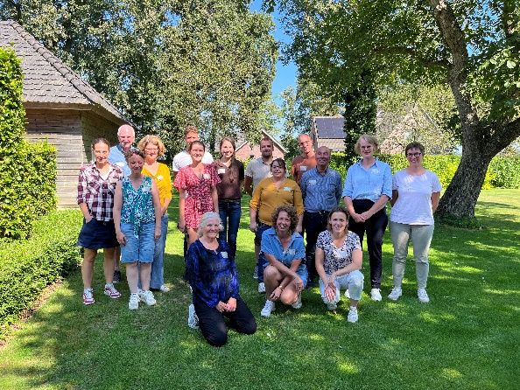 | 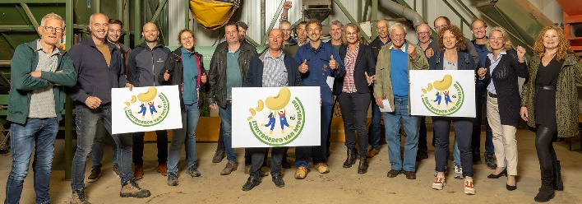
Visit Protein Farmers in the Netherlands – © Boerenbond (Vlaamse Eiwitboeren) | Project Partners Protein farmers the Netherlands - © Eiwitboeren van Nederland

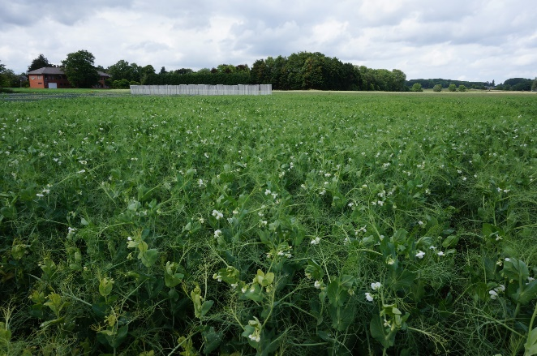 | 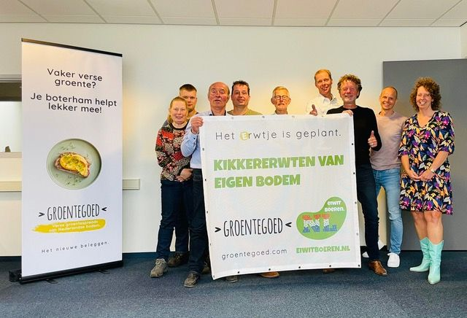
Protein crops © Boerenbond (Vlaamse eiwitboeren) | Collaboration Anna van der Bijl and Eiwitboeren van Nederland © Anna van der Bijl

Please feel free to use this press article and the pictures in your own publications and to inform your colleagues.
If you would like to receive all EU CAP Network press articles directly, please fill in the subscription form.

More information
The EU CAP Network promotes Innovation, knowledge exchange and EIP-AGRI in the EU CAP Network

The Support Facility for Innovation and Knowledge exchange including EIP-AGRI is part of the EU CAP Network. It connects diverse stakeholders, including farmers, foresters, advisors, researchers, businesses, and NGOs, to foster robust knowledge flows and accelerate innovation.
The activities of the EU CAP Network align with the Common Agricultural Policy (CAP) objectives, including modernising agriculture and rural areas through knowledge exchange, innovation and digitalisation.
By bridging research and practice, the network shares research results, best practices, and innovative solutions with end-users. This approach supports the development of effective Agricultural Knowledge and Innovation Systems (AKIS) across the EU.

EIP-AGRI Operational Groups

EIP-AGRI Operational Groups are small collaborative projects designed to foster grassroots innovation by bringing together partners with complementary expertise. The composition of each group varies based on the project’s theme and specific objectives. Farmers, advisors, scientists, businesses and other relevant partners collaborate to develop practical solutions to specific challenges or opportunities faced by European farmers and foresters. The involvement of farmers and foresters throughout the project ensures that the innovative solutions are practical and readily applicable in the field.

Operational Groups funded under Rural Development Programmes 2014 – 2022

- A total of 98 Rural Development Programmes (RDPs) from 2014 to 2022 provide support for innovative EIP-AGRI Operational Group projects
- 4247* Operational Group projects have been notified in the common EU data repository, with many currently ongoing or already completed as of May 2023. Member States continue to launch additional Operational Group projects under current transitional rules for EU Rural Development Programmes, with some running until 2025. Information on all of these projects can be found in the EIP-AGRI project database.

*Last update 8 April 2025

Operational Groups funded under CAP Strategic Plans 2023 – 2027

Under the common agricultural policy (CAP) for 2023-2027, the EU Member States have designed national CAP Strategic Plans (CSPs) which combine funding for income support, rural development, and market measures. All CAP Strategic Plans have been adopted, with implementation beginning on 1 January 2023.
A total of 26 CAP Strategic Plans include support for innovative EIP-AGRI Operational Groups. Altogether, 6,600 EIP-AGRI Operational Group projects have been planned.

Horizon Europe Multi-actor projects

Multi-actor projects are research and innovation initiatives where diverse stakeholders with complementary expertise - such as researchers, farmers, and local communities - work together to co-create solutions to real-world challenges.

Horizon Europe supports Thematic networks - collaborative platforms where individuals, organisations and Operational Groups share existing knowledge and best practices on a specific theme, presenting them in easily accessible formats for end-users such as farmers, foresters and advisors.

EIP-AGRI Operational Groups projects (EIP-AGRI OGs) are encouraged to take part in Horizon Europe multi-actor projects.

EU CAP Network ‘Innovation & knowledge exchange | EIP-AGRI’ activities

Focus Groups
- Focus Group 'Production of protein crops under climate change'
- Focus Group 'Crop associations including Milpa and protein crops'
- EIP-AGRI Focus Group on protein crops: report - factsheet
- EIP-AGRI Focus Group on new feed for pigs and poultry: report - factsheet

Events

- EIP-AGRI workshop ‘How to make protein crops profitable in the EU’: report

Publications & videos
- Press article: increasing farm resilience through crop associations
- EIP-AGRI challenge video: crop associations in France
- EIP-AGRI brochure on competitive protein crops

Operational Groups working on protein crops

142 Operational Groups working on protein crops are available in the EIP-AGRI project database (update March 2025)

- Austria (5)
- Belgium (6)
- Czechia (1)
- France (21)
- Germany (12)
- Hungary (4)
- Italy (30)
- Latvia (1)
- Lithuania (2)
- Malta (1)
- Netherlands (20)
- Poland (2)
- Romania (4)
- Slovenia (5)
- Spain (23)
- Sweden (3)

Horizon multi-actor projects

Multi-actor projects are research and innovation initiatives where diverse stakeholders with complementary expertise - such as researchers, farmers, and local communities – work together to co-create solutions to real-world challenges.

EIP-AGRI Operational Groups projects (EIP-AGRI OGs) are encouraged to take part in these types of collaborative research projects. As of January 2025, about 4000 EIP-AGRI OG projects – local, bottom-up innovation projects– have been experimenting, testing and implementing innovative practices, processes, products, services, and technologies. Building on these achievements, EIP OGs have several opportunities to engage in multi-actor projects (MAPs), including through Horizon Europe Cluster 6, which emphasise EIP-AGRI OGs involvement in MAPs and enhancing cooperation possibilities.

Thematic networks are collaborative platforms supported by Horizon Europe, where individuals, organisations and Operational Groups share existing knowledge and best practices on a specific theme, presenting them in easily accessible formats for end-users such as farmers, foresters and advisors.

EU CAP Network events focusing on innovation, knowledge exchange and EIP-AGRI (July 2024 – June 2025)
Find out more details on these events on the EU CAP Network website.

- Workshop: National networking for innovation and knowledge exchange, 29-30 January 2025
- Seminar: Robotics and artificial intelligence (AI) in farming and forestry, 19-20 February 2025
- Workshop: Circular bioeconomy – valorisation of forestry by-products and residues, 26-27 March 2025
- Focus Group: Alternative solutions for sustainable livestock product differentiation – 2nd meeting 9-10 April 2025
- Brokerage event: EU CAP Network brokerage event 'Partnering for innovation with impact in agriculture and rural areas' , 29-30 April 2025
- Cross-visits:
  - Cross-visit ‘Honeybees and other pollinators’ 7-8 May 2025
  - Cross-visit ‘Irrigation - optimising water use practices in annual (and perennial) crops’ 7-8 May 2025
  - Cross-visit ‘Monitoring animal welfare’ 8-9 May 2025
- Ad-hoc expert meeting: Ad-hoc national expert group meeting 2025 | EU CAP Network 15 May 2025
- Workshop: Innovation in logistics to improve the position of farmers in a supply chain, 20-21 May 2025
- Focus Group: Local perennial plant genetic resources in view of climate change and biodiversity loss – 2nd meeting 20-21 May 2025
- Focus Group: Production of protein crops under climate change – 2nd meeting, 27-28 May 2025
- Seminar: EU CAP Network Seminar ‘On-farm demonstrations for peer-to-peer learning & innovation’ , 17-18 June 2025

The common agricultural policy 2023-2027
Find information on the common agricultural policy 2023-2027 on the European Commission’s website.

