From farmer to farmer: the Polish Network of Demonstration Farms

Fostering knowledge exchange, peer learning, innovation uptake and sustainable practices through on-farm demonstrations

July 2025

From farmer to farmer: the Polish Network of Demonstration Farms

Fostering knowledge exchange, peer learning, innovation uptake and sustainable practices through on-farm demonstrations

The Polish Network of Demonstration Farms wants to improve knowledge exchange, peer learning and the uptake of innovations among farmers. Through on-farm demonstrations, it showcases good and innovative practices in agricultural production.

In general, demonstrations provide hands-on experience with new technologies, typically hosted on demonstration farms, living labs, lighthouse farms or educational and research institutions.

The Polish Network of Demonstration Farms ensures continuous access to innovative practices through practical events, helping farmers gain practical knowledge and insights that help improve their own methods. Its success depends on forward-thinking farmers who are willing to open their farms and share ideas with their peers. Ultimately, the network supports farmers committed to enhancing their practices and embracing innovation.

Cezary Grzegórski, a Polish farmer who participated in a demonstration event, explains: "Leaving my farm wasn’t easy, but I knew that to grow it further, I needed to learn from others who share the same passion for agriculture. By participating, I was able to join others eager to exchange knowledge."
The network emphasises farmer-to-farmer learning and strong collaboration between farmers and agricultural advisors. With the support of regional advisory services, it brings together expert advice and hands-on farming experience, organises farm demonstrations and encourages the sharing of good practices. It also supports hosting farmers to improve how they share knowledge and organise demonstration events. The network includes a wide range of farms, from small to large farms, with smart, profitable methods, all showcasing different kinds of innovations.

According to Paweł Krzeczunowicz (Polish Rural Network): "Peer-to-peer learning is a powerful tool for driving innovation, even in settings like Poland where farmer collaboration has been limited. Farm demonstrations are a highly effective way to exchange knowledge."

The Polish Network of Demonstration Farms involves sixteen regional agricultural advisory services in selecting demonstration sites and organising demonstration events. Each region has a coordinator, who is an agricultural advisor working for the public regional agricultural advisory service.
Coordinators play a crucial role in evaluating whether farms and their owners are ready to host demonstration activities. They are responsible for selecting suitable participants, engaging relevant experts and collaboratively determining the focus of each demonstration event with the host farm. The coordinators ensure that the needs of the target group are matched with appropriate demonstration sites and take charge of inviting participants to these events. They also assist in preparing agreements between host farms and the regional agricultural advisory services.

While most demonstrations involve farmers from the same region, some are organised across regions. Coordinators are essential to the smooth operation of the network and provide ongoing support to participating farms. Their core responsibilities include collaborating with demonstration farms, organising and managing events, overseeing monitoring and reporting, and promoting and further developing the network.

Background information
- From 17 to 18 June 2025, the EU CAP Network organised a seminar ‘On-farm demonstrations for peer-to-peer learning & innovation’ in Venice, Italy. The main objectives of the seminar were to promote the use of on-farm demonstrations as an essential tool for peer-to-peer learning and to improve the establishment and visibility of demonstration farms, as well as to foster their networks and connections with other relevant initiatives.
- CAP Strategic Plans - European Commission
- The Polish Network of Demonstration Farms
- In general, demonstration farms can be supported under CAP Strategic Plans. EU countries implement the 2023-2027 Common Agricultural Policy (CAP) through national plans tailored to local needs while aligning with EU goals and the European Green Deal. The CAP Strategic Plans play a key role in advancing agriculture towards sustainability, strengthening rural economies, supporting farm incomes and ensuring food security. They also promote climate action, protect natural resources and enhance biodiversity. A key focus of CAP Strategic Plans is to reinforce knowledge transfer through demonstration farms and to strengthen their role in the agricultural system.

Project information
✆ EU CAP Network contact

Ina Van Hoye
ina.vanhoye@eucapnetwork.eu
+32 486 90 77 43

Communication manager
‘Support Facility for Innovation &
Knowledge exchange | EIP-AGRI’
✆ Project contact

Paweł Krzeczunowicz
p.krzeczunowicz@cdr.gov.pl

Project photos
Click on the pictures to download the high-resolution versions. The pictures are free for use, please mention the copyright.

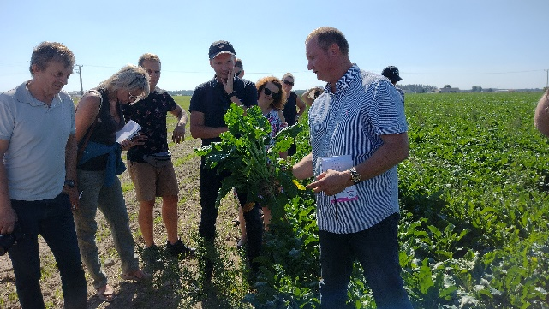 | 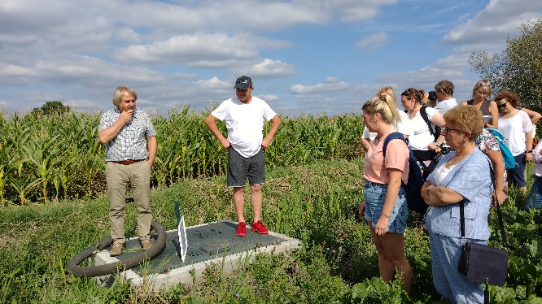
Tarnicki family demonstration farm in Kuyavia-Pomerania – © Agricultural Advisory Centre in Brwinów (CDR) | Barczak family demonstration farm in Kuyavia-Pomerania © Agricultural Advisory Centre in Brwinów (CDR)
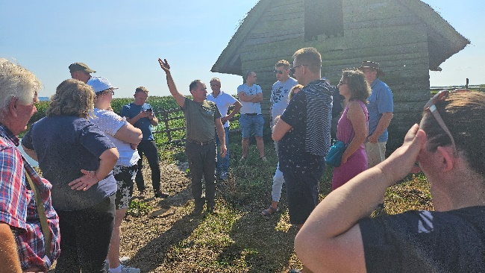 | 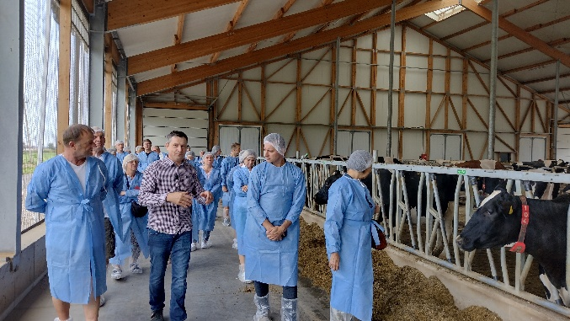
Smolczyński family demonstration farm in Western Pomerania © Agricultural Advisory Centre in Brwinów (CDR) | Kawula family demonstration farm in Kuyavia-Pomerania © Agricultural Advisory Centre in Brwinów (CDR)

Please feel free to use this press article and the pictures in your own publications and to inform your colleagues.
If you would like to receive all EU CAP Network press articles directly, please fill in the subscription form.

More information
The EU CAP Network promotes innovation, knowledge exchange and EIP-AGRI in the EU CAP Network.

The Support Facility for Innovation and Knowledge exchange including EIP-AGRI is part of the EU CAP Network. It connects diverse stakeholders, including farmers, foresters, advisors, researchers, businesses and NGOs to foster robust knowledge flows and accelerate innovation.
The activities of the EU CAP Network align with the CAP objectives, including modernising agriculture and rural areas through knowledge exchange, innovation and digitalisation.
By bridging research and practice, the network shares research results, best practices, and innovative solutions with end-users. This approach supports the development of effective Agricultural Knowledge and Innovation Systems (AKIS) across the EU.

EIP-AGRI Operational Groups

EIP-AGRI Operational Groups (OGs) are small collaborative projects designed to foster grassroots innovation by bringing together partners with complementary expertise. The composition of each group varies based on the project’s theme and specific objectives. Farmers, advisors, scientists, businesses and other relevant partners collaborate to develop practical solutions to specific challenges or opportunities faced by European farmers and foresters. The involvement of farmers and foresters throughout the project ensures that the innovative solutions are practical and readily applicable in the field.

Operational Groups funded under 2014-2022 Rural Development Programmes

- A total of 98 Rural Development Programmes (RDPs) from 2014 to 2022 provide support for innovative EIP-AGRI Operational Group projects
- 4382 Operational Group projects have been notified in the common EU data repository, with many currently ongoing or already completed as of May 2023.* Member States continue to launch additional Operational Group projects under the current transitional rules for EU Rural Development Programmes, with some running until 2025. Information on all of these projects can be found in the EIP-AGRI project database.

*Last update 16 June 2025

Operational Groups funded under the 2023-2027 CAP Strategic Plans

Under the CAP for 2023-2027, Member States have designed national CAP Strategic Plans (CSPs) which combine funding for income support, rural development, and market measures. All CSPs have been adopted, with implementation beginning on 1 January 2023. A total of 26 CSPs include support for innovative EIP-AGRI Operational Groups. Altogether, 6 600 EIP-AGRI Operational Group projects have been planned.

Horizon Europe multi-actor projects

Multi-actor projects are research and innovation initiatives where diverse stakeholders with complementary expertise, such as researchers, farmers and local communities, work together to co-create solutions real-world challenges.

Horizon Europe supports thematic networks – collaborative platforms where individuals, organisations and Operational Groups share existing knowledge and best practices on a specific theme, presenting them in easily accessible formats for end-users, such as farmers, foresters and advisors.

EIP-AGRI Operational Groups projects (EIP-AGRI OGs) are encouraged to take part in Horizon Europe multi-actor projects.

EU CAP Network ‘Innovation & knowledge exchange | EIP-AGRI’ activities

Events
- EU CAP Network Seminar ‘On-farm demonstrations for peer-to-peer learning & innovation’

Publications and videos
- Increasing farmers’ competitiveness

Operational Groups working on demonstration farms

507 Operational Groups working on demonstration farms are available in the EIP-AGRI project database (update May 2025)

- Austria (17)
- Belgium (37)
- Bulgaria (4)
- Croatia (4)
- Cyprus (3)
- Czechia (2)
- Denmark (17)
- Estonia (1)
- Finland (17)
- France (64)
- Germany (48)
- Greece (27)
- Hungary (6)
- Ireland (29)
- Italy (112)
- Latvia (6)
- Lithuania (25)
- Luxembourg (2)
- Malta (2)
- Netherlands (64)
- Other (46)
- Poland (18)
- Portugal (16)
- Romania (12)
- Slovakia (2)
- Slovenia (17)
- Spain (138)
- Sweden (10)

Horizon multi-actor projects

Multi-actor projects are research and innovation initiatives where diverse stakeholders with complementary expertise,– such as researchers, farmers, and local communities, work together to co-create solutions to real-world challenges.

EIP-AGRI Operational Groups projects (EIP-AGRI OGs) are encouraged to take part in these types of collaborative research projects. As of January 2025, about 4 000 EIP-AGRI OG projects – local, bottom-up innovation projects – have been experimenting, testing and implementing innovative practices, processes, products, services and technologies. Building on these achievements, EIP OGs have several opportunities to engage in multi-actor projects (MAPs), including through Horizon Europe Cluster 6, which emphasises EIP-AGRI OGs’ involvement in MAPs and enhancing cooperation possibilities.

Thematic networks are collaborative platforms supported by Horizon Europe, where individuals, organisations and Operational Groups share existing knowledge and best practices on a specific theme, presenting them in easily accessible formats for end-users such as farmers, foresters and advisors.

The 2023-2027 CAP

The 2023-2027 Common Agricultural Policy (CAP) is a modernised policy, with a strong emphasis on results and performance.

On 2 December 2021, the agreement on reforming the CAP was formally adopted. The new legislation, which entered into force on 1 January 2023, paves the way for a fairer, greener and more performance-based CAP.
It aims to ensure a sustainable future for European farmers, provide more targeted support to smaller farms and allow greater flexibility for EU countries to adapt measures to local conditions. Agriculture and rural areas are central to the European Green Deal.

