Transforming agriculture through sustainable supply chains

Empowering farmers through sustainable logistics and direct marketing

June 2025

Transforming agriculture through sustainable supply chains
Empowering farmers through sustainable logistics and direct marketing
Boosting innovation in sustainable logistics, direct sales, and shortening the distance with consumers in the supply chain can enhance farmer profitability and open up new marketing opportunities. Adamah BioHof is a family-run organic farm located just outside Vienna, Austria, covering 100 hectares of land where a range of root vegetables, fruits, herbs, and grains are grown. The farm has become a prime example of how farmers can benefit from sustainable logistics and direct marketing to enhance their market access, competitiveness, and profitability, while meeting sustainability goals.
Driven by a strong commitment, the farm sets an example for other farmers with their online shop, selling organic products directly to consumers, bypassing traditional retail intermediaries. As well as their own organic products, they offer a wide range of organic products from other farmers and producers, not only from the region and Austria, but also based in other countries. Because of this cooperation, they can offer a full range of over 2,500 organic products.
Through their BioKistl (organic boxes) delivery service, the farm supplies organic products to approximately 6 500 households every week, along with local restaurants, bistros, and organic stores in Vienna and its surroundings. Gerhard Zoubek, founder of Adamah BioHof, explains: “By distributing organic products through our farm’s online store, and by providing home delivery, we reach a broader customer base and further boost our income opportunities.”
Adamah BioHof serves as a model for other farms looking to establish a successful, sustainable logistics system centred around direct sales. By harvesting fresh produce daily and storing long-lasting crops in CO₂-neutral cooling units powered by solar energy, the farm significantly reduces both waste and greenhouse gas emissions. Its dedicated refrigerated vehicles, combined with bicycle courier collaborations in urban areas, enable efficient deliveries with minimal environmental impact, cutting down on unnecessary mileage and boosting the overall efficiency of logistics. This integrated approach demonstrates how farmers can increase the value of their products while simultaneously shrinking their carbon footprint.
Food waste reduction is a priority at the farm, ensuring that fruits and vegetables which may look imperfect but are high-quality and entirely edible are put to good use. By selling these products, they reduce the loss of produce that does not meet supermarket standards. “Unsold food products are either donated to charity or sold at a discount via the Too Good to Go app, ensuring that even produce not suited for standard retail is utilised and can still contribute to income.”, Gerhard explains. “The remaining products are composted or sent to a biogas plant where they are converted into energy, which not only supports sustainability but also reduces waste disposal costs.”
Packaging is another area where the farm’s approach sets an example. The farm focuses on cutting down single-use packaging by using reusable deposit crates, which can last up to 15 years. When packaging is necessary, eco-friendly options are prioritised, including recyclable, compostable, or biodegradable materials. This sustainable approach to packaging reduces overall waste, which promotes environmental responsibility.
Adamah BioHof demonstrates how sustainable logistics and direct marketing can enhance agricultural profitability by enabling farmers to connect directly with consumers and reduce dependence on intermediaries, in line with the Common Agricultural Policy (CAP) goals of strengthening farmers' roles in the value chain and increasing the farm’s competitiveness.

Background information
- From 20-21 May 2025, the EU CAP Network organised a workshop ‘Innovation in logistics to improve the position of farmers in a supply chain’ that took place in Rouen, France. The overall aim of the workshop was to explore innovative practices, new approaches, and new organisational or technological solutions that can optimise logistics in the supply chain for individual farms, producer groups and cooperatives.

Project information
✆ EU CAP Network contact

Ina Van Hoye
ina.vanhoye@eucapnetwork.eu
+32 486 90 77 43

Communication manager
‘Support Facility for Innovation &
Knowledge exchange | EIP-AGRI’
✆ Project contact

Gerhard Zoubek
biohof@adamah.at

Find more information:
- ADAMAH BioHof
- Too Good To Go

Project photos
Click on the pictures to download the high-resolution versions. These pictures are free for use, provided you mention the copyright.

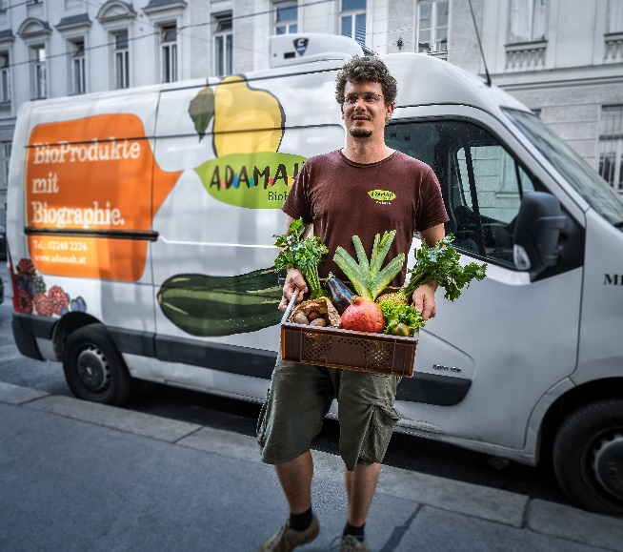 | 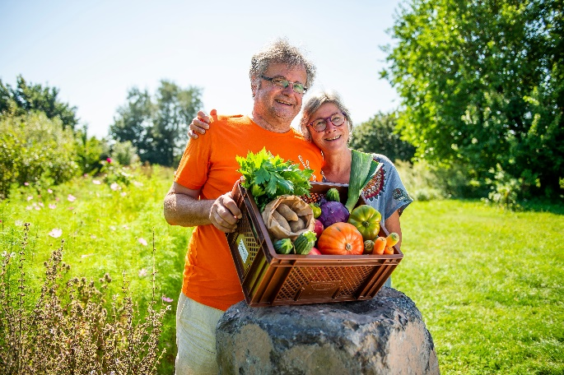
ADAMAH BioKistl delivery – © Thomas Apolt | Gerhard and Sigrid Zoubek © BMNT_Netzwerk Kulinarik_rr_POV1860
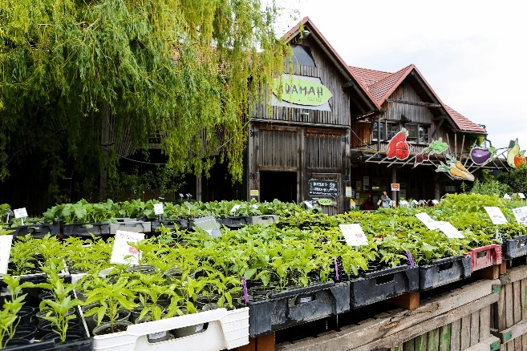
ADAMAH bio-plant market © Sandra Tauscher

Please feel free to use this press article and the pictures in your own publications and to inform your colleagues.
If you would like to receive all EU CAP Network press articles directly, please fill in the subscription form.

More information
- The Political Guidelines for the next European Commission (2024-2029) emphasise the need to ensure the farming sector’s sustainability while boosting long-term competitiveness across the food value chain through investment and innovation, not only on farms, but also in cooperatives, agri-food businesses and the many SMEs in the sector.

- The Strategic Dialogue on the future of EU Agriculture (September 2024) recently formulated some recommendations for the functional coordination and integration of economic, environmental and social factors in agricultural production. Key aspects include ensuring that innovation, access to new knowledge, cooperation and the use of technology align with a long-term vision for EU agriculture and food systems.

The EU CAP Network promotes Innovation, knowledge exchange and EIP-AGRI in the EU CAP Network

The Support Facility for Innovation and Knowledge exchange including EIP-AGRI is part of the EU CAP Network. It connects diverse stakeholders, such as farmers, foresters, advisors, researchers, businesses, and NGOs, to foster robust knowledge flows and accelerate innovation.
The activities of the EU CAP Network align with the Common Agricultural Policy (CAP) objectives, including modernising agriculture and rural areas through knowledge exchange, innovation and digitalisation.
By bridging research and practice, the network shares research results, best practices, and innovative solutions with end-users. This approach supports the development of effective Agricultural Knowledge and Innovation Systems (AKIS) across the EU.

EIP-AGRI Operational Groups

EIP-AGRI Operational Groups are small collaborative projects designed to foster grassroots innovation by bringing together partners with complementary expertise. The composition of each group varies based on the project’s theme and specific objectives. Farmers, advisors, scientists, businesses and other relevant partners collaborate to develop practical solutions to specific challenges or opportunities faced by European farmers and foresters. The involvement of farmers and foresters throughout the project ensures that the innovative solutions are practical and readily applicable in the field.

Operational Groups funded under Rural Development Programmes 2014 – 2022

- From 2014 to 2022, a total of 98 Rural Development Programmes (RDPs) provided support for innovative EIP-AGRI Operational Group projects.
- 4247* Operational Group projects have been registered in the common EU data repository, with many currently ongoing or already completed as of May 2023. Member States continue to launch additional Operational Group projects under the current transitional rules for EU Rural Development Programmes, with some running until 2025. Information on all of these projects can be found in the EIP-AGRI project database.

*Last update 8 April 2025

Operational Groups funded under CAP Strategic Plans 2023 – 2027

Under the Common Agricultural Policy (CAP) for 2023-2027, the EU Member States have designed national CAP Strategic Plans (CSPs) which combine funding for income support, rural development, and market measures. All CAP Strategic Plans have been adopted, with implementation beginning on 1 January 2023.
A total of 26 CAP Strategic Plans include support for innovative EIP-AGRI Operational Groups. Altogether, 6 600 EIP-AGRI Operational Group projects have been planned, of which 292 have already been launched.

Horizon Europe Multi-actor projects
Multi-actor projects are research and innovation initiatives where diverse stakeholders with complementary expertise - such as researchers, farmers, and local communities – work together to co-create solutions to real-world challenges.

Horizon Europe supports Thematic networks, collaborative platforms where individuals, organizations and Operational Groups share existing knowledge and best practices on a specific theme, presenting them in easily accessible formats for end-users such as farmers, foresters and advisors.

EIP-AGRI Operational Groups projects (EIP-AGRI OGs) are encouraged to participate in Horizon Europe multi-actor projects.

EU CAP Network ‘Innovation & knowledge exchange | EIP-AGRI’ activities

Focus Groups
  - Focus Group 'Alternative solutions for livestock product differentiation
  - Focus Group on Innovative Short Food Supply Chain Management

Events

- EU CAP Network workshop ‘Innovation in logistics to improve the position of farmers in a supply chain’
- EU CAP Network cross-visit ‘Use of agricultural and forestry residues for creating alternative sources of income for farmers and foresters’
- Workshop Innovation in the supply chain: creating value together
- Workshop on Cities & Food

Publications & videos
- EIP-AGRI Brochure Innovation in short food supply chains
- Factsheet Innovative Short Food Supply Chain Management
- Factsheet on Cities and Food

Inspirational ideas from the network

- A network of advisors specialised in short food supply chains
- Sustainable biorefineries based on agricultural residues
- Croatian farm promotes regenerative agricultural practices
- Increasing farm resilience through crop associations

Operational Groups working on Supply Chain

583 Operational Groups working on supply chain are available in the EIP-AGRI project database (as of April 2025)

- Austria (3)
- Belgium (5)
- Bulgaria (3)
- Croatia (9)
- Cyprus (1)
- Czechia (2)
- Finland (2)
- France (29)
- Germany (35)
- Ireland (2)
- Italy (224)
- Latvia (3)
- Lithuania (4)
- Netherlands (74)
- Poland (27)
- Portugal (21)
- Romania (1)
- Slovenia (4)
- Spain (100)
- Sweden (17)

Horizon multi-actor projects working on Supply Chain
- SKIN - Short supply chains Knowledge & Innovation Network
- WATSON
- Towards Innovation - driven and smart solutions in short food supply chains

Multi-actor projects are research and innovation initiatives where diverse stakeholders with complementary expertise, such as researchers, farmers, and local communities, work together to co-create solutions to real-world challenges.

EIP-AGRI Operational Groups projects (EIP-AGRI OGs) are encouraged to take part in these types of collaborative research projects. As of January 2025, approximately 4 000 EIP-AGRI OG projects – local, bottom-up innovation projects – had been experimenting with, testing and implementing innovative practices, processes, products, services, and technologies. Building on these achievements, EIP OGs have several opportunities to engage in multi-actor projects (MAPs), including through Horizon Europe Cluster 6, which emphasises EIP-AGRI OGs’ involvement in MAPs and enhances cooperation possibilities.

Thematic networks are collaborative platforms supported by Horizon Europe, where individuals, organisations and Operational Groups share existing knowledge and best practices on a specific theme, presenting them in easily accessible formats for end-users such as farmers, foresters and advisors.

EU CAP Network events focusing on innovation, knowledge exchange and EIP-AGRI (July 2024 – June 2025)

Find out more details on these events on the EU CAP Network website.

- Workshop: National networking for innovation and knowledge exchange, 29-30 January 2025
- Seminar: Robotics and artificial intelligence (AI) in farming and forestry, 19-20 February 2025
- Workshop: Circular bioeconomy – valorisation of forestry by-products and residues, 26-27 March 2025
- Focus Group: Alternative solutions for sustainable livestock product differentiation, 2nd meeting, 9-10 April 2025
- Brokerage event: EU CAP Network brokerage event 'Partnering for innovation with impact in agriculture and rural areas', 29-30 April 2025
- Cross-visits:
  - Cross-visit ‘Honeybees and other pollinators’,7-8 May 2025
  - Cross-visit ‘Irrigation - optimising water use practices in annual (and perennial) crops’, 7-8 May 2025
  - Cross-visit ‘Monitoring animal welfare’, 8-9 May 2025
- Ad-hoc expert meeting: Ad-hoc national expert group meeting 2025 | EU CAP Network, 15 May 2025
- Workshop: Innovation in logistics to improve the position of farmers in a supply chain, 20-21 May 2025
- Focus Group: Local perennial plant genetic resources in view of climate change and biodiversity loss, 2nd meeting, 20 -21 May 2025
- Focus Group: Production of protein crops under climate change, 2nd meeting, 27-28 May 2025
- Seminar: EU CAP Network Seminar ‘On-farm demonstrations for peer-to-peer learning & innovation’, 17-18 June 2025

The common agricultural policy 2023-2027
Find information on the common agricultural policy 2023-2027 on the European Commission’s website.

Thematic networks are collaborative platforms supported by Horizon Europe, where individuals, organisations and Operational Groups share existing knowledge and best practices on a specific theme, presenting them in easily accessible formats for end-users such as farmers, foresters and advisors.

EU CAP Network events focusing on innovation, knowledge exchange and EIP-AGRI (July 2024 – June 2025)

Find out more details on these events on the EU CAP Network website.

- Workshop: National networking for innovation and knowledge exchange, 29-30 January 2025
- Seminar: Robotics and artificial intelligence (AI) in farming and forestry, 19-20 February 2025
- Workshop: Circular bioeconomy – valorisation of forestry by-products and residues, 26-27 March 2025
- Focus Group: Alternative solutions for sustainable livestock product differentiation, 2nd meeting, 9-10 April 2025
- Brokerage event: EU CAP Network brokerage event 'Partnering for innovation with impact in agriculture and rural areas', 29-30 April 2025
- Cross-visits:
  - Cross-visit ‘Honeybees and other pollinators’,7-8 May 2025
  - Cross-visit ‘Irrigation - optimising water use practices in annual (and perennial) crops’, 7-8 May 2025
  - Cross-visit ‘Monitoring animal welfare’, 8-9 May 2025
- Ad-hoc expert meeting: Ad-hoc national expert group meeting 2025 | EU CAP Network, 15 May 2025
- Workshop: Innovation in logistics to improve the position of farmers in a supply chain, 20-21 May 2025
- Focus Group: Local perennial plant genetic resources in view of climate change and biodiversity loss, 2nd meeting, 20 -21 May 2025
- Focus Group: Production of protein crops under climate change, 2nd meeting, 27-28 May 2025
- Seminar: EU CAP Network Seminar ‘On-farm demonstrations for peer-to-peer learning & innovation’, 17-18 June 2025

The common agricultural policy 2023-2027
Find information on the common agricultural policy 2023-2027 on the European Commission’s website.

