From local innovations to global markets in the forestry bioeconomy

BioRural and MainstreamBIO advance the forestry bioeconomy

April 2025

Bridging local solutions and market potential in the forestry bioeconomy

BioRural and MainstreamBIO advance the forestry bioeconomy

With the global demand for sustainable resources on the rise, the forestry bioeconomy emerges as a key player in addressing climate challenges and fostering economic growth. Horizon Europe projects BioRural and MainstreamBIO are actively advancing the forest-based bioeconomy, by developing innovative bio-based solutions through sustainable resource utilisation. These projects are strengthening small-scale producers and rural communities, particularly in the forestry sector.
One of the BioRural project results is the European Rural Bioeconomy Network (ERBN) where farmers and foresters benefit from business blueprints, online tutorials, factsheets, bioeconomy inventories and other practical tools. Additionally, the BioRural toolkit offers farmers and foresters access to success stories, practical summaries, and collaboration ideas.
A success story from BioRural toolkit is the use of sheep wool to protect young forest stands from forest animals. Latvian company Biolana took on the challenge of recycling sheared wool, transforming it into a product that met the needs of Latvian State Forests. The wool can easily be spread manually in the forests and deters forest animals when it retains its natural smell. The wool is suitable in damp conditions and offers a more environmentally friendly protective measure. Seeing the potential for wool to be used in forest protection, sheep farmers recognised an opportunity to turn what was once waste into a source of income. Understanding the broader implications of their work, the Latvian State Forest prioritised sharing their findings and methods, not just within their immediate ecosystem but also with the global forestry community. Through this knowledge sharing, farmers are inspired to adopt these best practices and apply them to their own farms.
Project manager Bas Paris explains: “It’s all about practical, small-scale innovation –providing tools, knowledge, and support to help local producers develop and use sustainable and circular solutions tailored to their needs.”
Leonidas Parodos, project manager of MainstreamBIO, explains that in their project, forest residues are turned into valuable products like bioenergy, bio-based materials, and fertilisers. The project offers farmers and foresters access to a digital toolkit, featuring a wide range of bioeconomy tools (bioresource mapping, catalogues, side stream value tool, etc.) from other projects related to bioeconomy, and a repository with detailed description of business models, technologies, social innovations and other best practices. An example of a technology business model featured in the toolkit is that of MW Biomasse AG, a German company that processes forestry residues into pellets and wood chips for energy applications through mechanical disruption. Similarly, Biomassehof-Chiemgau, also based in Germany, utilises wood residues to produce energy pellets using mechanical processing. These examples showcase innovative approaches to transforming biomass into valuable products, supporting informed decision-making.

BioRural and MainstreamBIO are demonstrating how the potential of small-scale producers and rural communities, combined with market-driven innovation can advance the forestry-based bioeconomy to address climate challenges and foster economic growth. By strengthening rural engagement and promoting sustainable forestry practices, these projects go beyond simply bridging gaps – they are laying the foundation for a future where bio-bases solutions drive a thriving and environmentally resilient economy.

Background information
- EU CAP Network workshop 'Circular bioeconomy - valorisation of forest by-products' took place in Kouvola (Finland) from Wednesday 26 to Thursday 27 March 2025.
- BioRural toolkit
- MainstreamBIO digital toolkit

Project information BioRural

✆ Project contact

Thanos Balafoutis
a.balafoutis@certh.gr

Link to project

Project information MainstreamBIO

✆ EU CAP Network contact

Ina Van Hoye
ina.vanhoye@eucapnetwork.eu
+32 486 90 77 43

Communication manager
‘Support Facility for Innovation &
Knowledge exchange | EIP-AGRI’
✆ Project contact

Leonidas Parodos parodos@qplan-intl.gr

Link to project

Project photos
Click on the pictures to download the high-resolution versions. The pictures are free for use, please mention the copyright.

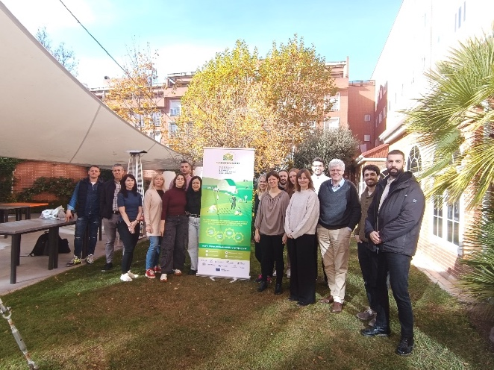 | 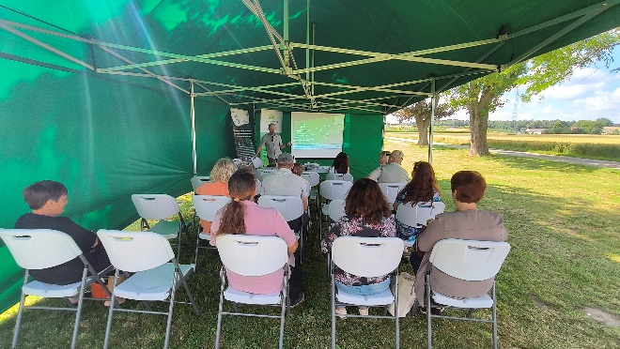
Project meeting © MainstreamBIO | Project presentation © MainstreamBIO
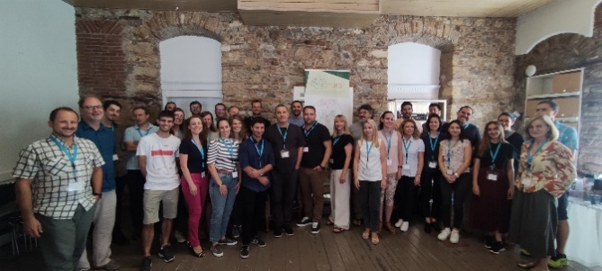 | 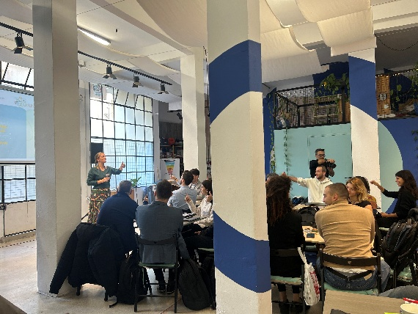
Project meeting BioRural © Reframe.food | South East regional bioeconomy challenge © Reframe.food

Please feel free to use this press article and the pictures in your own publications and to inform your colleagues.
If you would like to receive all EU CAP Network press articles directly, please fill in the subscription form.

More information on circular bioeconomy in forestry

EU CAP Network ‘Innovation & knowledge exchange | EIP-AGRI’ activities

Events

- EU CAP Network workshop 'Circular bioeconomy - valorisation of forest by-products'
- EU CAP Network cross-visit ‘Use of agricultural and forestry residues for creating alternative sources of income for farmers and foresters’
- EU CAP Network Seminar ‘Smart circular farming to address high energy and fertiliser prices’

Publications & videos
- Operational Groups and other innovative projects represented at the EIP-AGRI workshop Circular bioeconomy | EU CAP Network
- EIP-AGRI Workshop on Circular Bioeconomy: Final report | EU CAP Network

Inspirational ideas from the network

- Sustainable biorefineries based on agricultural residues
- Go nuts! The sustainable use of by-products from forestry | EU CAP Network

Operational Groups working on circular bioeconomy in forestry

9 Operational Groups are working on circular bioeconomy in forestry are available in the EIP-AGRI project database (update February 2025).

- Finland (1)
- Italy (1)
- Latvia (1)
- Spain (6)

Horizon multi-actor projects working on circular bioeconomy in forestry

Multi-actor projects are research and innovation initiatives where diverse stakeholders with complementary expertise, such as researchers, farmers, and local communities, work together to co-create solutions to real-world challenges. Operational Groups are strongly encouraged to take part in these types of collaborative research projects. By January 2025, about 4000 EIP-AGRI Operational Group projects (EIP-AGRI OGs) – bottom-up innovation projects at a local level – had been experimenting, testing and applying innovative practices, processes, products, services, and technologies. Building on these outstanding results, There are several opportunities for OGs to join in multi-actor projects, such as the calls for Horizon Europe Cluster 6, with a focus on the involvement of the EIP-AGRI OGs in Horizon multi-actor projects (MAPs) and enhancing cooperation possibilities for EIP-AGRI projects.

Thematic networks are collaborative platforms where individuals or organizations and Operational Groups share existing knowledge and best practices on a specific theme, presenting them in easily accessible formats for end-users such as farmers, foresters and advisors.

EU CAP Network events focusing on innovation, knowledge exchange and EIP-AGRI (until June 2025)

Find out more details on these events on the EU CAP Network website.

Recent events:

- Workshop: National networking for innovation and knowledge exchange, 29-30 January 2025
- Seminar: Robotics and artificial intelligence (AI) in farming and forestry, 19-20 February 2025
- Workshop: Circular bioeconomy – valorisation of forestry by-products and residues, 26-27 March 2025
- Focus Group: Alternative solutions for sustainable livestock product differentiation – 2nd meeting 9-10 April 2025

Upcoming events:

- EU CAP Network brokerage event 'Partnering for innovation with impact in agriculture and rural areas' , 29-30 April 2025
- Cross-visits: The EU CAP Network is organising three cross-visits between multiple OGs on water management, pollinators and animal welfare, From 5 to 9 May 2025
- Workshop: Innovation in logistics to improve the position of farmers in a supply chain, 20-21 May 2025
- Focus Group: Local perennial plant genetic resources in view of climate change and biodiversity loss – 2nd meeting 20 -21 May 2025
- Focus Group: Production of protein crops under climate change – 2nd meeting, 27-28 May 2025
- EU CAP Network Seminar ‘On-farm demonstrations for peer-to-peer learning & innovation’ , 17-18 June 2025

The common agricultural policy 2023-2027
Find information on the common agricultural policy 2023-2027 on the European Commission’s website.

Innovation, knowledge exchange and EIP-AGRI in the EU CAP Network

The Support Facility for Innovation and Knowledge exchange including EIP-AGRI is part of the EU CAP Network. It connects diverse stakeholders, including farmers, foresters, advisors, researchers, businesses, and NGOs, to foster robust knowledge flows and accelerate innovation.
The activities of the EU CAP Network align with the Common Agricultural Policy (CAP) objectives, including modernising agriculture and rural areas through knowledge exchange, innovation and digitalisation.
By bridging research and practice, the network shares research results, best practices, and innovative solutions with end-users. This approach supports the development of effective Agricultural Knowledge and Innovation Systems (AKIS) across the EU.

EIP-AGRI Operational Groups

EIP-AGRI Operational Groups are small collaborative projects designed to foster grassroots innovation by bringing together partners with complementary expertise. The composition of each group varies based on the project’s theme and specific objectives. Farmers, advisors, scientists, businesses and other relevant partners collaborate to develop practical solutions to specific challenges or opportunities faced by European farmers and foresters. The involvement of farmers and foresters throughout the project ensures that the innovative solutions are practical and readily applicable in the field.

Operational Groups funded under Rural Development Programmes 2014 – 2022

- A total of 98 Rural Development Programmes (RDPs) from 2014 to 2022 provide support for innovative EIP-AGRI Operational Group projects
- 3,843* Operational Group projects have been notified in the common EU data repository, with many currently ongoing or already completed as of May 2023. Member States continue to launch additional Operational Group projects under current transitional rules for EU Rural Development Programmes, with some running until 2025. Information on all of these projects can be found in the EIP-AGRI project database.

*Last update 30 January 2025

Operational Groups funded under CAP Strategic Plans 2023 – 2027

- Under the common agricultural policy (CAP) for 2023-2027, the EU Member States have designed national CAP Strategic Plans (CSPs) which combine funding for income support, rural development, and market measures. All CAP Strategic Plans have been adopted, implementation beginning on 1 January 2023.

- A total of 26 CAP Strategic Plans include support for 6600 planned EIP-AGRI Operational Groups. 220 Operational Group projects have already been notified in the common EU data repository.

