Robotics and artificial intelligence in farming and forestry

Satellite-assisted robots to tackle weed and increase the productivity and sustainability of dairy farming

March 2025

Robotics and artificial intelligence in farming and forestry
Satellite-assisted robots to tackle weed and increase the productivity and sustainability of dairy farming

The GALIRUMI Horizon project created robots in 2023 for herbicide-free weed control in dairy farming. The robots are assisted by Galileo, the European global navigation satellite system, to tackle the weed Broad-leaved dock (Rumex obtusifolius). Thanks to the use of robots with advanced weed detection, dairy farms become more sustainable and can potentially decrease labour costs.

Robotics and artificial intelligence (AI) are transforming farming and forestry by fostering innovation and boosting competitiveness across multiple sectors, including agriculture. Simultaneously, robotics facilitate precise operations, enabling farmers and foresters to concentrate on high-value tasks, thereby improving productivity and promoting sustainability.

Esther López, project coordinator of the GALIRUMI project from ACORDE Technologies in Spain, explains that the development of the robots was inspired by dairy farmers who were struggling with weeds invading their grasslands. Manually removing the weeds is labour-intensive, while in some production systems, such as in organic farming, it is not possible to use chemical pesticides. The use of robots significantly reduces the need for manual labour in weeding, thus reducing the costs associated with weed management, and ensuring the grass retains high quality and yield. Meanwhile, the farmers have more time available for other tasks, without compromising productivity.

Concretely, GALIRUMI developed two weeding units with two different systems. The first one is designed for electric weeding and uses high-voltage electric shocks to eliminate weeds. The second one uses laser-weeding technology. The robot systematically traverses the entire field capturing images to identify the weed. It uses a laser to destroy the leaves of the weeds, effectively degrading them.
Both units use Galileo to record the precise locations of the identified weeds. At a later stage of the process, the robot navigates directly to the stored weed locations, moving from one to the next, eliminating them. Both systems can be attached to any robot or tractor to control Broad-leaved dock. Field demonstrations took place in cooperation with farmers in the Netherlands, Denmark and France.

While the GALIRUMI project was finished in 2023, the project partners at the University of Wageningen are working on improving the robot, for example to make the navigation more precise. They are also working on a third, medium sized robot system with an electrocution tool that requires single season application in the field.

Background information
On 19-20 February 2025, the EU CAP Network organised the seminar on ‘Robotics and Artificial Intelligence in Farming and Forestry’. The project partners were present at this seminar.

Project information
✆ EU CAP Network contact

Ina Van Hoye
ina.vanhoye@eucapnetwork.eu
+32 486 90 77 43

Communication manager
‘Support Facility for Innovation &
Knowledge exchange | EIP-AGRI’
Find out more about the project.

✆ Project contact

Esther López
galirumi@galirumi-project.eu

Project photos
Click on the pictures to download the high resolution versions. The pictures are free for use, please mention the copyright.

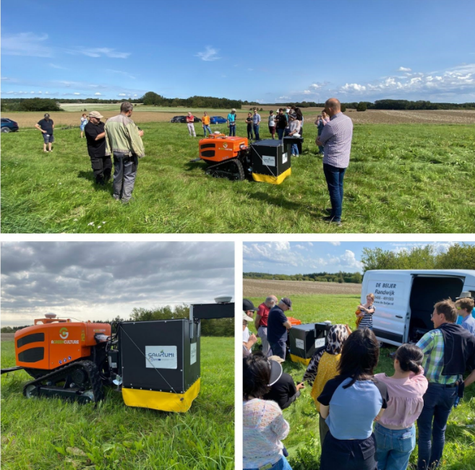 | 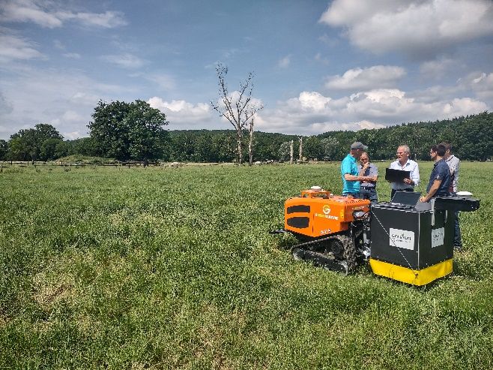
Demonstration in Denmark – © GALIRUMI project | Demonstration in France © GALIRUMI project
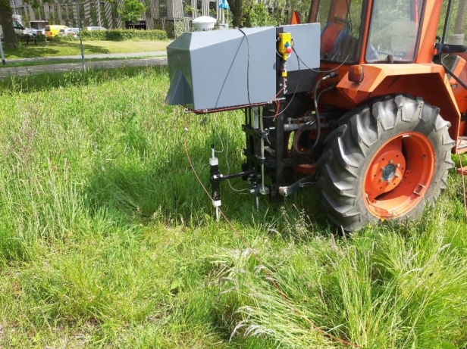
Demonstration electric weeding in the Netherlands © GALIRUMI project

Please feel free to use this press article and the pictures in your own publications and to inform your colleagues.
If you would like to receive all EU CAP Network press articles directly, please fill in the subscription form.

More information on robotics and AI in farming and forestry

EU CAP Network ‘Innovation & knowledge exchange | EIP-AGRI’ activities

Focus Groups
- EIP-AGRI Focus Group on Digital tools for nutrient management: Final report
- Focus Group 'Alternative solutions for livestock product differentiation' - 1st meeting

Events

- EU CAP Network seminar ‘Robotics and Artificial Intelligence in farming and forestry’ | EU CAP Network
- EIP-AGRI Innovation Awards 2024
- EIP-AGRI Workshop Farm data for better farm performance – report - factsheet

Publications & videos

Press Article - Using digital tools to promote sustainable and productive organic agriculture

Video - AGRI Challenge: Digital tools for nutrient management

EIP-AGRI Brochure Shaping the digital (r)evolution in agriculture

Inspirational ideas from the network

A hive of digital activity | EU CAP Network

EU CAP Network seminar ‘Robotics and Artificial Intelligence in farming and forestry’ | EU CAP Network

Discover more in the new digitalisation portal on the EU CAP Network website

Operational Groups working on robotics and AI in farming and forestry

300 Operational Groups working on Robotics and artificial intelligence in farming and forestry are available in the EIP-AGRI project database (update January 2025)

- Austria (7)
- Belgium (4)
- Bulgaria (6)
- Croatia (1)
- Finland (8)
- France (14)
- Germany (39)
- Ireland (3)
- Italy (41)
- Latvia (4)
- Lithuania (6)
- Malta (1)
- Netherlands (17)
- Poland (13)
- Portugal (1)
- Romania (1)
- Slovenia (11)
- Spain (98)
- Sweden (21)

Horizon multi-actor projects working on Robotics and AI in farming and forestry

- SMART agriculture for innovative vegetable crop PROTECTion: harnessing advanced methodologies and technologies | EU CAP Network
- Sm@RT: Small Ruminant Technology - Precision Livestock Farming and Digital Technology for Small Ruminants | EU CAP Network

Multi-actor projects are research and innovation projects in which end users and multipliers of research results such as farmers and farmers’ groups, advisors, enterprises and others, closely cooperate throughout the whole project. Operational Groups are strongly encouraged to participate in this type of research project. By January 2025, about 4000 EIP-AGRI Operational Group projects (EIP-AGRI OGs) – bottom-up innovation projects at a local level – had been experimenting, testing and applying innovative practices, processes, products, services, and technologies. Building on these outstanding results, There are several opportunities for OGs to join in multi-actor projects, such as the calls for Horizon Europe Cluster 6, with a focus on the involvement of the EIP-AGRI OGs in Horizon multi-actor projects (MAPs) and enhancing cooperation possibilities for EIP-AGRI projects.

Thematic networks are multi-actor projects which collect existing knowledge and best practices on a given theme to make it available in easily understandable formats for end-users such as farmers, foresters, advisors etc.

Upcoming EU CAP Network events focusing on innovation, knowledge exchange and EIP-AGRI (July 2024 – June 2025)

Find out more details on these events on the EU CAP Network website.

- Workshop: National networking for innovation and knowledge exchange, 29-30 January 2025
- Seminar: Robotics and artificial intelligence (AI) in farming and forestry, 19-20 February 2025
- Workshop: Circular bioeconomy – valorisation of forestry by-products and residues, 26-27 March 2025
- Focus Group: Alternative solutions for sustainable livestock product differentiation – 2nd meeting 9-10 April 2025
- EU CAP Network brokerage event 'Partnering for innovation with impact in agriculture and rural areas' , 29-30 April 2025
- Cross-visits: The EU CAP Network is organising three cross-visits between multiple OGs on water management, pollinators and animal welfare, From 5 to 9 May 2025
- Workshop: Innovation in logistics to improve the position of farmers in a supply chain, 20-21 May 2025
- Focus Group: Local perennial plant genetic resources in view of climate change and biodiversity loss – 2nd meeting 20 -21 May 2025
- Focus Group: Production of protein crops under climate change – 2nd meeting, 27-28 May 2025
- EU CAP Network Seminar ‘On-farm demonstrations for peer-to-peer learning & innovation’ , 17-18 June 2025

EU Policy on robotics and AI

  - The European AI Office is the centre of AI expertise across the EU. It plays a key role in implementing the AI Act - especially for general-purpose AI - fostering the development and use of trustworthy AI, and international cooperation.
  - The AI Act is the first-ever legal framework on AI, which addresses the risks of AI and positions Europe to play a leading role globally.
  - Robotics : the EU actively promotes research, job creation and innovation through better and safer robots, while safeguarding ethical aspects of the progress achieved.

The common agricultural policy 2023-2027

Find information on the common agricultural policy 2023-2027 on the European Commission’s website.

Innovation, knowledge exchange and EIP-AGRI in the EU CAP Network

The Support Facility for Innovation and Knowledge exchange including EIP-AGRI is part of the EU CAP Network. It connects diverse stakeholders, including farmers, foresters, advisors, researchers, businesses, and NGOs, to foster robust knowledge flows and accelerate innovation.
The activities of the EU CAP Network align with the Common Agricultural Policy (CAP) objectives, including modernising agriculture and rural areas through knowledge exchange, innovation and digitalisation.
By bridging research and practice, the network shares research results, best practices, and innovative solutions with end-users. This approach supports the development of effective Agricultural Knowledge and Innovation Systems (AKIS) across the EU.

EIP-AGRI Operational Groups

EIP-AGRI Operational Groups are small collaborative projects designed to foster grassroots innovation by bringing together partners with complementary expertise. The composition of each group varies based on the project’s theme and specific objectives. Farmers, advisors, scientists, businesses and other relevant partners collaborate to develop practical solutions to specific challenges or opportunities faced by European farmers and foresters. The involvement of farmers and foresters throughout the project ensures that the innovative solutions are practical and readily applicable in the field.

Operational Groups funded under Rural Development Programmes 2014 – 2022

- A total of 98 Rural Development Programmes (RDPs) from 2014 to 2022 provide support for innovative EIP-AGRI Operational Group projects
- 3,843* Operational Group projects have been notified in the common EU data repository, with many currently ongoing or already completed as of May 2023. Member States continue to launch additional Operational Group projects under current transitional rules for EU Rural Development Programmes, with some running until 2025. Information on all of these projects can be found in the EIP-AGRI project database.

*Last update 30 January 2025

Operational Groups funded under CAP Strategic Plans 2023 – 2027

- Under the common agricultural policy (CAP) for 2023-2027, the EU Member States have designed national CAP Strategic Plans (CSPs) which combine funding for income support, rural development, and market measures. All CAP Strategic Plans have been adopted, implementation beginning on 1 January 2023.
- A total of 26 CAP Strategic Plans include support for 6600 planned EIP-AGRI Operational Groups. 220 Operational Group projects have already been notified in the common EU data repository.

