Increasing farmers’ competitiveness

BioBased Innovations Garden - showcasing biobased innovations for sustainable and competitive farming practices

February 2025

Increasing farmers’ competitiveness

BioBased Innovations Garden - showcasing biobased innovations for increased sustainability and competitiveness in the farming sector
Founded in 2014 at the Arable Innovation and Knowledge Centre in Rusthoeve in the Netherlands, the BioBased Innovations Garden meets the growing need for sustainable agricultural practices that enhance soil management and crop resilience. As a demonstration farm, it tests various crops as raw materials for biobased products, and experiments with more sustainable ways of growing crops. The Garden is also a platform for different stakeholders to develop innovative value chains and applications within the biobased economy.

In response to increasing pressure on agricultural systems from climate change and resource limitations, the Garden demonstrates how biobased innovations can transform farming into a more sustainable and competitive sector. The cultivation of biobased crops reduces dependency on fossil-based resources.

Over the past decade, the Biobased Innovations Garden has cultivated more than 100 different crops, utilising their products and by-products in various applications with potential in the biobased economy. For instance, a by-product from growing tansy is used as an insecticide, purpurin from madder plant roots serves as a cobalt replacement in batteries, and fibres from hemp, flax and straw are used in insulation. Some products, such as mint and solanine, even find applications in cosmetics.

The BioBased Innovations Garden acts as a hub and demonstration farm where agricultural entrepreneurs, knowledge institutes, and industries such as construction and chemistry collaborate to foster innovation and experiment with new biobased solutions. It supports regional value chain development, helping farmers become more resilient to rising energy costs by reducing their dependency on fossil fuels.

Through its experiments, the BioBased Innovations Garden has discovered solutions for a wide range of agricultural challenges. These solutions include improved soil health, enhanced crop resilience and a reduction in chemical inputs. Additionally, the Garden raises awareness and disseminates knowledge by organising workshops for farmers and local stakeholders and developing educational materials on biobased practices. Participants involved in the experimental area of the Garden have provided valuable insights into challenges such as adaptation resistance, high initial costs and investments, technical difficulties, regulatory obstacles, climate variability and scalability issues.

As part of the biobased economy, the BioBased Innovations Garden identifies opportunities for greening fertilisers, developing crop protection agents of natural origin, and producing ingredients such as minerals, fatty acids, proteins, fibres, and sugars. It also supports protein transition. According to the project partners, further crop selection linked to specific applications could lead to additional research on breeding techniques and cultivation methods, enhancing the suitability of these plants as crops for long-term use in the biobased economy.

Background information
  - https://www.biobasedgarden.nl/
  - Biobased Innovations Garden (@growing4future) / X
  - Biobased Innovation Garden: Overview | LinkedIn
  - Facebook

Project information
✆ EU CAP Network contact

Ina Van Hoye
ina.vanhoye@eucapnetwork.eu
+32 486 90 77 43

Communication manager
‘Support Facility for Innovation &
Knowledge exchange | EIP-AGRI’
✆ Project contact

Cor van Oers
C.vanOers@delphy.nl
06 53 42 72 46

Project photos
Click on the images to download the high-resolution versions. The images are free for use, but please remember to mention the copyright.

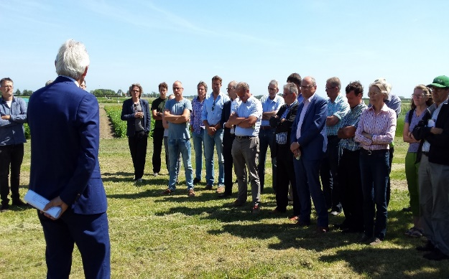 | 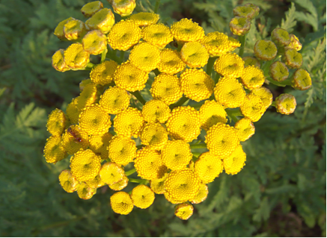
Field visit – © BioBased Innovations Garden | Tanacetum vulgare – © BioBased Innovations Garden
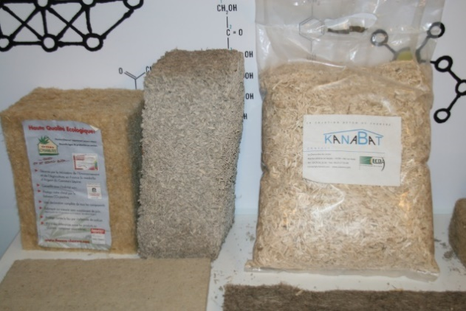 | 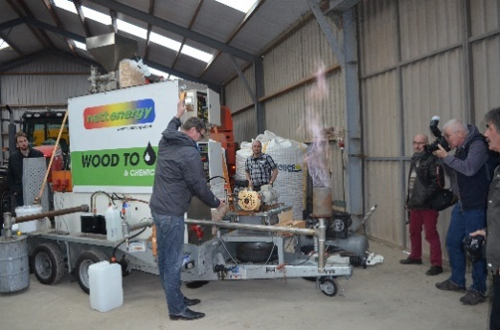
Hemp – © Biobased Innovations Garden | Public visit – © Biobased Innovations Garden

Please feel free to use this press article and the pictures in your own publications and to inform your colleagues.
If you would like to receive all EU CAP Network press articles directly, please fill in the subscription form.

More information on increasing farmers’ competitiveness

EU CAP Network ‘Innovation & knowledge exchange | EIP-AGRI’ activities

Focus Groups
- Alternative solutions for livestock product differentiation – Focus Group ongoing
- Production of protein crops under climate change – Focus Group ongoing
- Local perennial plant genetic resources in view of climate change and biodiversity loss – Focus Group ongoing
- Regenerative agriculture for soil health – read the report published in 2024
- Competitive and resilient mountain areas - read the report and factsheet produced in 2024
- Nature-based solutions for water management – read the report published in 2022
- Digital tools for nutrient management – read the report and factsheet published in 2022
- Sustainable beef production systems – read the report and factsheet published in 2021-2022
- Reducing antimicrobial use in poultry farming – read the report and factsheet published in 2021
- Sustainable industrial crops – read the report and factsheet published in 2021-2022
- Sustainable ways to reduce pesticides in pome and stone fruit production – read the report and factsheet published in 2022
- Plant-based medicinal and cosmetic products – read the report published in 2020
- Reducing food loss on the farm – read the report and factsheet published in 2020-2021
- Renewable energy on the farm – read the report and factsheet published in 2019

Events
Upcoming events
- EU CAP Network seminar ‘Robotics and Artificial Intelligence in farming and forestry’ - 19-20 February 2025
- EU CAP Network workshop on ‘Circular bioeconomy – Valorisation of forestry by-products and residues’ - 26-27 March 2025
- EU CAP Network workshop ‘Logistics to improve the position of farmers in a supply chain’ - May 2025

Previous events
- EU CAP Network cross-visit ‘Climate adaptation on the ground - innovative solutions to build farm resilience’ – took place in 2024
- EU CAP Network cross-visit ‘Use of agricultural and forestry residues for creating alternative sources of income for farmers and foresters’ – took place in 2024
- EU CAP Network Workshop ‘Circular water management’ – took place in 2024, read the report
- EU CAP Network cross-visit ‘Circular and organic soil management’ – took place in 2023
- EU CAP Network cross-visit ‘Organic farming supply and value chain optimisation’ – took place in 2023
- EU CAP Network Seminar ‘Smart circular farming to address high energy and fertiliser prices’ – took place in 2022, read the report
- EIP-AGRI Workshop on Farm data for better farm performance – took place in 2021, read the report

Publications & videos

- Video: EIP-AGRI Challenge: smart circular farming to address high energy and fertiliser prices (Portugal)
- Video: EIP-AGRI Challenge: smart circular farming to address high energy prices (Belgium)
- Factsheet - EU CAP Network Focus Group ‘Competitive and resilient mountain areas' | EU CAP Network (Romania)
- EIP-AGRI Brochure Climate-smart agriculture: Solutions for resilient farming and forestry | EU CAP Network
- EIP-AGRI Brochure on Competitive protein crops | EU CAP Network
- Circular water solutions | EU CAP Network

Inspirational ideas from the network

- Corn residue harvested as a renewable energy source (Slovenia)
- Training 10 000 European advisors to help accelerate the shift to climate-resilient farming (EU)
- Recycling waste from horticulture into substrates and fertilisers (the Netherlands)
- Sustainable biorefineries based on agricultural residues (EU)

Find out more inspirational ideas on the EU CAP Network website
In November 2024, the EU CAP Network published a thematic issue of the Innovation and Knowledge Exchange | EIP-AGRI Newsletter focusing on innovation and knowledge exchange for competitiveness, resilience, and sustainability in farming, forestry, and rural areas.

Operational Groups working on increasing farmers’ competitiveness

2735 Operational Groups working on increasing farmers’ competitiveness are available in the EIP-AGRI project database (update December 2024).

EIP-AGRI Operational Groups bring together diverse actors, including farmers, researchers, and businesses, to co-create innovative solutions in agriculture. They focus on practical solutions that can be implemented in real-world settings to enhance both competitiveness and sustainability.

- Inishowen Upland Farmers EIP Operational Group (Ireland)
This group has successfully worked to increase the profitability and sustainability of farms located on the Inishowen Peninsula in Ireland.

- Parsutt Operational Group (Italy)
This group focuses on enhancing the sustainability standards of Parma ham production, a significant agricultural and economic activity in Italy. This initiative has been recognised for its high sustainability standards and won an EIP-AGRI Innovation Award in 2024.

- Podlaskie Dobre Smaki (Poland)
This group consists of six agricultural producers in the Mazowieckie region. Their project focuses on developing and promoting local food products, supporting regional agricultural traditions and enhancing the competitiveness of local farmers.

Horizon multi-actor projects working on farmer’s competitiveness

Multi-actor projects are research and innovation initiatives where diverse stakeholders with complementary expertise, such as researchers, farmers, and local communities, work together to co-create solutions to real-world challenges. Operational Groups are strongly encouraged to take part in these types of collaborative research projects. By January 2025, about 4000 EIP-AGRI Operational Group projects (EIP-AGRI OGs) – bottom-up innovation projects at a local level – had been experimenting, testing and applying innovative practices, processes, products, services, and technologies. Building on these outstanding results, there are several opportunities for OGs to join in multi-actor projects, such as the calls for Horizon Europe Cluster 6, with a focus on the involvement of the EIP-AGRI OGs in Horizon multi-actor projects (MAPs) and enhancing cooperation possibilities for EIP-AGRI projects.

Thematic networks are collaborative platforms where individuals or organizations and Operational Groups share existing knowledge and best practices on a specific theme, presenting them in easily accessible formats for end-users such as farmers, foresters and advisors.

- SmartAgriHubs
This Horizon Europe project aims to connect digital innovation hubs across Europe, empowering the agri-food sector with advanced digital technologies.

- STEP UP
STEP UP is a Horizon Europe project designed to upgrade livestock production systems across Europe, making them more sustainable.

- Food Sharing Compass
This Horizon Europe project brings together 19 partners from across Europe to develop innovative solutions for urban food sharing.

The common agricultural policy 2023-2027
Find information on the common agricultural policy 2023-2027 on the European Commission’s website.

Innovation, knowledge exchange and EIP-AGRI in the EU CAP Network

The Support Facility for Innovation and Knowledge exchange including EIP-AGRI is part of the EU CAP Network. It connects diverse stakeholders, including farmers, foresters, advisors, researchers, businesses, and NGOs, to foster robust knowledge flows and accelerate innovation.
The activities of the EU CAP Network align with the Common Agricultural Policy (CAP) objectives, including modernising agriculture and rural areas through knowledge exchange, innovation and digitalisation.
By bridging research and practice, the network shares research results, best practices, and innovative solutions with end-users. This approach supports the development of effective Agricultural Knowledge and Innovation Systems (AKIS) across the EU.

EIP-AGRI Operational Groups

EIP-AGRI Operational Groups are small collaborative projects designed to foster grassroots innovation by bringing together partners with complementary expertise. The composition of each group varies based on the project’s theme and specific objectives. Farmers, advisors, scientists, businesses and other relevant partners collaborate to develop practical solutions to specific challenges or opportunities faced by European farmers and foresters. The involvement of farmers and foresters throughout the project ensures that the innovative solutions are practical and readily applicable in the field.

Operational Groups funded under Rural Development Programmes 2014 – 2022

- A total of 98 Rural Development Programmes (RDPs) from 2014 to 2022 provide support for innovative EIP-AGRI Operational Group projects
- 3,843* Operational Group projects have been notified in the common EU data repository, with many currently ongoing or already completed as of May 2023. Member States continue to launch additional Operational Group projects under current transitional rules for EU Rural Development Programmes, with some running until 2025. Information on all of these projects can be found in the EIP-AGRI project database.

*Last update 30 January 2025

Operational Groups funded under CAP Strategic Plans 2023 – 2027

Under the common agricultural policy (CAP) for 2023-2027, the EU Member States have designed national CAP Strategic Plans (CSPs) which combine funding for income support, rural development, and market measures. All CAP Strategic Plans have been adopted, implementation beginning on 1 January 2023.

A total of 26 CAP Strategic Plans include support for 6600 planned EIP-AGRI Operational Groups. 220 Operational Group projects have already been notified in the common EU data repository.

