Go nuts!
The sustainable use of
by-products from forestry

Polish project explores the use of acorns
as a basis for vegan food

February 2024

Go nuts! The sustainable use of by-products from forestry

Polish Operational Group explores the use of acorns as a basis for vegan food
The sustainable use of by-products from forestry can lead to the development of new value chains and business models which are tailored to the needs of producers and rural areas. This provides a diversified income, adds value to products and delivers better resource efficiency. The Polish Acorn project harvests acorns from a natural forest, Jarocin Forest District, in Poland, that were initially not harvested. During the project, which started in 2014, the partners have developed and implemented a technology for using acorns as a basis for meat-free alternative products. With the use of this technology, an innovative vegan ingredient based on the bitter mass of acorns is obtained and effectively preserved.

The project was initiated by Jarosław Żytowicz, an entrepreneur who was looking for innovative possibilities for the production of ready-made vegan meals. In recent years, there has been a growing demand for vegan products and the range of these products is expanding. Alternative raw materials are being introduced to the market and this means producers of vegan products can offer a more diversified choice to consumers.

The partners from the Operational Group wanted to use acorns as a food ingredient and therefore developed a method based on vacuum pressure. The mass obtained from acorns is decomposed by using vacuum infusion. Thanks to the starch that acorns contain, the processed acorn mass is a natural technological additive with stabilising and thickening properties when used in vegan products.

Acorns have always been important food resources in human history, as well as one of the main food ingredients substitutes during periods of food crises. But up until now, mainly dry forms of acorns have been used as an ingredient for consumer products such as cereal coffee and flour for bread, pasta or biscuits. The use of acorns can be implemented more broadly thanks to the thickening structure of the processed acorns, for instance as a basis for soup. In addition, the high amount of starch enriches the nutritional value of food products, making it comparable to that of cereals. Additionally, the project partners established a method for preserving the acorn mass in laboratory conditions and for evaluating its quality over six months of storage.

Acorns remain an expensive raw material due to the fact that they are susceptible to insects and fungi. In the future, the Polish Acorn project partners hope to investigate whether it also would be possible to use other forest tree nuts to produce food products for creating an alternative source of income.

Background information
Operational Group: “Development of product and process innovation related to the technology of production of vegan thickets containing the bitter mass of acorns, with the effect of stabilizing the product structure as a new direction for natural resource management in the forest.”

The project partners of the Operational Group were present as participants at the EU CAP Network cross-visit ‘Use of agricultural and forestry residues for creating alternative sources of income for farmers and foresters’ | EU CAP Network.

Learn more from other EIP-AGRI Operational Groups.

Project information
✆ EU CAP Network contact

Ina Van Hoye
ina.vanhoye@eucapnetwork.eu
+32 486 90 77 43

Communication manager
‘Support Facility for Innovation &
Knowledge exchange | EIP-AGRI’
✆ Project contact

Paula Baumgart
paula@instytut.info.pl
+48 517 119 535
https://www.orzechdebu.pl/

Project photos
Click on the pictures to download the high resolution versions. The pictures are free for use, please mention the copyright.
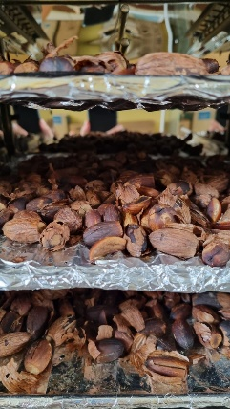

Dried acorns – copyright Marlena Baranowksa
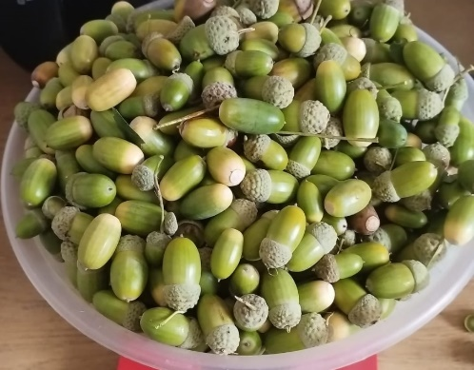
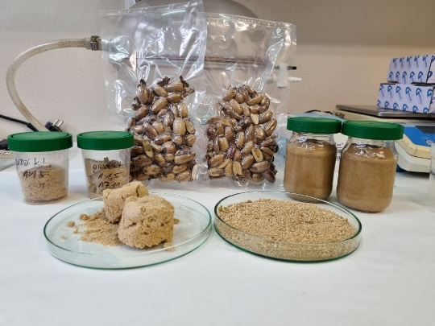

Different forms of processed acorns – copyright Marlena Baranowska
Acorns – copyright Marlena Baranowska

Please feel free to use this press article and the pictures in your own publications and to inform your colleagues.
If you would like to receive all EU CAP Network press articles directly, please fill in the subscription form.

More information on circular bioeconomy

EU CAP Network ‘Innovation & knowledge exchange | EIP-AGRI’ activities

Events
- EU CAP Network workshop ‘circular bioeconomy – valorisation of forestry by-products (March 2025)
- EU CAP Network cross-visit ‘Use of agricultural and forestry residues for creating alternative sources of income for farmers and foresters’ (June 2024)
- EU CAP Network cross-visit ‘Circular and organic soil management’ (June 2024)
- EU CAP Network Seminar ‘Smart circular farming to address high energy and fertiliser prices’ | EU CAP Network
- EIP-AGRI Workshop on 'Opportunities for farm diversification in the circular bio-economy' (2019)

Publications & videos
- Booklet on Operational Groups and other innovative projects represented at the EIP-AGRI workshop on circular bioeconomy
- EIP-AGRI Factsheet Bioeconomy
- EIP-AGRI Brochure Innovation for European forestry

- Agrinnovation Magazine - Issue 10 - highlights innovative solutions for the sustainable and circular use of natural resources in agriculture, forestry and rural communities
- EIP-AGRI Challenge: Smart circular farming to address high energy prices - the ECOSEED project
- EIP-AGRI Challenge: Smart circular farming to address high energy prices - small-scale biogas installation
- EIP-AGRI Challenge video: Smart circular farming to address high energy and fertiliser prices – ECOSEED project

Inspirational ideas from the network
- Recycling waste from horticulture into substrates and fertilisers (Netherlands and Belgium)
- Sustainable biorefineries based on agricultural residues
- A sustainable model for reusing water for olive groves (Spain)
- Smart circular farming in Malta (Malta)
- Improving the viability and competitiveness of high added-value by-products from berries (Lithuania)
- Livestock effluents as a resource for reducing emissions and loss of nutrients (Portugal)

Horizon multi-actor projects working on circular bioeconomy
Multi-actor projects are research and innovation projects in which end users and multipliers of research results such as farmers and farmers’ groups, advisors, enterprises and others, closely cooperate throughout the whole project. Operational Groups are strongly encouraged to participate in this type of research project.
- Browse the EIP-AGRI project database for many Horizon projects related to circular bioeconomy

- MAINSTREAMing small-scale BIO-based solutions across rural Europe via regional Multi-actor Innovation Platforms and tailored innovation support – website - https://mainstreambio-project.eu/ (01/09/2022-31/08/2025)
- BRANCHES - Boosting Rural Bioeconomy Networks following multi-actor approaches – web-page - Home Page (01/01/2021-31/12/2023)

Thematic networks are multi-actor projects which collect existing knowledge and best practices on a given theme to make it available in easily understandable formats for end-users such as farmers, foresters, advisors etc.
- Horizon 2020 Thematic networks:
  - PANACEA - A thematic network to design the penetration PAth of Non-food Agricultural Crops into European Agriculture - website - CORDIS (11/2017-10/2020)
  - ENABLING - Enhance New Approaches in BioBased Local Innovation Networks for Growth - website - CORDIS (12/2017-11/2020)

Other related information
- Circular Bio-based Europe Joint Undertaking (CBE JU)

EU CAP Network events focusing on innovation, knowledge exchange and EIP-AGRI July 2024 – June 2025

Find out more details on these events on the EU CAP Network website.

- Focus Group: Production of protein crops under climate change
- Focus Group: Alternative solutions for sustainable livestock product differentiation
- Focus Group: Local perennial plant genetic resources in view of climate change and biodiversity loss
- Workshop: National networking for innovation and knowledge exchange, 29-30 January 2025
- Seminar: Robotics and artificial intelligence (AI) in farming and forestry, 19-20 February 2025
- Workshop: Circular bioeconomy – valorisation of forestry by-products and residues, 26-27 March 2025
- Cross-visits: The EU CAP Network is organising three cross-visits between multiple OGs on water management, pollinators and animal welfare, May 2025
- Workshop: Innovation in logistics to improve the position of farmers in a supply chain, May 2025
- Seminar: Demonstration farms, June 2025
- Brokerage event: Horizon Europe project calls, March-April 2025

The common agricultural policy 2023-2027
Find information on the common agricultural policy 2023-2027 on the European Commission’s website.

Innovation, knowledge exchange and EIP-AGRI in the EU CAP Network

The European CAP Network acts as a mediator, enhancing communication and cooperation between everyone with a keen interest in innovation and sharing knowledge for sustainable agriculture, forestry and rural areas.

The European Innovation Partnership 'Agricultural Productivity and Sustainability' (EIP-AGRI) was launched in 2013 by the European Commission in a bid to promote

rapid modernisation of the sectors by efforts to step up innovation. The EIP-AGRI aims to foster innovation in the agricultural and forestry sectors and in rural areas by bringing

research and practice closer together – in innovation projects as well as via the European CAP Network and the national CAP Networks. Also, grassroots ideas from farmers are developed into concrete innovative solutions through ‘Operational Group’ innovation projects. The EIP-AGRI aims to streamline, simplify and better coordinate existing instruments and initiatives, and complement them with actions where necessary.

EIP-AGRI Operational Groups

EIP-AGRI Operational Groups are groups of people who work together in an innovation project. They bring together partners with complementary knowledge. The composition of the group will vary according to the theme and specific objectives of each project. Farmers, advisors, scientists, businesses or other relevant partners work together to find practical solutions for specific problems or opportunities for European farmers and foresters. Farmers and foresters need to cooperate throughout the project to ensure that the innovative solutions are practical and likely to be quickly applied in the field. Read the basic principles. Innovation support services (including advisors with a focus on innovation), and in particular innovation brokering, can therefore play a crucial role in getting worthwhile projects off the ground by facilitating contacts.

Operational Groups funded under Rural Development Programmes 2014 – 2022

- 98 Rural Development Programmes 2014-2020 (RDPs) provide support to innovative EIP-AGRI Operational Group projects
- More than 3200 Operational Group projects have been notified in the common EU data repository and are currently ongoing (or already finished)*. Member States will still start more Operational Group projects which may run until 2025 (under current transitional rules for EU Rural Development Programmes). Find information on all of these projects in the EIP-AGRI project database.

Operational Groups funded under CAP Strategic Plans 2023 – 2027

Within the common agricultural policy 2023-27 (CAP), the EU Member States have designed national CAP Strategic Plans combining funding for income support, rural development, and market measures. All CAP Strategic Plans have been adopted and their implementation started on 1 January 2023.

26 CAP Strategic Plans include support for innovative EIP-AGRI Operational Groups. In total, 6600 EIP-AGRI Operational Group projects have been planned.

