Climate adaptation on the ground: Increasing farmers’ resilience to climate change

PreConAgri: Sustainable soil management and precision agriculture techniques to ensure the viability of arable crops

February 2025

Increasing farmers’ resilience to climate change
PreConAgri: Sustainable soil management and precision agriculture techniques to ensure the viability of arable crops

The effects of climate change are becoming increasingly apparent across Europe, with farmers bearing the brunt of these impacts. In regions such as Krokos in Kozani and Nikaia in Larissa in Greece, severe soil degradation exacerbates these challenges, threatening farm productivity and environmental sustainability. Addressing these pressing issues and enhancing sector resilience requires innovative, on-the-ground solutions. Since 2023, the Operational Group PreConAgri (Precision, Conservation and Agriculture) has been supporting climate-smart agricultural practices to boost soil fertility and prevent erosion, helping farmers in this region become more resilient to climate change. The active involvement of multiple stakeholders in the Operational Group, including farmers and researchers, enhances the practicality, scalability, and impact of the solutions developed, paving the way for widespread adoption of sustainable practices.

The PreConAgri Operational Group integrates conservation and precision agriculture techniques to develop a cultivation model that improves the environmental impact of conventional farming practices. Myrto Kosti, the project coordinator, explains: “Through methods like conservation tillage, differential fertilisation strategies, and controlled machinery movement, we aim to increase soil carbon sequestration, improve soil quality, and enhance crop yields.” Pilot trials are being conducted in durum wheat fields in Greece, with final results expected in August 2025.
Conservation agriculture methods include minimal or no-tillage and maintaining permanent soil cover with vegetation and crop residues for mulching. Precision agriculture techniques involve Variable Rate Nutrient Application based on real-time sensing and actuation, as well as map-based actuation in plots using Machine Guidance for precise fertilisation. Controlled Traffic Farming optimises machinery paths within and around fields, minimising soil compaction and improving operational efficiency. By testing these practices in real production conditions, the project demonstrates their practical advantages and long-term sustainability for farmers. Concrete benefits include the reduction of fossil fuel use, prevention of erosion and enhancement of soil biodiversity.
The project is developing a cultivation model that is adaptable to various crops and regions, which means a higher potential for scalability and increased adoption of sustainable farming practices. Different crop rotation practices are tested, for example, by incorporating crops with varying root zone depths and utilising winter cereals, such as barley, to improve soil fertility.
Myrto concludes: “With the project outcomes, PreConAgri wants to strengthen the resilience and sustainability of agriculture in Greece and beyond.”

Background information
The PreConAgri Operational group participated in the EU CAP Network cross-visit ‘Climate adaptation on the ground - innovative solutions to build farm resilience’, which took place on 26 and 27 June 2024, in Thessaloniki, Greece. The cross-visit report was recently published.

Between 5 May and 9 May 2025, three new cross-visits for Operational Groups will focus on water management, pollinators and animal welfare.

Find out more about EU CAP Network cross-visits for Operational Groups. These cross-visits foster in-depth, transnational exchanges of knowledge, by connecting EIP-AGRI Operational Groups from different Member States that are active in the same field of work.

Project information
Find out more about the project. | ✆ EU CAP Network contact  Ina Van Hoye  ina.vanhoye@eucapnetwork.eu  +32 486 90 77 43  Communication manager  ‘Support Facility for Innovation &  Knowledge exchange | EIP-AGRI’
✆ Project contact

Myrto Kosti
m.kosti@certh.gr info@preconagri.gr
+30 2111084307

Project photos
Click on the pictures to download the high-resolution versions. The pictures are free for use; please mention the copyright ©.

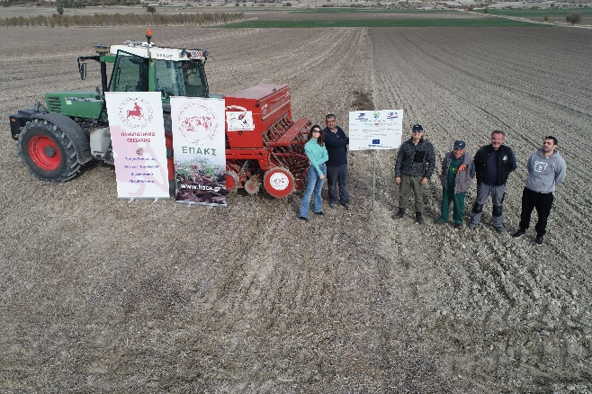 | 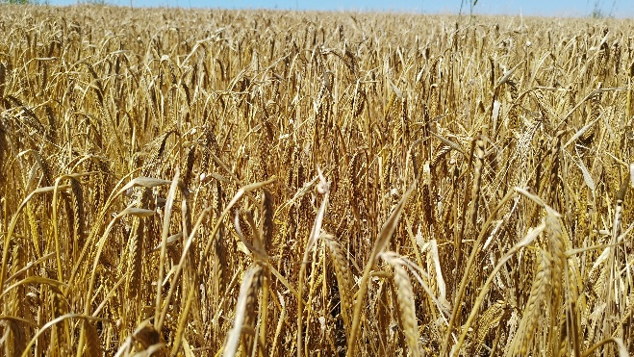
Project partners in the field – ©  Myrto Kosti | Durum wheat - ©  Myrto Kosti
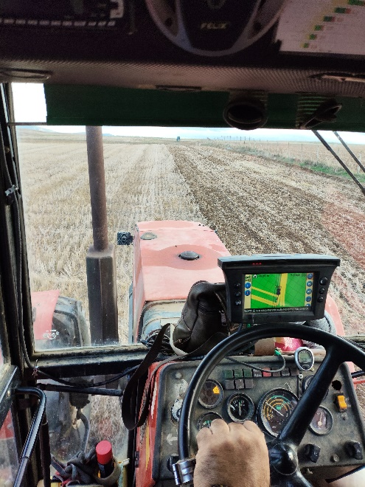 | 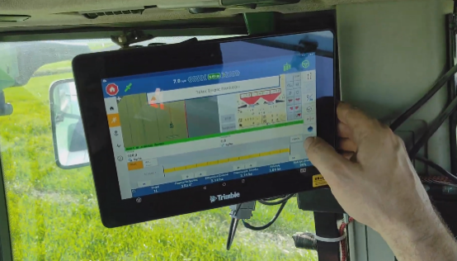
No-till seeding with the help of GPS guidance device - ©  Myrto Kosti | GPS guidance device - ©  Myrto Kosti

Please feel free to use this press article and the accompanying pictures in your publications and to inform your colleagues.
If you would like to receive all EU CAP Network press articles directly, please fill out the subscription form.

More information on climate adaptation on the ground

Related EU CAP Network ‘Innovation & knowledge exchange | EIP-AGRI’ activities.

Focus Groups
- Production of protein crops under climate change – Focus Group ongoing
- Local perennial plant genetic resources in view of climate change and biodiversity loss – Focus Group ongoing
- Regenerative agriculture for soil health – read the report published in 2024
- Competitive and resilient mountain areas - read the report and factsheet produced in 2024
- Nature-based solutions for water management – read the report published in 2022
- Digital tools for nutrient management – read the report and factsheet published in 2022
- Sustainable beef production systems – read the report and factsheet published in 2021-2022
- Sustainable industrial crops – read the report and factsheet published in 2021
- Sustainable ways to reduce pesticides in pome and stone fruit production – read the report and factsheet published in 2022
- Climate-smart (sub)tropical food crops in the EU – read the report published in 2021
- Reducing food loss on the farm – read the report and factsheet published in 2020-2021
- Renewable energy on the farm – read the report and factsheet published in 2019

Other events.

- EU CAP Network cross-visit ‘Climate adaptation on the ground - innovative solutions to build farm resilience’
- EU CAP Network cross-visit ‘Circular and organic soil management’
- EIP-AGRI Brokerage event 'Get involved in the EU Mission: A Soil Deal for Europe'

Publications & videos

- EIP-AGRI Challenge: Regenerative agriculture for soil health
- EIP-AGRI Brochure Climate-smart agriculture: Solutions for resilient farming and forestry

Inspirational ideas from the network

- Increasing farm resilience through crop associations (the Netherlands)
- Showcasing the added value of ecosystem services of farming in mountain areas (Austria)
- Climate-adaptive soil moisture management (the Netherlands)

Find out more inspirational ideas

Operational Groups working on climate adaptation
There are 284 Operational Groups focused on climate adaption listed in the EIP-AGRI project database (update January 2025)

- Austria (7)
- Belgium (2)
- Croatia (2)
- Cyprus (1)
- Finland (3)
- France (24)
- Germany (39)
- Hungary (1)
- Ireland (2)
- Italy (56)
- Latvia (2)
- Lithuania (2)
- Netherlands (22)
- Portugal (7)
- Slovenia (14)
- Spain (88)
- Sweden (9)

Horizon multi-actor projects working on climate adaptation
There are 36 ongoing Horizon Multi-actor projects and four Thematic networks in the EIP-AGRI project database (update January 2025)
Some examples:

- Oper8 – European Thematic Network for unlocking the full potential of Operational Groups on alternative weed control
- CLIMED-FRUIT : Adaptation to climate change and mitigation for perennial crops in Mediterranean Area
- Climate Neutral Farms – ClieNFarms
- OPTAIN - Optimal strategies to retain and re-use water and nutrients in small agricultural catchments across different soil-climatic regions in Europe
- Optimising Forest management decisions for a low-carbon, climate resilient future in Europe
- Re-Livestock - Facilitating Innovations for Resilient Livestock Farming Systems

Multi-actor projects are research and innovation initiatives where diverse stakeholders with complementary expertise, such as researchers, farmers, and local communities, work together to co-create solutions to real-world challenges. Operational Groups are strongly encouraged to take part in these types of collaborative research projects. By January 2025, about 4000 EIP-AGRI Operational Group projects (EIP-AGRI OGs) – bottom-up innovation projects at a local level – had been experimenting, testing and applying innovative practices, processes, products, services, and technologies. Building on these outstanding results, there are several opportunities for OGs to join in multi-actor projects, such as the calls for Horizon Europe Cluster 6, with a focus on the involvement of the EIP-AGRI OGs in Horizon multi-actor projects (MAPs) and enhancing cooperation possibilities for EIP-AGRI projects.

Thematic networks are collaborative platforms where individuals or organisations and Operational Groups share existing knowledge and best practices on a specific theme, presenting them in easily accessible formats for end-users such as farmers, foresters and advisors.

Upcoming EU CAP Network events focusing on innovation, knowledge exchange and EIP-AGRI (July 2024 – June 2025)

Find out more details on these events on the EU CAP Network website.

- Focus Group: Production of protein crops under climate change – 2nd meeting April/May 2025
- Focus Group: Alternative solutions for sustainable livestock product differentiation – 2nd meeting 9-10 April 2025
- Focus Group: Local perennial plant genetic resources in view of climate change and biodiversity loss – 2nd meeting April/May 2025
- Workshop: National networking for innovation and knowledge exchange, 29-30 January 2025
- Seminar: Robotics and artificial intelligence (AI) in farming and forestry, 19-20 February 2025
- Workshop: Circular bioeconomy – valorisation of forestry by-products and residues, 26-27 March 2025
- Cross-visits: The EU CAP Network is organising three cross-visits between multiple OGs on water management, pollinators and animal welfare, between 5 and 9 May 2025
- Workshop: Innovation in logistics to improve the position of farmers in a supply chain, 20-21 May 2025
- Seminar: Demonstration farms, June 2025
- Brokerage event: Horizon Europe project calls, April 2025

The common agricultural policy 2023-2027
For detailed information on the Common Agricultural Policy 2023-2027, please visit the European Commission’s website.

Innovation, knowledge exchange and EIP-AGRI in the EU CAP Network

The Support Facility for Innovation and Knowledge exchange including EIP-AGRI is part of the EU CAP Network. It connects diverse stakeholders, including farmers, foresters, advisors, researchers, businesses, and NGOs, to foster robust knowledge flows and accelerate innovation. The activities of the EU CAP Network align with the Common Agricultural Policy (CAP) objectives, including modernising agriculture and rural areas through knowledge exchange, innovation and digitalisation. By bridging research and practice, the network shares research results, best practices, and innovative solutions with end-users. This approach supports the development of effective Agricultural Knowledge and Innovation Systems (AKIS) across the EU.

EIP-AGRI Operational Groups

EIP-AGRI Operational Groups are small collaborative projects designed to foster grassroots innovation by bringing together partners with complementary expertise. The composition of each group varies based on the project’s theme and specific objectives. Farmers, advisors, scientists, businesses and other relevant partners collaborate to develop practical solutions to specific challenges or opportunities faced by European farmers and foresters. The involvement of farmers and foresters throughout the project ensures that the innovative solutions are practical and readily applicable in the field.

Operational Groups funded under Rural Development Programmes 2014 – 2022

- A total of 98 Rural Development Programmes (RDPs) from 2014 to 2022 provide support for innovative EIP-AGRI Operational Group projects
- 3,843* Operational Group projects have been notified in the common EU data repository, with many currently ongoing or already completed as of May 2023. Member States continue to launch additional Operational Group projects under current transitional rules for EU Rural Development Programmes, with some running until 2025. Information on all of these projects can be found in the EIP-AGRI project database.

*Last update 30 January 2025

Operational Groups funded under CAP Strategic Plans 2023 – 2027

- Under the common agricultural policy (CAP) for 2023-2027, the EU Member States have designed national CAP Strategic Plans (CSPs) which combine funding for income support, rural development, and market measures. All CAP Strategic Plans have been adopted, with implementation beginning on 1 January 2023.
- A total of 26 CAP Strategic Plans include support for innovative EIP-AGRI Operational Groups. All together, 6,600 EIP-AGRI Operational Group projects have been planned.

