Agricultural cooperative in Slovakia applies regenerative farming to restore soil health and productivity
Regenerative practices have helped a cooperative to save input costs and reduce soil erosion

October 2024

Agricultural cooperative in Slovakia applies regenerative farming to restore soil health and productivity

Regenerative practices have helped a cooperative to save input costs and reduce soil erosion
Following a change of management in 2010, Krakovany – Stráže, an agricultural cooperative in Slovakia, has been gradually introducing regenerative agricultural practices to restore and maintain soil health and productivity. The cooperative has 54 shareholders, and 640 ha. of farmland.

Before beginning regenerative practices, after many years of intensive farming and chemical treatment, sustainable management was difficult. Robert Dohál, the chairman of the board of directors, says: “After tens of years of conventional farming, the soil was not in good condition and the farm was working at a loss. As a way to regenerate the economy of Krakovany – Stráže, we decided to experiment with regenerative agriculture.”

The adoption of the practices was gradual. They began by reducing tillage of the soil and the use of machinery on the fields, a few years later they introduced cover crops, and from 2016 they switched to no-till, directly sowing into the remains of the pre-crop or cover crop. The cooperative stopped using fungicides, insecticides and artificial fertilisers. Today they apply organic fertilisers and compost only on the surface of the soil. They have also planted flower strips. Robert explains: “In regenerative farming, we want to imitate the way nature works, allowing all biological processes to take place naturally in the soil, bringing life back to the soil and making our farm innovative thanks to it.”

A large variety of crops are grown by the agricultural cooperative: this is key for many of the practices, promoting diversity and preventing pests and diseases. Last year the main crops were peas, durum wheat, and maize, and on the remaining 40% of the land, they grew 11 other crops, including vetch, poppy, rapeseed, buckwheat, rye, barley, and phacelia. Krakovany – Stráže is currently running field trials for rapeseed, and experimenting with practices without use of insecticides and fungicides. Species and combinations of cover crops are also being constantly studied and improved.

Regenerative practices have helped Krakovany – Stráže to save input costs and eliminate soil erosion. The environmental element was also important. Robert explains again: “We manage the soil gently, in harmony with nature, with natural resources, with respect for Mother Earth. In regenerative farming, the soil is not disturbed by anything, and the soil is covered by plants or plant residues all year round.”

The application of regenerative agriculture practices has had many benefits for the cooperative. Organic carbon content in the soils has increased, in some fields from 1.7% in 2013 to 2.6% in 2021. The amount of CO₂ sequestered has also gone up, and there has been no soil erosion in the past 12 years. A study in 2021 showed that water retention capacity was 100 litres per m² per year higher in their soils than in surrounding agricultural land. Input costs significantly lowered, while yields have been maintained to match the local average. This has had a fundamental impact on economic stability, and the cooperative has consistently made a profit for the past 5 years. Biodiversity has also increased, supporting beekeepers by providing bee pastures throughout the season. To improve soil health even further, the cooperative now aims to progressively reduce the application of herbicides.

Krakovany – Stráže regularly shares its experiences, celebrating soil health and promoting education about regenerative farming. They welcome school visits and organise information days.

Robert Dohál concludes, “Agriculture is not, and must not be a business based on the plundering of resources. They are not inexhaustible. Let's change it. Let's start farming and teach with a clear conscience.”

Background information
Regenerative agriculture is an approach to farming and land management that focuses on restoring and enhancing the health of ecosystems while promoting sustainable food production. When more than 60% of EU soils are currently considered unhealthy due to current management practices, pollution, urbanisation, and the effects of climate change (EU Soil Observatory), regenerative agriculture can be used as a way to sustain yields on a long-term basis without negative impact on the soil and with minimal dependence on agrochemicals.

Regenerative agriculture for soil health is the topic of a current EU CAP Network Focus Group. The group looks specifically into regenerative agriculture practices and how they can help farmers to restore, protect and improve soil health and productivity. The 20 experts of this group will meet for a second time on 23-24 April 2024 in Odense, Denmark.

Krakovany – Stráže is participating in EU project PREPSOIL as a Community of Practice. The PREPSOIL project facilitates the deployment of EU mission "A Soil Deal for Europe" across European regions by helping key players to reduce soil degradation, while increasing soil awareness and soil literacy.

More information about Krakovany – Stráže:
  - Farm website
  - Further information
  - Facebook
  - YouTube
Other useful links:
  - EU Soil Observatory

Project information
✆ EU CAP Network contact

Ina Van Hoye
ina.vanhoye@eucapnetwork.eu
+32 486 90 77 43

Communication manager
‘Support Facility for Innovation &
Knowledge exchange | EIP-AGRI’
✆ Project contact

Ján Hegyi
Jankohegyi@gmail.com
+421915783005

Project photos
Click on the pictures to download the high-resolution versions. The pictures are free for use, please mention the copyright.

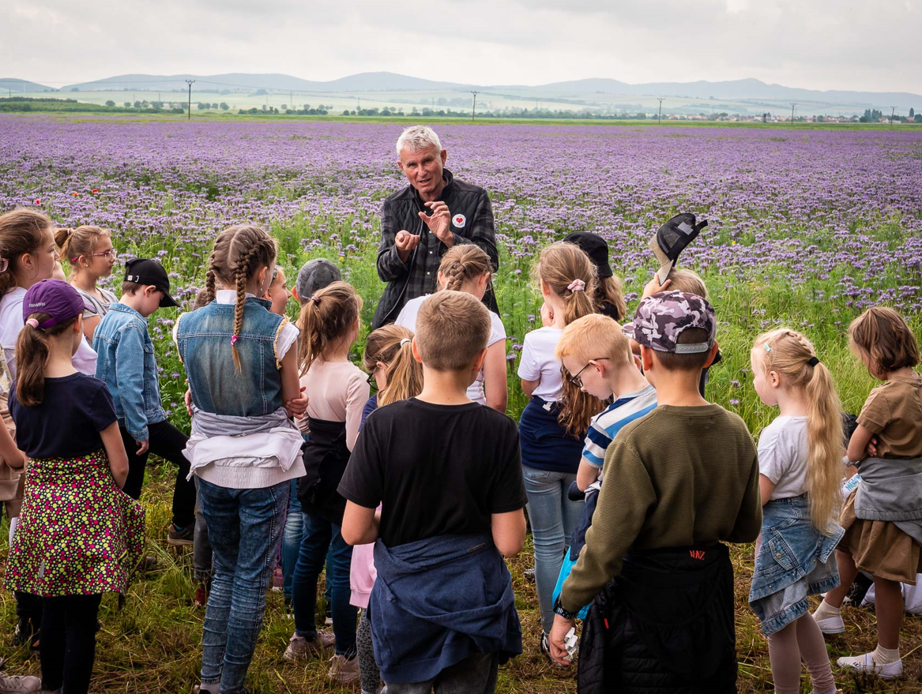 | 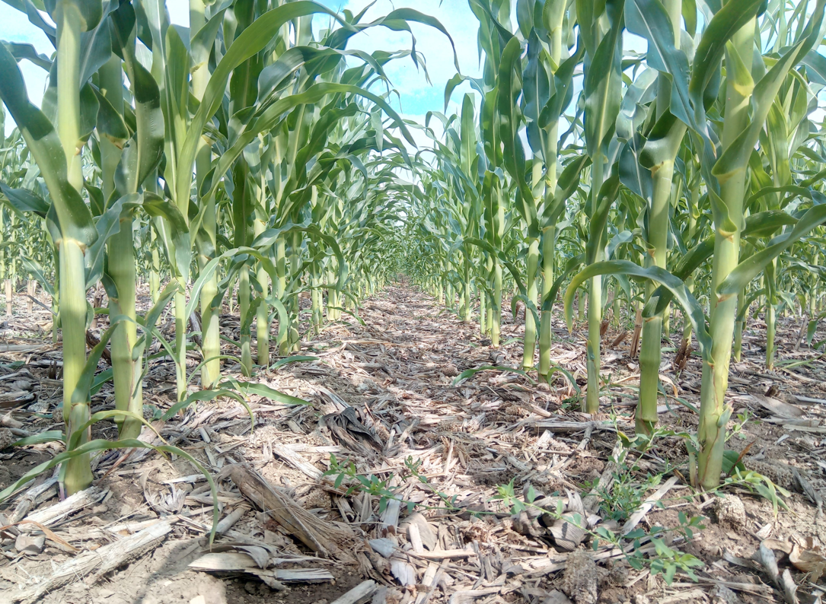
Robert Dohál, the chairman of the board of directors for Krakovany – Stráže carrying out a site visit for a school group – copyright Krakovany – Stráže | The soil is never bare – copyright Krakovany – Stráže
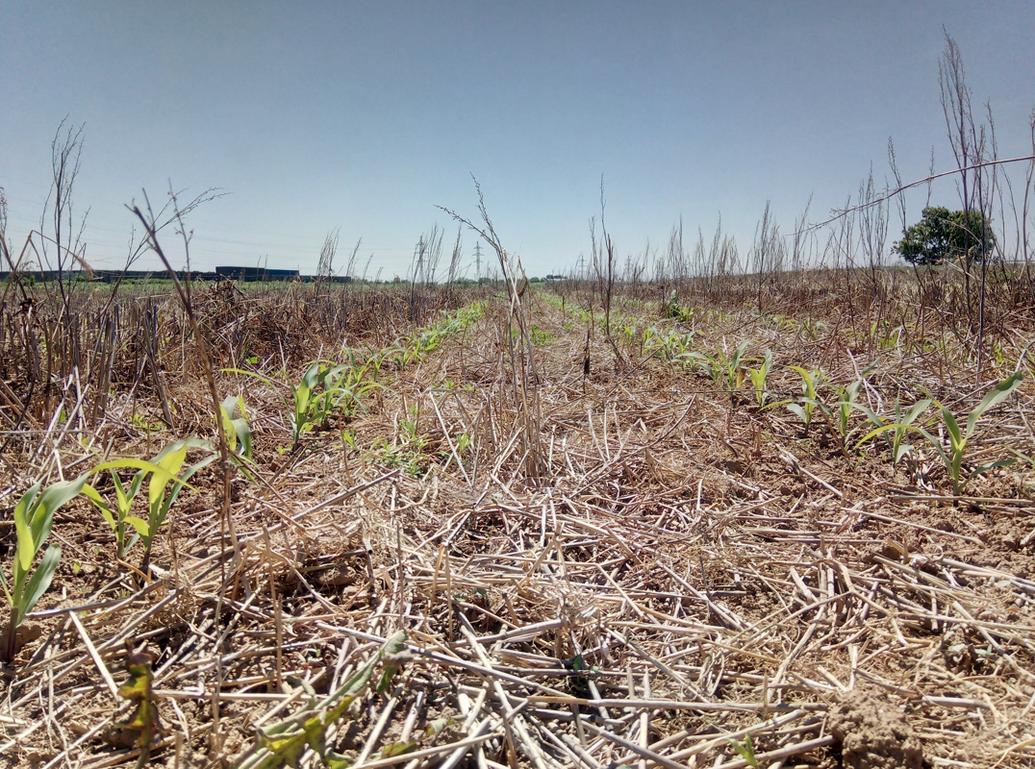 | 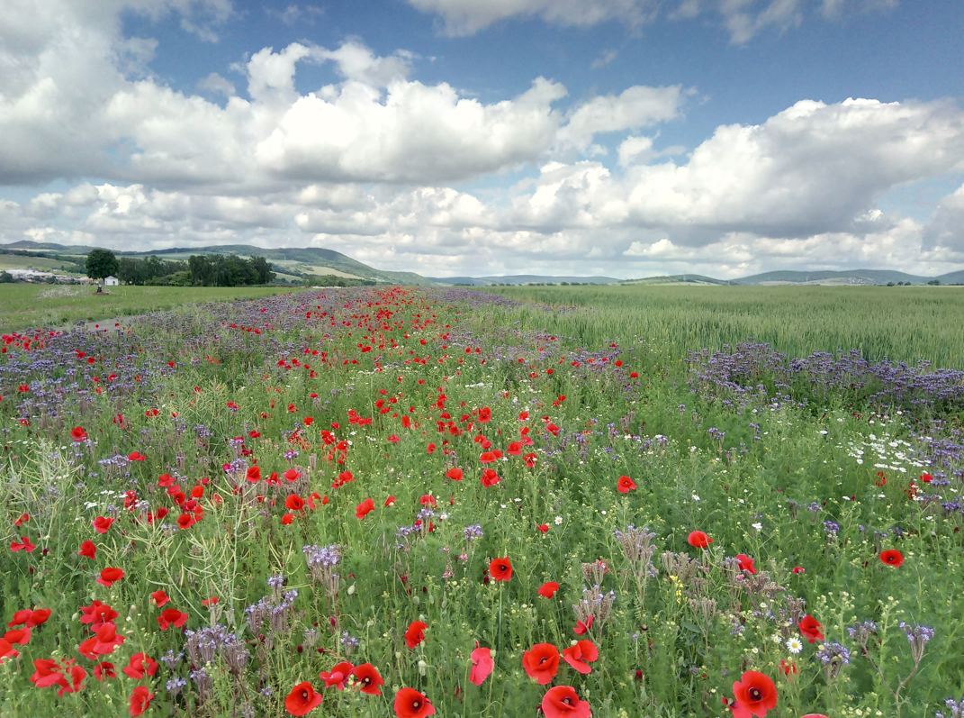
Crops sown into organic residues – copyright Krakovany – Stráže | Flowers on the farm, increasing biodiversity – copyright Krakovany – Stráže

Please feel free to use this press article and the pictures in your own publications and to inform your colleagues.
If you would like to receive all EU CAP Network press articles directly, please fill in the subscription form.

More information on regenerative farming

EU CAP Network ‘Innovation & knowledge exchange | EIP-AGRI’ activities

Focus Groups
  - Regenerative agriculture for soil health
  - Enhancing the biodiversity on farmland through high-diversity landscape features
  - High Nature Value (HNV) - Farming profitability
  - Nature-Based Solutions for water management under climate change
  - Non-chemical weed management in arable cropping systems
  - Soil organic matter content in Mediterranean regions
  - Agroforestry: introducing woody vegetation into specialised crop and livestock systems
  - Carbon storage in arable farming: Moving from source to sink
  - Digital tools for sustainable nutrient management
  - Diseases and pests in viticulture
  - Optimising profitability of crop production through Ecological Focus Areas
  - Grazing for Carbon
  - Mixed Farming Systems: Livestock/Cash crops
  - Nutrient recycling
  - Organic farming - Optimising arable yields
  - Pests and diseases of the olive tree
  - Protecting agricultural soils from contamination
  - IPM practices for suppression of soil-borne diseases in vegetables and arable crops
  - Sustainable beef production systems
  - Water & agriculture: adaptive strategies at farm level

Events

- EU CAP Network Seminar ‘Smart circular farming to address high energy and fertiliser prices’ (2022
- EU CAP Network cross-visit ‘Use of agricultural and forestry residues’ (2024)
- EU CAP Network cross-visit ‘Circular and organic soil management’ (2023)
- EU CAP Network workshop ‘Promoting pollinator-friendly farming’ (2024)
- EU CAP Network workshop ‘Enhancing food security under changing weather patterns: farm adaptation’ (2023)
- EIP-AGRI brokerage event 'Get involved in the EU Mission: A Soil Deal for Europe' (2022)
- EIP-AGRI seminar: Healthy soils for Europe: sustainable management through knowledge and practice (2021)
- EIP-AGRI Workshop Cropping for the future: networking for crop rotation and crop diversification (2019)

Publications & videos
- AGRI challenge: nature-based solutions for water management (2022)
- AGRI Challenge: Non-chemical weed management in arable cropping systems – (2020)
- EIP-AGRI inspirational video: AGRI challenge: crop diversification in grassland (2019)
- AGRI challenge - Increasing biodiversity in agricultural landscapes (2019)
- EIP-AGRI inspirational video: AGRI challenge: soil fertility through carbon storage (2018)
- EIP-AGRI Brochure Soil organic matter matters
- EIP-AGRI Brochure Sustainable and resilient farming: Inspiration from agro-ecology
- Agrinnovation magazine - Issue n° 7 - September 2020 - places soil health in the spotlight
- EIP-AGRI Brochure Climate-smart agriculture: Solutions for resilient farming and forestry
- EIP-AGRI Factsheet on Agroforestry
- Soil health: Strip-till and strip-plant methods to improve soil fertility
- EIP-AGRI Brochure Water and Agriculture

Inspirational ideas from the network
- Agricultural cooperative in Slovakia applies regenerative farming to restore soil health and productivity (Slovakia)
- Improving soil biodiversity to reduce inputs (Spain)
- Walloon farmers test pesticide and tillage reduction strategies in soil living lab (Belgium)
- Increasing farm profitability while cutting carbon emissions, a toolkit developed by farmers for farmers (UK)
- Farmers tackling drought and flooding (Belgium)
- Arable cropping systems adapted to climate change (Germany)
- Cover crops for quality soil in the Po River valley (Italy)
- Italian table grape farmers cooperate to improve soil quality (Italy)
- Looking after the soil to bring life and carbon back (Austria)
- The Soil Box (Germany)
- Mycorrhiza fungi as green alternative for mineral fertilisers (Germany)
- Preserving soil organic matter and protecting water sources (Portugal)
- Protecting soil organic carbon in Poland (Poland)
- Grazing management with a heart for soil health (UK)
- Biostimulants for sustainable agriculture (Italy)
- From deserted area to oasis of biodiversity (Greece)
- Strip-till and strip-plant methods to improve soil fertility (Germany)
- New machinery for soil health in arable crop production (Italy)

Operational Groups working on regenerative farming

17 Operational Groups working on regenerative farming are available in the EIP-AGRI project database (update April 2024)

Horizon multi-actor projects working on regenerative farming

- REVINE - Regenerative agricultural approaches to improve ecosystem services in Mediterranean vineyards
- AgriCaptureCO₂ - Regenerating soils for climate and farmers
- SoildiverAgro - Soil biodiversity enhancement in European agroecosystems to promote their stability and resilience by external inputs reduction and crop performance increase
- PATHWAYS for sustainable food
- BEST4SOIL - Boosting 4 BEST practices for SOIL health in Europe
- Inno4Grass Thematic Network - Shared Innovation Space for Sustainable Productivity of Grasslands in Europe
- Legumes Translated - Translating knowledge for legume-based farming for feed and food systems
- OK-Net-Arable - OK-Net Ecofeed
- BIOFRUITNET - Innovative solutions in organic pome fruit production

Multi-actor projects are research and innovation projects in which end-users and multipliers of research results such as farmers and farmers’ groups, advisors, enterprises and others closely cooperate throughout the whole project. Operational Groups are strongly encouraged to participate in this type of research project.

Thematic networks are multi-actor projects which collect existing knowledge and best practices on a given theme to make it available in easily understandable formats for end-users such as farmers, foresters, advisors, etc.

Related videos
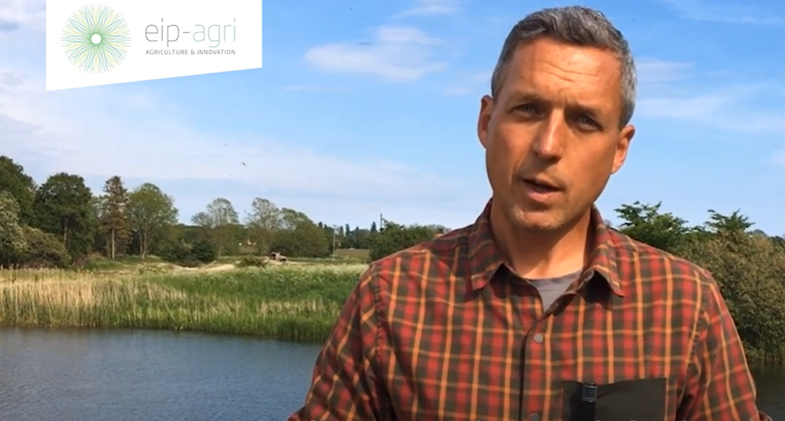 | 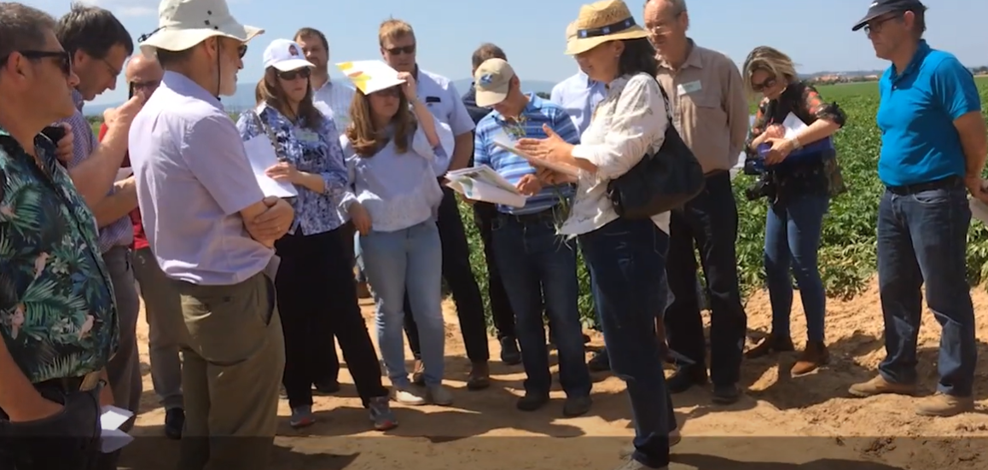
AGRI challenge: nature-based solutions for water management (2022) | AGRI Challenge: Non-chemical weed management in arable cropping systems – (2020)

Innovation, knowledge exchange and EIP-AGRI events 2023-2024
- Brokerage event: EU CAP Network Brokerage event 'Accelerating the innovation process through Horizon Europe multi-actor projects', 19-20 October 2023 – Antwerp, Belgium
- Focus Group meetings on:
  - Regenerative agriculture for soil health (23-24 April 2024)
  - Crop associations including Milpa and protein crops (29-30 May 2024)
  - Competitive and resilient mountain areas (6-7 March 2024)
- Workshop: National networking for innovation, 30 November-1 December 2023 – Talinn, Estonia
- Workshop: Circular water management, 12-13 March 2024
- Workshop: Women-led innovations in agriculture and rural areas, 17-18 April 2024
- Workshop: Promoting pollinator-friendly farming, 18-19 June 2024
- Seminar: Skills and Lifelong Learning, 21-22 February 2024 – Vienna, Austria
- Conference & award ceremony focusing on Operational Groups, 6-8 May 2024
- Ad-hoc national experts meeting (12 June 2024)
- Cross-visits, 26-27 June 2024 (Call closed 14/04/2024)
  - Climate adaptation on the ground
  - Use of agricultural and forestry residues

The common agricultural policy 2023-2027
Find information on the common agricultural policy 2023-2027 on the European Commission’s website.

Innovation, knowledge exchange and EIP-AGRI in the EU CAP Network

The new European CAP Network ‘Support Facility for Innovation & Knowledge exchange | EIP-AGRI’ acts as a mediator, enhancing communication and cooperation between everyone with a keen interest in innovation and sharing knowledge for sustainable agriculture, forestry and rural areas.

The European Innovation Partnership 'Agricultural Productivity and Sustainability' (EIP-AGRI) was launched in 2013 by the European Commission in a bid to promote rapid modernisation of the sectors through efforts to step up innovation. The EIP-AGRI aims to foster innovation in the agricultural and forestry sectors and in rural areas by bringing research and practice closer together, in innovation projects as well as via the European CAP Network and the national CAP Networks. Also, grassroots ideas from farmers are developed into concrete innovative solutions through ‘Operational Group’ innovation projects. The EIP-AGRI aims to streamline, simplify and better coordinate existing instruments and initiatives, and complement them with actions where necessary.

Common Agricultural Policy 2023-27

EIP-AGRI Operational Groups

EIP-AGRI Operational Groups are groups of people who work together on an innovation project. They bring together partners with complementary knowledge. The composition of the group will vary according to the theme and specific objectives of

each project. Farmers, advisors, scientists, businesses, or other relevant partners work together to find practical solutions for specific problems or opportunities for European farmers and foresters. Farmers and foresters need to cooperate throughout the project to ensure that the innovative solutions are practical and likely to be quickly applied in the field. Read the basic principles. Innovation support services (including advisors with a focus on innovation), and in particular innovation brokering, can therefore play a crucial role in getting worthwhile projects off the ground by facilitating contacts.

Operational Groups funded under Rural Development Programmes 2014 – 2022

- 98 Rural Development Programmes 2014-2020 (RDPs) provide support to innovative EIP-AGRI Operational Group projects

- More than 3200 Operational Group projects have been notified in the common EU data repository and are currently ongoing (or already finished)*. Member States will still start more Operational Group projects which may run until 2025 (under current transitional rules for EU Rural Development Programmes). Find information on all of these projects in the EIP-AGRI project database.

Operational Groups funded under CAP Strategic Plans 2023 – 2027

Within the common agricultural policy 2023-27 (CAP), the EU Member States have designed national CAP Strategic Plans combining funding for income support, rural development, and market measures. All CAP Strategic Plans have been adopted and their implementation started on 1 January 2023.

26 CAP Strategic Plans include support for innovative EIP-AGRI Operational Groups. In total, 6600 EIP-AGRI Operational Group projects have been planned.

May 2023

