Showcasing the added value of ecosystem services for farming in mountain areas

‘Value-added mountain farming’ is an Operational Group in Austria developing business models based on ecosystem services to improve the socio-economic and environmental resilience of mountain areas and their communities

April 2024

Showcasing the added value of ecosystem services for farming in mountain areas
‘Value-added mountain farming’ is an Operational Group in Austria developing business models based on ecosystem services to improve the socio-economic and environmental resilience of mountain areas and their communities.

Farmer Regina Aspalter is leading an Operational Group within the ‘National Park Kalkapen’ in the region of Upper Austria, a project to showcase how new business models could be created, which enables farmers to generate income from ecosystem services in mountain areas.

Covering around 30% of the EU territory, mountain areas face significant challenges that make them both ecologically and socially fragile. Regina says “By diversifying farming income and developing a wide range of ecosystem services, farmers can have a huge positive impact on local communities while ensuring their farms are viable, competitive and sustainable businesses.”

The new business models for mountain farmers focus specifically on ecosystem services related to nature conservation and biodiversity. In this mountainous region of Austria, certain features can be observed in high numbers, such as extensive grasslands and pastures. These areas boast rich biodiversity, housing a diverse array of plant and insect species. They also play a crucial role in groundwater recharge, contributing to high water quality and maintaining the typical image of the cultural landscape.

The project started in 2022, and will end later this year. Four farmers are involved in the Operational Group, and have been working with research organisations to assess the benefits of ecosystem services linked to nature conservation and biodiversity. The project partners began by carrying out an analysis to quantify and map measurable and marketable ecosystem services in the context of mountain agriculture in the Kalkapen National Park. As part of this analysis, the project consulted and involved external stakeholders, including 30 other farmers, and also carried out a data-based assessment of the ecosystem services.

Regina explains “Researchers from the project have helped to turn this information into indicators to measure a farm’s performance in relation to the ecosystem services studied.” Based on this, business models are being studied to reward farmers for environmental performance. These include grants, loan interest discounts, or acknowledgement through specific labels and certifications. To roll this out, the partners are in contact with companies, banks and public authorities. Regarding these different rewarding options, the project is specifically interested in forming strategic partnerships with commercial enterprises to market the ecosystem services. To this end, close cooperation between agriculture, business and science will create a long-term opportunity to generate additional income for mountain farms. The new marketable business models arising from the project will be shared on a specially developed platform.

“Our results so far show that we, mountain farmers, have a high level of awareness and implementation rates of biodiversity-friendly practices. Such practices can be compensated to support the viability of our farms and keep stimulating our performance. Furthermore, practices which protect biodiversity or clean water retention will represent an increasingly important social and economic value in the future.” - Regina Aspalter.

Background information
Mountain areas are particularly vulnerable to changes in weather patterns and extreme weather events brought about by climate change. Their isolated locations also mean they are more susceptible to the decline in agricultural holdings, population ageing, and land abandonment, including abandonment of cultivated grassland. However, agriculture and forests in mountain areas offer many ecosystem services for their communities, such as water storage, biodiversity and food security.

  - Value-added mountain farming - Operational Group page on EU CAP Network projects database
  - Value-added mountain farming – website (in German/and English)
  - Value-added mountain farming – webpage (in English)

Project information
✆ EU CAP Network contact

Ina Van Hoye
ina.vanhoye@eucapnetwork.eu
+32 486 90 77 43

Communication manager
‘Support Facility for Innovation &
Knowledge exchange | EIP-AGRI’
✆ Project contact

Anita Haider
anita.haider@blw-npregion.com
+43 664 455 99 11

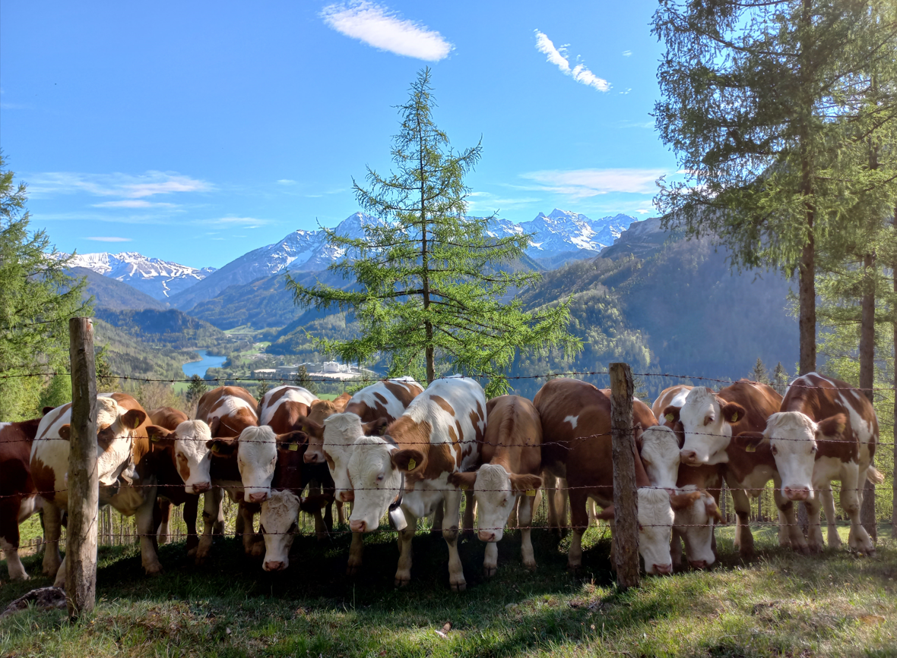 | 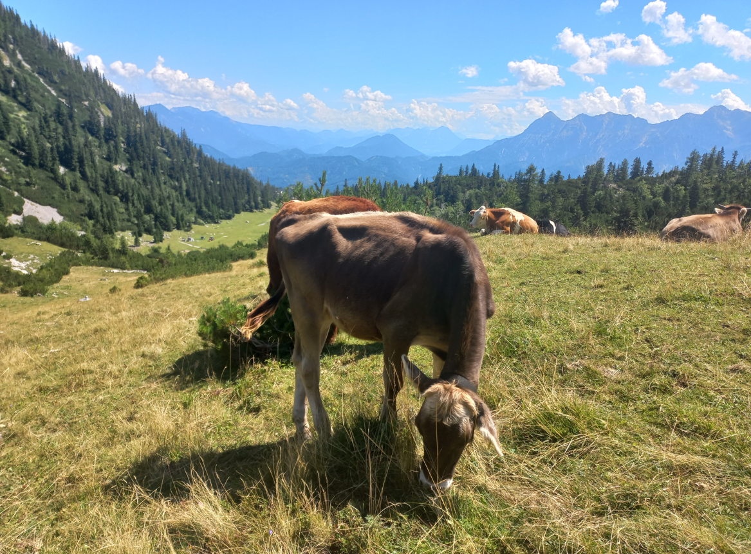
Cattle breeding in mountain areas - ©Kirchweger | Young heifers grazing on alpine pastures - ©Kirchweger
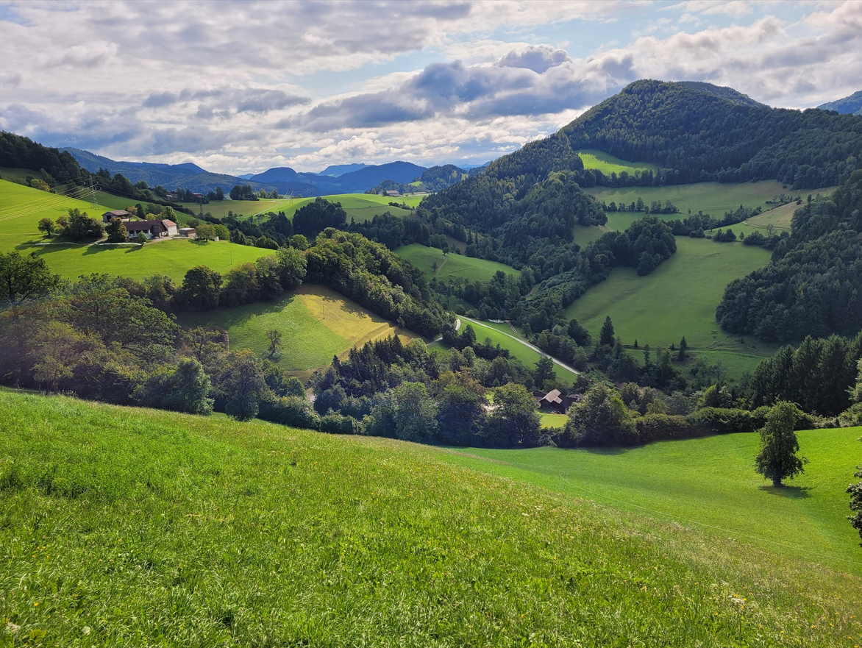 | 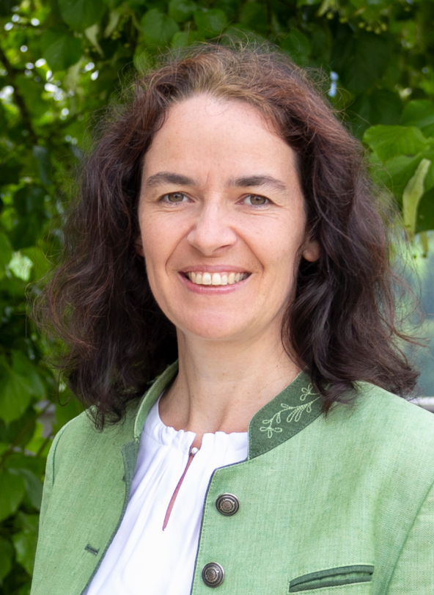
Steep and small grassland plots in mountain areas - ©Müller | Regina Aspalter, farmer and leader of the Operational Group - ©Aspalter

More information on competitive and resilient mountain areas

EU CAP Network ‘Innovation & knowledge exchange | EIP-AGRI’ activities

Focus Groups
  - Focus Group 'Competitive and resilient mountain areas'
  - Focus Group ‘Recovery of abandoned agricultural lands’
  - Focus Group Enhancing the biodiversity on farmland through high-diversity landscape features

Publications & videos
- Social innovation – Solutions for thriving agriculture, forestry and rural areas

Inspirational ideas from the network

- Press article - Protecting farmland pollinators
- Inspirational idea: Farm carbon

Operational Groups working on competitive and resilient mountain areas

84 Operational Groups working on mountains are available in the EIP-AGRI project database (updated April 2024):

Horizon multi-actor projects working on competitive and resilient mountain areas

- MOVING Mountain Valorisation through Interconnectedness and Green Growth
- Newbie New Entrant netWork: Business models for Innovation, entrepreneurship and resilience in European agriculture

Multi-actor projects are research and innovation projects in which end users and multipliers of research results such as farmers and farmers’ groups, advisors, enterprises, and others closely cooperate throughout the whole project. Operational Groups are strongly encouraged to participate in this type of research project.

Thematic networks are multi-actor projects which collect existing knowledge and best practices on a given theme to make it available in easily understandable formats for end-users such as farmers, foresters, advisors etc.

Research needs from practice related to competitive and resilient mountain areas

The last report of research needs from practice by the CAP Network compiles some knowledge gaps that would benefit from further research and that are relevant to mountain areas. These fall mainly under 3 key research areas: resource management; integrated ecological approaches, from farm to landscape level; and
new openings for rural growth and enhancing the human and social capital in rural areas.
These research needs demand more knowledge, for example on the impact of grass-based beef production systems on climate, biodiversity and animal welfare; management measures on High Nature Value (HNV) pasture; tools to improve land management and avoid conflicts between wildlife and farming; impact and opportunities of small scale farming; governance models for rural areas; studies on social perception and consumer behaviour, in particular related to willingness to pay, etc.

Innovation, knowledge exchange and EIP-AGRI events 2023-2024
- Brokerage event: EU CAP Network Brokerage event 'Accelerating the innovation process through Horizon Europe multi-actor projects', 19-20 October 2023 – Antwerp, Belgium
- Focus Group meetings on:
  - Regenerative agriculture for soil health (23-24 April 2024)
  - Crop associations including Milpa and protein crops (29-30 May 2024)
  - Competitive and resilient mountain areas (6-7 March 2024)
- Workshop: National networking for innovation, 30 November-1 December 2023 – Talinn, Estonia
- Workshop: Circular water management, 12-13 March 2024
- Workshop: Women-led innovations in agriculture and rural areas, 17-18 April 2024
- Workshop: Promoting pollinator-friendly farming, 18-19 June 2024
- Seminar: Skills and lifelong learning, 21-22 February 2024 – Vienna, Austria
- Conference & award ceremony focusing on Operational Groups, 6-8 May 2024
- Ad-hoc national experts meeting, 12 June 2024 online (Call closed 14/05/2024)
- Cross-visits, 26-27 June 2024 (Call closed 14/04/2024)
  - Climate adaptation on the ground
  - Use of agricultural and forestry residues

The common agricultural policy 2023-2027
Find information on the common agricultural policy 2023-2027 on the European Commission’s website.

Innovation, knowledge exchange and EIP-AGRI in the EU CAP Network

The new European CAP Network ‘Support Facility for Innovation & Knowledge exchange | EIP-AGRI’ acts as a mediator, enhancing communication and cooperation between everyone with a keen interest in innovation and sharing knowledge for sustainable agriculture, forestry and rural areas.

The European Innovation Partnership 'Agricultural Productivity and Sustainability' (EIP-AGRI) was launched in 2013 by the European Commission in a bid to promote rapid modernisation of the sectors by efforts to step up innovation. The EIP-AGRI aims to foster innovation in the agricultural and forestry sectors and in rural areas by bringing research and practice closer together – in innovation projects as well as via the European CAP Network and the national CAP Networks. Also, grassroots ideas from farmers are developed into concrete innovative solutions through ‘Operational Group’ innovation projects. The EIP-AGRI aims to streamline, simplify and better coordinate existing instruments and initiatives, and complement them with actions where necessary.

Common agricultural policy 2023-27

EIP-AGRI Operational Groups

EIP-AGRI Operational Groups are groups of people who work together in an innovation project. They bring together partners with complementary knowledge. The composition of the group will vary according to the theme and specific objectives of each project. Farmers, advisors, scientists, businesses or other relevant partners work together to find practical solutions for specific problems or opportunities for European farmers and foresters. Farmers and foresters need to cooperate throughout the project to ensure that the innovative solutions are practical and likely to be quickly applied in the field. Read the basic principles. Innovation support services (including advisors with a focus on innovation), and in particular innovation brokering, can therefore play a crucial role in getting worthwhile projects off the ground by facilitating contacts.

Operational Groups funded under Rural Development Programmes 2014 – 2022

- 98 Rural Development Programmes 2014-2020 (RDPs) provide support to innovative EIP-AGRI Operational Group projects
- More than 3200 Operational Group projects have been notified in the common EU data repository and are currently ongoing (or already finished)*. Member States will still start more Operational Group projects which may run until 2025 (under current transitional rules for EU Rural Development Programmes). Find information on all of these projects in the EIP-AGRI project database.
* May 2023

Operational Groups funded under CAP Strategic Plans 2023 – 2027

Within the common agricultural policy 2023-27 (CAP), the EU Member States have designed national CAP Strategic Plans combining funding for income support, rural development, and market measures. All CAP Strategic Plans have been adopted, and their implementation started on 1 January 2023.

26 CAP Strategic Plans include support for innovative EIP-AGRI Operational Groups. In total, 6600 EIP-AGRI Operational Group projects have been planned.

