Increasing farm resilience through crop associations

A farm in the Netherlands has developed an innovative, viable and sustainable business model based on agroecology, making efficient use of natural resources while reducing the dependency on external inputs

May 2024

Increasing farm resilience through crop associations

A farm in the Netherlands has developed an innovative, viable and sustainable business model based on agroecology, making efficient use of natural resources while reducing the dependency on external inputs

Ekoto is an organic farm in the south of the Netherlands. On their 7 hectares of land, they grow arable crops, including over 30 different types of vegetables and herbs in strip cropping. Their ‘mission’ is to ‘accelerate the transition to a sustainable and transparent supply chain’.

The farm was set up by a young farmer, Ivar van Dorst, in 2020. His motivation was to provide local, organic alternatives to the products we buy in everyday life, such as tea and beans. Ivar grew up on the family farm, and, as his parents had already left farming, he was well aware of the challenges linked to the profession. “I had in mind from the start that I needed to make a living out of the farm, otherwise it would not be sustainable. I also needed to find ways to ensure the farm could cope with external variables, such as the changing climate”.

In his first year, in 2020, Ivar decided to start with a technical approach, focusing on which crops grow best next to each other. Each year since, he has added other elements; for example, exploring what works financially and how to maintain employment on the farm. As part of his business model, Ivar innovates with sales based on customer demand. He supplies local businesses with products such as veg box schemes, provides zero-waste shops, cafés and bakeries with a variety of produce, and also has a shop and a ‘pick-your-own’ service.

The strip-cropping is made up of a rotation of five crops: a cereal crop (mainly oats), a fruit crop (pumpkin), a legume crop to fix nitrogen, several vegetables, and an ‘experimental crop’ as the fifth. Ivar and his team apply strip cropping on most of the fields. They test combinations of crops to determine which can be most effective. For the strips which are 6 metres wide, to accommodate the 3-metre-wide machinery, GPS is used to make sure they are in the same place every year. The strip crop method increases biodiversity, and makes it more difficult for pests and diseases to spread. This means lower inputs are needed, and creates a healthier environment for the people working on the farm and better products for the consumer. The fields also have flowering borders, which attract beneficial insects and serve as a buffer against invading snails and slugs.

Ivar has been experimenting with different varieties of beans, and the combination of the bean crop with yarrow and camomile for tea has proven very successful. Even though broad beans suffer greatly from aphids, the nearby herbs and flowers attract ladybirds that feast on the aphids and naturally limit the damage to the bean crop. He says “Since we moved the herbal strips close to the beans, we have certainly seen an increase in natural enemies and a reduction in crop damage to the beans due to pests.”

As some companies have shown a particular interest in certain ancient bean varieties, the farm is now running a research project with local funding to experiment further with beans as an effective crop for strip-cropping. They obtained 50 different ancient bean varieties from the seed bank, and are conducting field trials.

Ivar and his team would like to take this innovative business model based on strip-cropping further “I would really love to continue scaling up the cultivation of beans in Europe, tackling the distribution and business-model side, and promoting beans as a viable crop for European farmers.”

Background information
Ivar is a member of the EU CAP Network Focus Group 'Crop associations including Milpa and protein crops'. He has also won several awards for his entrepreneurship including the Food100 award – in 2023 he was in the top three of the one hundred game-changers in the agri-food industry that were selected.

  - Ekoto website
  - Ekoto on Instagram
  - Video on Ekoto
  - EU CAP Network Focus Group 'Crop associations including Milpa and protein crops'

Project information
✆ EU CAP Network contact

Ina Van Hoye
ina.vanhoye@eucapnetwork.eu
+32 486 90 77 43

Communication manager
‘Support Facility for Innovation &
Knowledge exchange | EIP-AGRI’
✆ Project contact

Ivar van Dorst
ivar@ekoto.nl
https://www.linkedin.com/in/ivar-van-dorst/

Project photos
Click on the pictures to download the high-resolution versions. The pictures are free for use, please mention the copyright.

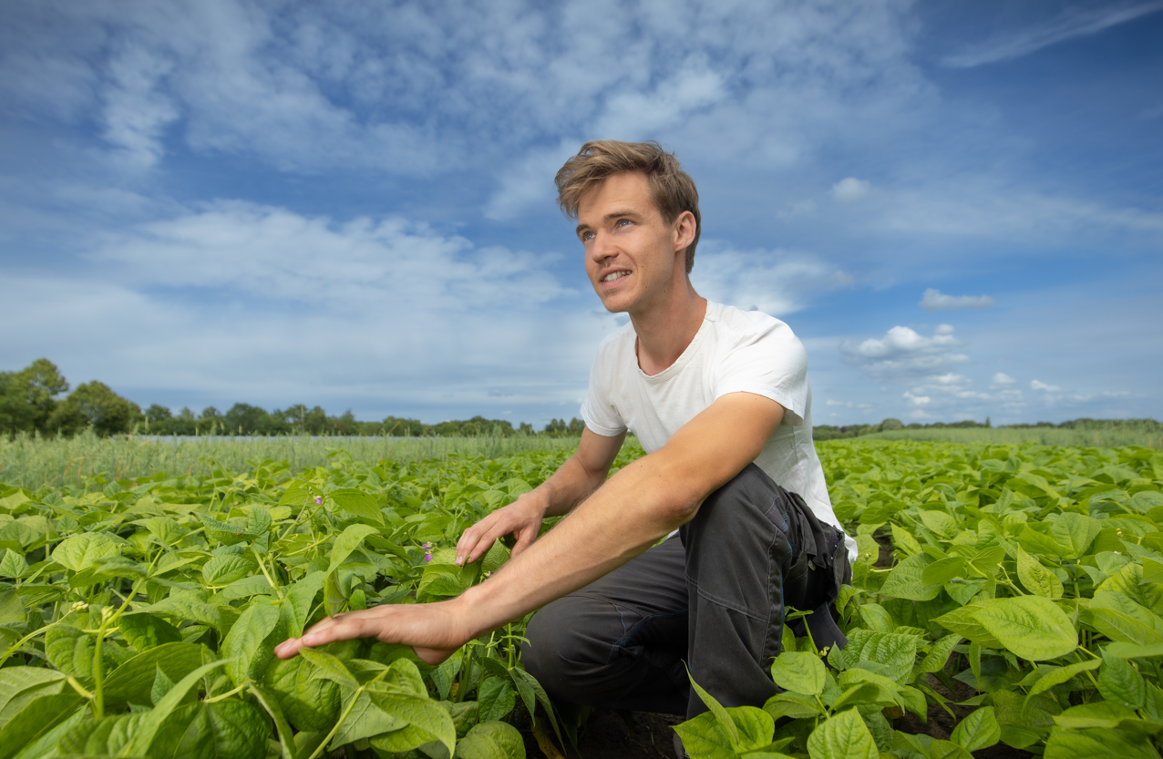
Ivar van Dorst – copyright Erik van der Burgt | Chickpeas in stripcropping – copyright Ivar van Dorst
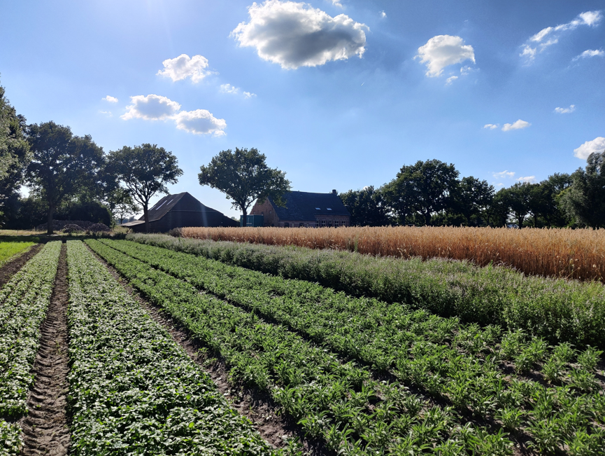
Strip cropping – copyright Ivar van Dorst

Please feel free to use this press article and the pictures in your own publications and to inform your colleagues.
If you would like to receive all EU CAP Network press articles directly, please fill in the subscription form.

More information on crop associations

EU CAP Network ‘Innovation & knowledge exchange | EIP-AGRI’ activities

Focus Groups
  - Integrated Pest Management (IPM) - Focus on Brassica species
  - Crop associations including Milpa and protein crops
  - Non-chemical weed management in arable cropping systems
  - Bee health and sustainable beekeeping
  - IPM practices for soil-borne diseases suppression in vegetables and arable crops

Events

- Cropping for the future: networking for crop rotation and crop diversification (2019)
- Innovative arable crop protection using pesticides sustainably (2023)

Publications & videos
- AGRI challenge: increasing biodiversity in agricultural landscapes - 4 November 2019

Inspirational ideas from the network

- Inspirational idea: increasing farm resilience through crop associations (the Netherlands)
- Inspirational idea: Strip-till and strip-plant methods to improve soil fertility (Germany)
- Inspirational Ideas: Protecting farmland pollinators (Ireland)

Operational Groups working on crop associations

Many Operational Groups working on crop associations are available in the EIP-AGRI project database. Some examples below:

- France: MARFOREST Bio
- Spain: HEALTH OF THE CORMS OF CROCUS SATIVUS
- Portugal: ConVigna
- Hungary: Adaptation of crop mixes adapted to crops and soil types for use in ecological seedlings
- Italy: CABios
- Austria: Agroecological and economical evaluation system stripfarming and development guidelines
- Netherlands: Akker van de toekomst (Future field)

Horizon multi-actor projects working on crop associations

- LEGVALUE Fostering sustainable legume-based farming systems and agri-feed and food chains in the EU
- TRUE Transition paths to sustainable legume-based systems in Europe
- REMIX Redesigning European cropping systems based on species MIXtures
- DIVERSify Designing InnoVative plant teams for Ecosystem Resilience and Agricultural Sustainability
- DIVERIMPACTS Diversification through Rotation, Intercropping, Multiple Cropping, Promoted with Actors and Value-Chains Towards Sustainability
- DIVERFARMING Crop diversification and low-input farming across Europe: from practitioners engagement and ecosystems services to increased revenues and chain organisation
- Legumes Translated Translating knowledge for legume-based farming for feed and food systems
- SOLACE Solutions for improving Agroecosystem and Crop Efficiency for water and nutrient use
- SUPER-G Developing SUstainable PERmanent Grassland systems and policies
- MIXED Multi-actor and transdisciplinary development of efficient and resilient MIXED farming and agroforestry-systems
- AGROMIX AGROforestry and MIXed farming systems - Participatory research to drive the transition to a resilient and efficient land use in Europe
- INTERCROPVALUES Developing Intercropping for agrifood Value chains and Ecosystem Services delivery in Europe and Southern countries
- LEGUMINOSE Legume-cereal intercropping for sustainable agriculture across Europe
- VALPROPATH New VALue landscapes for plant PROtein Pathways

Multi-actor projects are research and innovation projects in which end users and multipliers of research results such as farmers and farmers’ groups, advisors, enterprises, and others, closely cooperate throughout the whole project. Operational Groups are strongly encouraged to participate in this type of research project.

Thematic networks are multi-actor projects which collect existing knowledge and best practices on a given theme to make it available in easily understandable formats for end-users such as farmers, foresters, advisors, etc.

Related videos
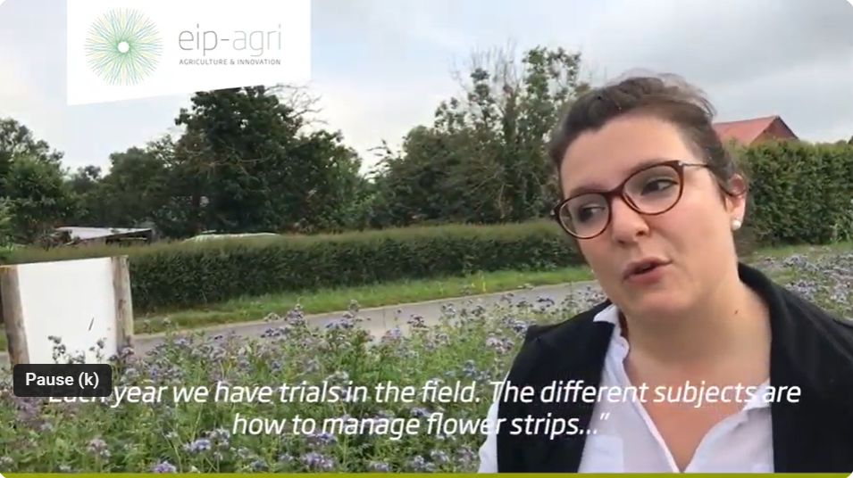

AGRI challenge: increasing biodiversity in agricultural landscapes - 4 November 2019

Innovation, knowledge exchange and EIP-AGRI events 2023-2024
- Brokerage event: EU CAP Network Brokerage event 'Accelerating the innovation process through Horizon Europe multi-actor projects', 19-20 October 2023 – Antwerp, Belgium
- Focus Group meetings on:
  - Regenerative agriculture for soil health (23-24 April 2024)
  - Crop associations including Milpa and protein crops (29-30 May 2024)
  - Competitive and resilient mountain areas (6-7 March 2024)
- Workshop: National networking for innovation, 30 November-1 December 2023 – Talinn, Estonia
- Workshop: Circular water management, 12-13 March 2024
- Workshop: Women-led innovations in agriculture and rural areas, 17-18 April 2024
- Workshop: Promoting pollinator-friendly farming, 18-19 June 2024
- Seminar: Skills and lifelong learning, 21-22 February 2024 – Vienna, Austria
- Conference & award ceremony focusing on Operational Groups, 6-8 May 2024
- Ad-hoc national experts meeting 12June 2024 – online meeting
- Cross-visits, 26-27 June 2024
  - Climate adaptation on the ground
  - Use of agricultural and forestry residues

The common agricultural policy 2023-2027
Find information on the common agricultural policy 2023-2027 on the European Commission’s website.

Innovation, knowledge exchange and EIP-AGRI in the EU CAP Network

The new European CAP Network ‘Support Facility for Innovation & Knowledge exchange | EIP-AGRI’ acts as a mediator, enhancing communication and cooperation between everyone with a keen interest in innovation and sharing knowledge for sustainable agriculture, forestry and rural areas.

The European Innovation Partnership 'Agricultural Productivity and Sustainability' (EIP-AGRI) was launched in 2013 by the European Commission in a bid to promote rapid modernisation of the sectors by efforts to step up innovation. The EIP-AGRI aims to foster innovation in the agricultural and forestry sectors and in rural areas by bringing research and practice closer together – in innovation projects as well as via the European CAP Network and the national CAP Networks. Also, grassroots ideas from farmers are developed into concrete innovative solutions through ‘Operational Group’ innovation projects. The EIP-AGRI aims to streamline, simplify and better coordinate existing instruments and initiatives, and complement them with actions where necessary.

Common agricultural policy 2023-27

EIP-AGRI Operational Groups

EIP-AGRI Operational Groups are groups of people who work together on an innovation project. They bring together partners with complementary knowledge. The composition of the group will vary according to the theme and specific objectives of each project. Farmers, advisors, scientists, businesses or other relevant partners work together to find practical solutions for specific problems or opportunities for European

farmers and foresters. Farmers and foresters need to cooperate throughout the project to ensure that the innovative solutions are practical and likely to be quickly applied in the field. Read the basic principles. Innovation support services (including advisors with a focus on innovation), and in particular innovation brokering, can therefore play a crucial role in getting worthwhile projects off the ground by facilitating contacts.

Operational Groups funded under Rural Development Programmes 2014 – 2022

- 98 Rural Development Programmes 2014-2020 (RDPs) provide support to innovative EIP-AGRI Operational Group projects
- More than 3200 Operational Group projects have been notified in the common EU data repository and are currently ongoing (or already finished)*. Member States will still start more Operational Group projects which may run until 2025 (under current transitional rules for EU Rural Development Programmes). Find information on all of these projects in the EIP-AGRI project database.* May 2023

Operational Groups funded under CAP Strategic Plans 2023 – 2027

Within the common agricultural policy 2023-27 (CAP), the EU Member States have designed national CAP Strategic Plans combining funding for income support, rural development, and market measures. All CAP Strategic Plans have been adopted, and their implementation started on 1 January 2023.

26 CAP Strategic Plans include support for innovative EIP-AGRI Operational Groups. In total, 6600 EIP-AGRI Operational Group projects have been planned.

