Promoting gender equality in European agriculture and rural areas

Horizon Europe project SWIFT seeks to make the importance of women in agriculture more visible

March 2024

Promoting gender equality in European agriculture and rural areas
Horizon Europe project SWIFT seeks to make the importance of women in agriculture more visible

SWIFT is a Horizon Europe project to advance gender equality in farming and rural areas in Europe from an ‘intersectional, feminist and human rights-based perspective’. Marta Rivera-Ferre, project coordinator: “Despite the crucial contributions of women to European agriculture, they remain discriminated against in different ways. SWIFT will analyse and amplify women-led innovations and empower those acting for change in farming and rural areas.”

Women remain under-represented in agricultural associations and, as a result, the take-up of their perspectives and rights in policies, programmes and legal frameworks is limited. The low levels of female farm ownership or lack of access to land are indicative of persistent structural inequalities in rural areas. Faced with this context, gender mainstreaming has become an important principle of the Common Agricultural Policy. The current CAP Strategic Plans (2023-2027), require a gender equality approach and the increased participation of women in farming, in addition to the assessment of women’s position in agriculture, forestry and rural areas and the challenges they face.

Therefore, SWIFT will set up shared spaces and exchanges among 19 agricultural organisations and initiatives in Europe, Brazil and the US which are working on women-led innovations. This will facilitate social learning and enable the co-creation of new approaches and social networks between different local groups. They will promote the use of videos, podcasts, photovoice and other participatory methodologies that facilitate the co-construction of knowledge. This includes tools to reframe agricultural and rural policies. One of these tools for example is gender-responsive budgeting, examining a whole budget cycle from design and allocation to spending and monitoring with the participation of individuals and communities affected by the budget evaluated.

Since the start of the project in 2023, the partners have been setting up collaborations between network members that will be maintained over the coming years. Each of the organisations involved bring different experiences, perspectives and skills to the table. For example, La Via Campesina Austria is a women’s group which is part of the ÖBV (Austria mountain farmers and peasants organisation) working and fighting for self-determination of women in agriculture – on farms, in communities and for policy change (interconnection of agricultural, climate, rural, women policies, etc.)

The Sindicato Labrego Galego, Spain, is another group involved. They support small local farms, many of which are managed by women. Sindicato Labrego Galego considers equality to be fundamental and as an organisation they defend women’s rights at all levels.

SWIFT strives to contribute to adapting policy and governance frameworks to build alternative narratives around food that can boost women’s roles in the sustainable development of rural areas and innovation in farming. SWIFT will further support the capacity of rural women to innovate for change and to find solutions to challenges faced by rural women, through the creation and strengthening of networks.

Background information
  - SWIFT website

Project information
✆ Project contact

Marta G. Rivera-Ferre
Project coordinator
mgrivfer@upv.edu.es

Stefanie Lemke
Project lead at BOKU (project partner)
stefanie.lemke@boku.ac.at

✆ EU CAP Network contact

Ina Van Hoye
ina.vanhoye@eucapnetwork.eu
+32 486 90 77 43

Communication manager
‘Support Facility for Innovation &
Knowledge exchange | EIP-AGRI’

Project photos
Click on the pictures to download the high resolution versions. The pictures are free for use, please mention the copyright.

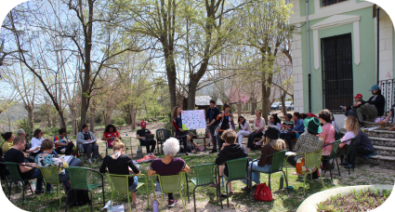 | 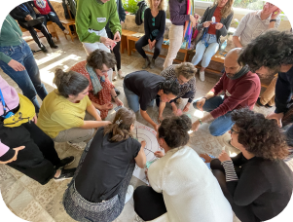
Exchanges during SWIFT Inception workshop, Spain, March 2023  © Mar Calvet | Exchanges during SWIFT Inception workshop, Spain, March 2023  © Stefanie Lemke
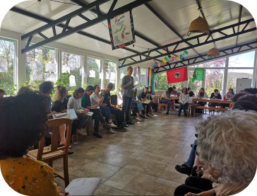 | 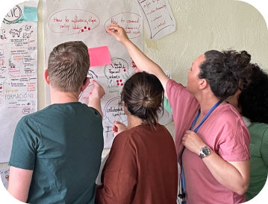
Photo 3: Organisations introduce their work, SWIFT Inception workshop, Spain, March 2023  © Mar Calvet | Co-creating project aims and methodological approaches, SWIFT Inception workshop, Spain, March 2023  © Stefanie Lemke

Please feel free to use this press article and the pictures in your own publications and to inform your colleagues.
If you would like to receive all EU CAP Network press articles directly, please fill in the subscription form.

More information on gender equality in agriculture, focus on women-led innovations

EU CAP Network ‘Innovation & knowledge exchange | EIP-AGRI’ activities

Events

- EU CAP Network workshop ‘Women-led innovations in agriculture and rural areas’

Publications & videos
- AGRI challenge: biodiversity - 14 September 2022
- AGRI Challenge: Non-chemical weed management in arable cropping systems - 10 February 2020
- AGRI challenge: increasing biodiversity in agricultural landscapes - 4 November 2019
- You can also take a look at the 7th edition of the Agrinnovation magazine, chapter called “With heart and soil EIP-AGRI soilmates share their views on soil health” – many of the ‘soilmates’ are women.

Inspirational ideas from the network

- Promoting gender equality in European agriculture and rural areas (EU)
- Inspirational ideas: Improving the quality and productivity of fig trees (Portugal)
- Inspirational ideas: Estonian farmer turns grassland grazing into climate solution (Estonia)
- Inspirational ideas: European innovation prize for women farmers (Ireland)
- Inspirational ideas: A planning tool for reindeer husbandry (Sweden)
- Inspirational ideas: Combatting weeds with non-chemical alternatives (Portugal)
- Inspirational ideas: Optimising irrigation in Spanish greenhouses (Spain)
- Inspirational ideas: Working on resilient dairy farming (Germany)
Read the EU CAP Network Innovation & knowledge exchange | EIP-AGRI newsletter from October 2022 which focused on rural women

Read the news item Rural women – inspiration from the EIP-AGRI network

Horizon multi-actor projects working on gender equality in agriculture, focus on women-led innovations

- SWIFT Supporting Women-led Innovation in Farming Territories
- GRASS CEILING Gender Equality in Rural and Agricultural Innovation Systems
- FLIARA Female-Led Innovation in Agriculture and Rural Areas

Multi-actor projects are research projects in which end users and multipliers of research results such as farmers and farmers’ groups, advisers, enterprises and others, closely cooperate throughout the whole project. Operational Groups are strongly encouraged to participate in this type of research project.

Thematic networks are multi-actor projects which collect existing knowledge and best practices on a given theme to make it available in easily understandable formats for end users such as farmers, foresters, advisers, etc.

Related videos
AGRI challenge biodiversity
Ana Paula Gama is a Portuguese fruit producer, who joined the Operational Group ‘PoliMax’ to promote and increase the efficiency of insect pollination in apple, pear and cherry trees. Watch her story.

Innovation, knowledge exchange and EIP-AGRI events 2023-2024
- Brokerage event: EU CAP Network Brokerage event 'Accelerating the innovation process through Horizon Europe multi-actor projects', 19-20 October 2023 – Antwerp, Belgium
- Focus Group meetings on:
  - Regenerative agriculture for soil health
  - Crop associations including Milpa and protein crops
  - Competitive and resilient mountain areas
- Workshop: National networking for innovation, 30 November-1 December 2023 – Tallinn, Estonia
- Workshop: Circular water management, 12-13 March 2024
- Workshop: Women-led innovations in agriculture and rural areas, 17-18 April 2024 (Call closed 05/02/2024)
- Workshop: Promoting pollinator-friendly farming, 18-19 June 2024 (Call closed 26/02/2024)
- Seminar: Skills and lifelong learning, 21-22 February 2024 – Vienna, Austria
- Conference & award ceremony focusing on Operational Groups, 6-8 May 2024
- Ad hoc national experts meeting (June 2024)
- Cross-visits (May/June 2024)

The common agricultural policy 2023-2027
Find information on the common agricultural policy 2023-2027 on the European Commission’s website.

Innovation, knowledge exchange and EIP-AGRI in the EU CAP Network

The new European CAP Network ‘Support Facility for Innovation & Knowledge exchange | EIP-AGRI’ acts as a mediator, enhancing communication and cooperation between everyone with a keen interest in innovation and sharing knowledge for sustainable agriculture, forestry and rural areas.

The European Innovation Partnership ‘Agricultural Productivity and Sustainability’ (EIP-AGRI) was launched in 2013 by the European Commission in a bid to promote rapid modernisation in the sectors through efforts to step up innovation. The EIP-AGRI aims to foster innovation in the agricultural and forestry sectors and in rural areas by bringing research and practice closer together – in innovation projects as well as via the European CAP Network and the national CAP Networks. Also, grassroots ideas from farmers are developed into concrete innovative solutions through ‘Operational Group’ innovation projects. The EIP-AGRI aims to streamline, simplify and better coordinate existing instruments and initiatives, and complement them with actions where necessary. Common agricultural policy 2023-27.

EIP-AGRI Operational Groups

EIP-AGRI Operational Groups are groups of people who work together in an innovation project. They bring together partners with complementary knowledge. The composition of the group will vary according to the theme and specific objectives of each project. Farmers, advisers, scientists, businesses or other relevant partners work together to find practical solutions for specific problems or opportunities for European farmers and foresters. Farmers and foresters need to cooperate throughout the project to ensure that the innovative solutions are practical and likely to be applied rapidly in the field. Read the basic principles. Innovation support services (including advisers with a focus on innovation), and in particular innovation brokering, can therefore play a crucial role in getting worthwhile projects off the ground by facilitating contacts.

Operational Groups funded under Rural Development Programmes 2014-2022

- 98 Rural Development Programmes 2014-2020 (RDPs) provide support to innovative EIP-AGRI Operational Group projects.
- More than 3200 Operational Group projects have been notified in the common EU data repository and are currently ongoing (or already finished).* Member States will still start more Operational Group projects which may run until 2025 (under current transitional rules for EU Rural Development Programmes). Find information on all these projects in the EIP-AGRI project database.
* May 2023

Operational Groups funded under CAP Strategic Plans 2023-2027

Within the common agricultural policy 2023-27, the EU Member States have designed national CAP Strategic Plans combining funding for income support, rural development, and market measures. All CAP Strategic Plans have been adopted and their implementation started on 1 January 2023.

26 CAP Strategic Plans include support for innovative EIP-AGRI Operational Groups. In total, 6 600 EIP-AGRI Operational Group projects have been planned.

