FOREST4EU Thematic network broadens outreach of Operational Group results

FOREST4U is a Horizon Thematic network promoting Operational Groups dedicated to forestry and agroforestry

March 2024

FOREST4EU Thematic network broadens outreach of Operational Group results
FOREST4U is a Horizon Thematic network promoting Operational Groups dedicated to forestry and agroforestry

“Numerous innovations have been developed by Operational Groups which hold the potential to benefit the forestry and agroforestry sectors. However, the results remain mainly localised, due, for example, to a lack of sufficient tools for information transfer,” explains Francesca Giannetti. Francesca is from the Horizon Europe project FOREST4EU, which was launched to ensure that innovative outcomes from Operational Groups (OGs) in forestry and agroforestry are shared beyond national borders.

Thematic networks are Horizon Europe multi-actor projects that collect existing knowledge and best practices on a given theme and make this available in easily understandable and accessible formats. FOREST4EU is a thematic network on forestry and agroforestry that focuses particularly on increasing the uptake of European Innovation Partnerships for Agricultural Productivity and Sustainability EIP-AGRI Operational Group (OG) results throughout Europe.

In order to achieve this goal, FOREST4EU, which was launched in January 2023, has established interregional innovation topic hubs. The 'ITHubs' collect, share and disseminate existing knowledge generated by Ogs, which can be applied in similar environmental and territorial contexts elsewhere or support further innovations. They also produce practice abstracts and develop capacity-building materials according to identified regional needs. Each innovation hub deals with one key area within the forestry sector: wood mobilisation, climate change adaptation, sustainable forest management, non-wood forest products and agroforestry. FOREST4EU also collaborates with policymakers and local-level innovation to stimulate new initiatives in regions with lower numbers of OGs. FOREST4EU thereby hopes to promote a more balanced geographic spread of innovation in the forestry sector in the EU.

Francesca explains the added values for the OGs involved in the thematic network: “I believe that being interconnected with other OGs is of primary importance to stimulate new innovations. Learning from what others have done can reduce the risk of failure and can lead to the development of even more diverse innovations.” By being part of this thematic network, OGs can also access training and support, further disseminate their results and can increase visibility for their work.

Farmers, forest managers and others who are not currently involved in an OG can also benefit, accessing new and innovative practices from different countries. Francesca adds: “The idea is to enable other stakeholders to set up new OGs, designing their projects based on pieces of innovation from different countries and topics. This approach allows them to start with solid and consolidated bases, to learn from those who have applied these innovations before and avoid repeating the same mistakes.”

The involvement of the OGs in FOREST4EU is crucial. Initially, they were involved in the collection of various innovations. In the upcoming stages, they will be invited to participate in international and national workshops and seminars, network events and policy focus groups and to host study visits. These will be opportunities for OGs to showcase innovations and address potential barriers for their uptake.

In only this first year, the FOREST4EU has 85 OGs involved. The innovation hubs have gathered a total of 174 innovations across ten different countries.

Background information

FOREST4EU project information
- FOREST4EU website
- FOREST4EU on LinkedIn
- FOREST4EU on YouTube

Horizon Europe call
Horizon Europe has launched several EU-wide thematic networks that share best practices from EIP-AGRI Operational Groups across borders, for a wider uptake of innovative results. Examples also include CLIMED-FRUIT, Oper8, NUTRI-KNOW and several more are starting at the beginning of 2024.

- More information on Horizon Europe thematic networks
- EU CAP Network brochure on funding opportunities under Horizon Europe - Calls 2024
- EU CAP Network Brokerage event entitled 'Accelerating the innovation process through Horizon Europe multi-actor projects' – report now available

Project information
✆ EU CAP Network contact

Ina Van Hoye
ina.vanhoye@eucapnetwork.eu
+32 486 90 77 43

Communication manager
‘Support Facility for Innovation &
Knowledge exchange | EIP-AGRI’
✆ Project contact

Francesca Giannetti
francesca.giannetti@unifi.it
+393896831656

Project photos
Click on the pictures to download the high-resolution versions. The pictures are free for use. Please mention the copyright.

 | 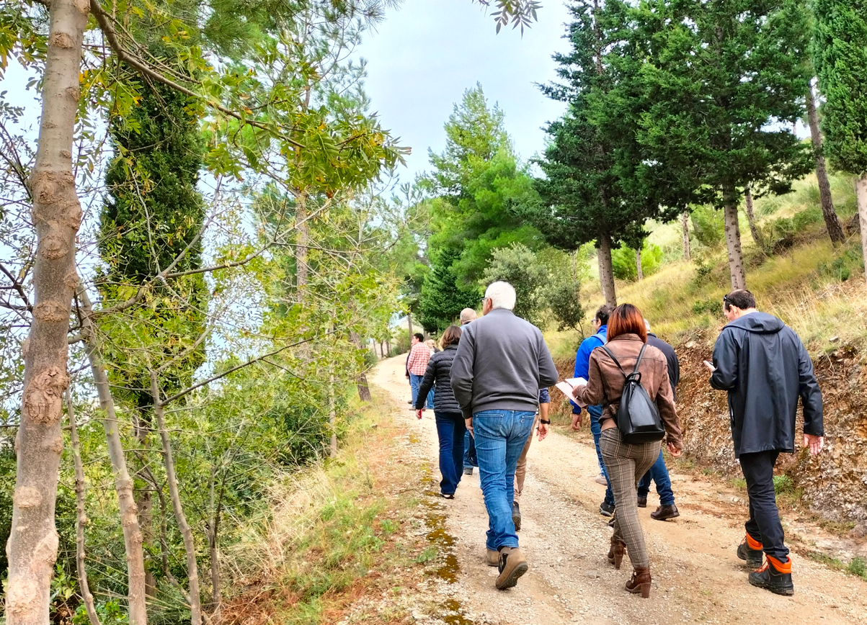
Safeguarding EU forests through the spread of innovative outcomes from Operational Groups  © Francesca Giannetti | Forestry field trip  © Francesca Giannetti
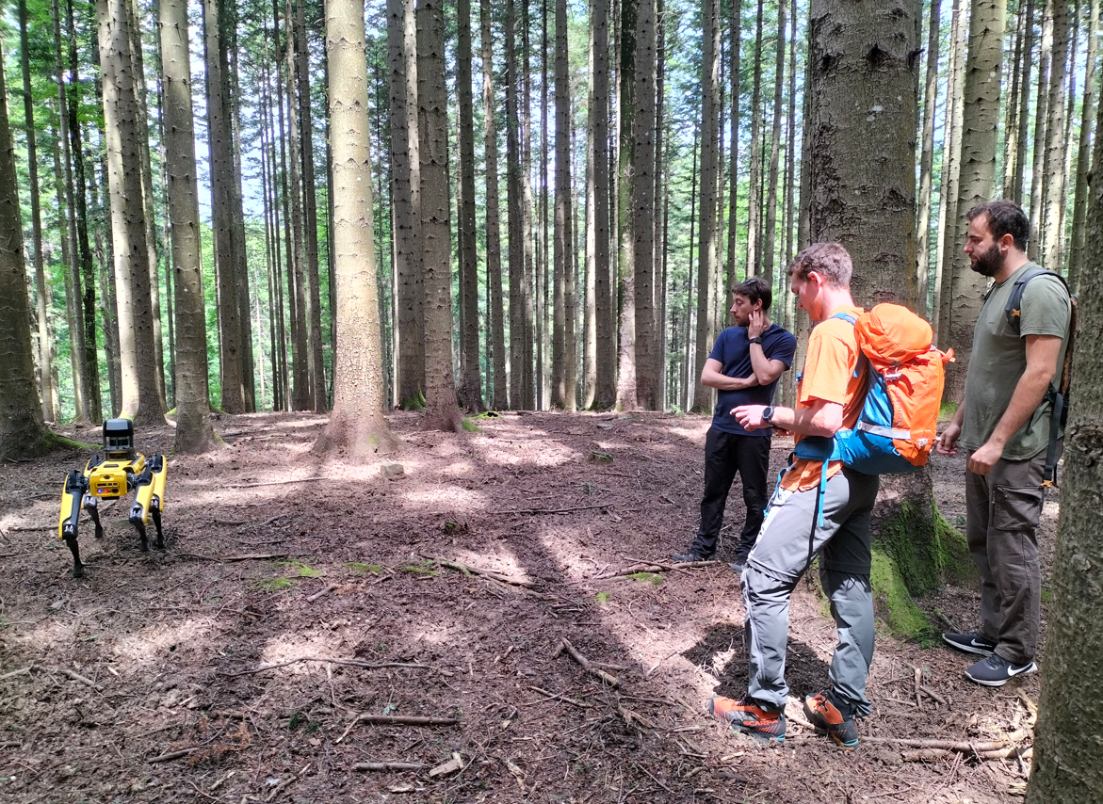 | 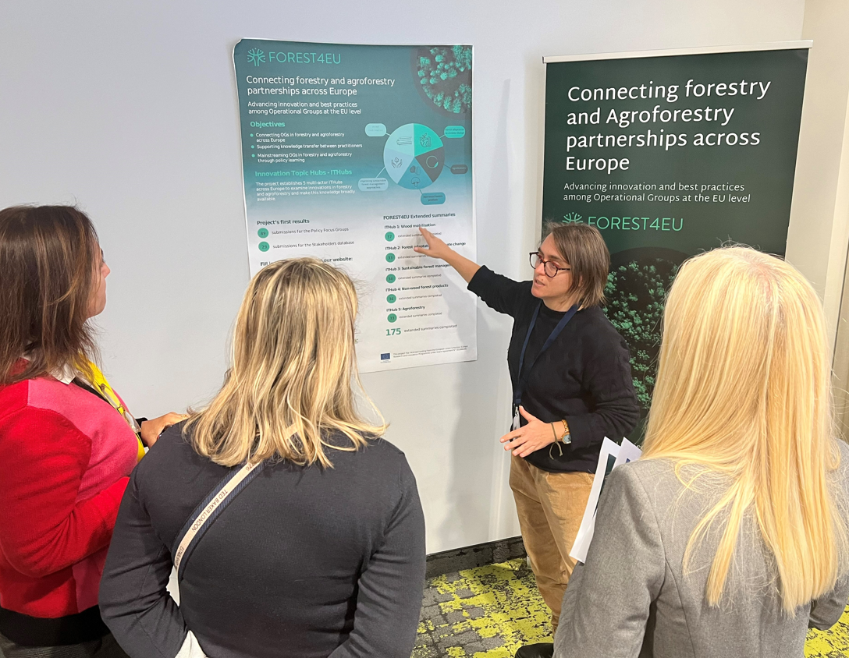
Demonstrating innovations for forestry  © Francesca Giannetti | Francesca Giannetti presents FOREST4EU at EU CAP Network event  © Francesca Giannetti

Please feel free to use this press article and the pictures in your own publications and to inform your colleagues.
If you would like to receive all press articles directly, please fill in the subscription form.

More information on thematic networks – Closing the research and innovation divide

EU CAP Network ‘Innovation & knowledge exchange | EIP-AGRI’ activities

Events

- EU CAP Network Brokerage event entitled 'Accelerating the innovation process through Horizon Europe multi-actor projects', October 2023
- EU CAP Network Brokerage event entitled ‘Get involved in Horizon Europe advisory networks’, January 2023

Publications & videos

- Brochure - Funding opportunities under Horizon Europe - Calls 2024
- Factsheet - Tips and tricks to apply for Horizon Europe calls
- Agrinnovation Magazine - Issue 9 (page 13)

Inspirational ideas from the network

- Inspirational idea: FOREST4EU Thematic network broadens outreach of EIP-AGRI OG results

EU CAP Network website

- Webpage on Thematic Networks

Operational Groups

Browse the nearly 3 000 Operational Groups available on the EIP-AGRI project database.

Horizon projects under the topic: ‘Broaden EIP Operational Group outcomes across borders by means of thematic networks, compiling and sharing knowledge ready for practice’

- FOREST4EU - Promoting Operational Groups dedicated to forestry and agroforestry - CORDIS (1 January 2023 - 31 December 2025)
- NUTRI-KNOW - Broadening the impact of Operational Groups in the field of nutrient management - CORDIS (1 January 2023 - 31 December 2025)
- CLIMED-FRUIT - Climate change resilience for perennial crops – CORDIS (1 October 2022 - 30 September 2025)
- Oper8 - Unlocking the full potential of Operational Groups on alternative weed control CORDIS (1 October 2022 - 30 September 2025)

Thematic networks are multi-actor projects which collect existing knowledge and best practices on a given theme to make it available in easily understandable formats for end-users such as farmers, foresters, advisors etc.

Multi-actor projects are research and innovation projects in which end-users and multipliers of research results, such as farmers and farmers’ groups, advisors, enterprises and others closely cooperate throughout the whole project. Operational Groups are strongly encouraged to participate in this type of research project.

Innovation, knowledge exchange and EIP-AGRI events 2023-2024
- Brokerage event: EU CAP Network Brokerage event entitled 'Accelerating the innovation process through Horizon Europe multi-actor projects', 19-20 October 2023 – Antwerp, Belgium
- Focus Group meetings on:
  - Regenerative agriculture for soil health
  - Crop associations including Milpa and protein crops
  - Competitive and resilient mountain areas
- Workshop: National networking for innovation, 30 November-1 December 2023 – Talinn, Estonia
- Workshop: Circular water management, 12-13 March 2024 (Call closed 11/12/2023)
- Workshop: Boosting women-led innovation, 17-18 April 2024 (Call closed 05/02/2024)
- Workshop: Promoting pollinator-friendly farming, 18-19 June 2024 (Call open until 29 February 2024)
- Seminar: Skills and lifelong learning, 21-22 February 2024 – Vienna, Austria
- Conference & award ceremony focusing on Operational Groups, 6-8 May 2024
- (Call closed 08/02/2024)

- Ad-hoc national experts meeting (June 2024)
- Cross-visits (May/June 2024)

The Common Agricultural Policy 2023-2027
Common Agricultural Policy 2023-2027

Innovation, knowledge exchange and EIP-AGRI in the EU CAP Network

The European CAP Network entitled ‘Support Facility for Innovation & Knowledge exchange | EIP-AGRI’ acts as a mediator, enhancing communication and cooperation between everyone with a keen interest in innovation and sharing knowledge for sustainable agriculture, forestry and rural areas.

The European Innovation Partnership entitled 'Agricultural Productivity and Sustainability' (EIP-AGRI) was launched in 2013 by the European Commission in a bid to promote rapid modernisation of the sectors concerned by efforts to step up innovation. The EIP-AGRI aims to foster innovation in the agricultural and forestry sectors and in rural areas by bringing research and practice closer together – in innovation projects as well as via the European CAP Network and the national CAP Networks. Also, grassroots ideas from farmers are developed into concrete innovative solutions through ‘Operational Group’ innovation projects. The EIP-AGRI aims to streamline, simplify and better coordinate existing instruments and initiatives, and complement them with actions where necessary.

More information on Innovation, knowledge exchange and EIP-AGRI is available on the EU CAP Network website.

EIP-AGRI Operational Groups

EIP-AGRI Operational Groups are groups of people who work together in an innovation project. They bring together partners with complementary knowledge. The composition of the group will vary according to the theme and specific objectives of each project. Farmers, advisors, scientists, businesses and other relevant partners work together to find practical solutions for specific problems or opportunities for European farmers and foresters. Farmers and foresters need to cooperate throughout the project to ensure that the innovative solutions are practical and likely to be quickly applied in the field. The basic principles. Innovation support services (including advisors with a focus on innovation) and, in particular innovation brokering, can play a crucial role in getting worthwhile projects off the ground by facilitating contacts.

Operational Groups funded under Rural Development Programmes 2014-2022

- 98 Rural Development Programmes 2014-2020 (RDPs) provide support to innovative EIP-AGRI Operational Group projects
- More than 3 200 Operational Group projects have been notified in the common EU data repository and are currently ongoing (or have already finished)*. Member States will still start more Operational Group projects which may run

until 2025 (under current transitional rules for EU Rural Development Programmes). Find information on all of these projects in the EIP-AGRI project database.
* May 2023

Operational Groups funded under CAP Strategic Plans 2023- 2027

Within the Common Agricultural Policy 2023-27 (CAP), the EU Member States have designed national CAP Strategic Plans combining funding for income support, rural development and market measures. All CAP Strategic Plans have been adopted and their implementation started on 1 January 2023.

28 CAP Strategic Plans include support for innovative EIP-AGRI Operational Groups. In total, 6 600 EIP-AGRI Operational Group projects have been planned.

