Organic experimental farm in Finland testing methods for improved animal welfare

Mustiala Organic Farm collaborates with farmers, researchers and Operational Groups

December 2023

Organic experimental farm in Finland testing methods for improved animal welfare

Mustiala Organic Farm collaborates with farmers, researchers and Operational Groups

The HAMK Mustiala campus farm is an experimental organic dairy farm in Finland that offers a working environment for research, education and innovation projects. Research institutes, advisory services and agricultural companies cooperate with Mustiala on-site, carrying out tests and research activities, many of which are related to animal welfare.

Today, the farm has 79 dairy cows, 66 young cattle, 20 ha of pasture and a free-stall housing area, and produces its own organic crops for feed on 185 ha of arable land. In terms of the welfare of the animals, the farm is constantly striving to improve conditions, testing measures which can be rolled out by farmers.

In terms of infrastructure, the cows can lie down comfortably on stall mats, which are kept dry with bedding that is spread automatically. A rubber surface in front of the feeding trough on top of the slatted floor was installed.

Simo Pärssinen, the cattle manager at the farm, explains: “This is because organic production requires half of the surface area available to the animal to be solid. A solid floor is considered to be beneficial for the endurance of the animals.”

In the calf area, there are individual pens with solid floors, warm bedding and heat lamps for the youngest calves. The group pens have deep litters. “This provides a firm, dry and warm surface for the calves. In addition, there is less cleaning work. The pens are dried a couple of times a week,” Adds Simo. There are three group pens for calving or sick cows, so that they can be kept separate, and deep bedding made of straw and peat to provide a non-slip, warm lying area. They also have a separate milking system so that the cows do not have to be moved to be milked.

In the cow building, the partitions of the calf areas can be removed so that the small calves can get to know their neighbour and can move on to the group pen with a friend, which makes finding their place in the group less stressful.

The cows can choose to go out all year round. During the summer months they all go out to pasture, where they also have access to forest areas for cover. The pasture is divided into sections and the animals move to a new section in the rotation every day. Having new grass every day encourages them to graze more.

On the Mustiala farm, the animals have a lot of contact with people. The farm organises many open days. As Simo explains, “the cows are calm and easy to handle. Students are on duty every week and so these animals see and hear people more often than in other barns. This accustoms the animals to human presence and makes them feel safe”.

The Mustiala farm is involved in EIP-AGRI Operational Groups, for example the Smart drinking cup project, which is developing a technology to measure cows’ water consumption at individual level. Monitoring the amount of water that a cow drinks can improve the chances of detecting deviations in welfare, behaviour and production more accurately and earlier. The farm is also involved in activities with projects and initiatives from other EU countries, to share their results and learn from others on a wide scale, such as a visit in September from the Swedish and the Finnish Agricultural Knowledge and Innovation Systems (AKIS) thematic groups.

Background information
On 9-11 May 2023, the Directorate General for Agriculture and Rural Development organised the ‘Animal welfare and innovation’ workshop together with the EU CAP Network Support Facility ‘Innovation & knowledge exchange | EIP-AGRI’. The workshop report and field visits report were published in early October 2023. This factsheet provides all the information from the EU CAP Network 'Animal welfare and innovation' workshop at a glance.

Project information
- Mustiala organic farm website
- Smart drinking cup Operational Group
- Digipaali (Digibale) Operational Group (of which HAMK is a partner)

✆ EU CAP Network contact

Ina Van Hoye
ina.vanhoye@eucapnetwork.eu
+32 486 90 77 43

Communication manager
‘Support Facility for Innovation &
Knowledge exchange | EIP-AGRI’
✆ Project contact

Tiiti Kämäri
tiiti.kamari@hamk.fi

Project photos
Click on the pictures to download the high resolution versions. The pictures are free to use. Please mention the copyright.

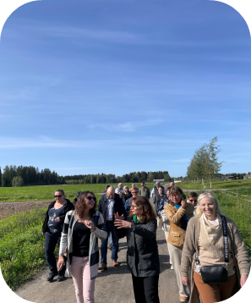 | 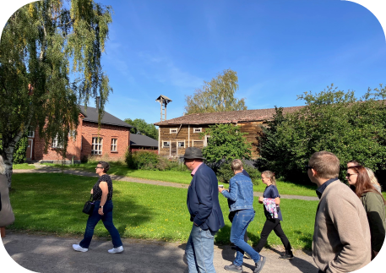
Visiting Mustiala Organic Farm in September 2023 – copyright Mustiala Organic Farm | Visiting Mustiala Organic Farm in September 2023 – copyright Mustiala Organic Farm

Please feel free to use this press article and the pictures in your own publications and to inform your colleagues.
If you would like to receive all EU CAP Network press articles directly, please fill in the subscription form.

More information on animal welfare

EU CAP Network ‘Innovation & knowledge exchange | EIP-AGRI’ activities

Focus Groups
  - Animal husbandry - Reduction of antibiotic use in the pig sector
  - Robust and resilient dairy production systems
  - Bee health and sustainable beekeeping
  - Reducing antimicrobial use in poultry farming
  - Sustainable beef production systems

Events
  - EU CAP Network 'Animal welfare and innovation' workshop
  - EIP-AGRI 'Organic is Operational' workshop
  - EIP-AGRI 'Innovative solutions for small farms and forest holdings and access of small farms and forest holdings to new technologies' workshop

Publications & videos
  - EIP-AGRI Brochure Reducing antibiotics in pig farming
  - EIP-AGRI Brochure Organic farming: Innovative approaches to support conversion
  - EIP-AGRI Brochure Organic is operational
  - EIP-AGRI Brochure Sustainable livestock farming
  - AGRI challenge video: crop diversification in grassland
  - AGRI challenge video: monitoring bee health through beehive sensors
  - AGRI challenge video: reducing antimicrobials in poultry

Inspirational ideas from the network
  - A national network stimulating knowledge exchange on animal welfare in Germany (Germany)
  - Organic experimental farm in Finland testing methods for improved animal welfare (Finland)
  - Smart barn makes for happy pigs (The Netherlands)
  - Everything you need to know about sheep in one digital platform (Bulgaria)
  - A hive of digital activity (Bulgaria)
  - Improving welfare for cows…and farmers (Denmark)
  - Concrete solutions for sustainability and animal welfare (The Netherlands)
  - Working on resilient dairy farming (Germany)
  - Alternatives for expensive protein feed for laying hens (Germany)
  - Goats in good company (Italy)
  - Sustainable egg production (EU, the Netherlands)
  - Automatic cleaning for pigs (Sweden)
  - Improving chicken value chains - an Operational Group in Germany (Germany)
  - A network to improve health management in pigs (Germany)
  - Cutting antibiotic use in pig farming (the Netherlands)
  - Adding a touch of spice to improve animal health (Greece)

Read the EU CAP Network Newsletter on Innovation & knowledge exchange | EIP-AGRI which focused on the theme of animal welfare:
Thematic newsletter October 2023: English French German

Horizon multi-actor projects working on animal welfare

  - DISARM - Disseminating Innovative Solutions for Antibiotic Resistance Management: CORDIS (01/2019-12/2021)
  - EuroSheep - European Network for interactive and innovative knowledge exchange on animal health and nutrition between the sheep industry actors and stakeholders: CORDIS (01/2020-12/2022)
  - aWISH - Animal Welfare Indicators at the Slaughterhouse (11/2022-2026)
  - PPILOW - Poultry and Pig Low-input and Organic production systems' Welfare (9/2019 – 8/2024)
  - TechCare - Integrating innovative technologies along the value chain to improve small ruminant welfare management (9/2020 – 8/2024)
  - EU PiG - EU Pig Innovation Group: CORDIS - videos on pig health & welfare (11/2016-10/2020)

Multi-actor projects are research projects in which end users and multipliers of research results such as farmers and farmers’ groups, advisors, enterprises and others, closely cooperate throughout the whole project. Operational Groups are strongly encouraged to participate in this type of research project.

Thematic networks are multi-actor projects which collect existing knowledge and best practices on a given theme to make it available in easily understandable formats for end-users such as farmers, foresters, advisors etc.

Operational Groups working on animal welfare

Many Operational Group projects focus on finding innovative solutions for animal health and welfare. Browse this database (look in the keywords column for ‘Animal husbandry and welfare’).

Research needs from practice on animal welfare

- The need for a more holistic approach, including synergies and trade-offs between animal welfare and environmental impacts;
- Sensors and AI for monitoring animal welfare and the use of deep learning for video analysis of behaviour;
- Indicators and monitoring methods: Monitoring welfare and productivity, investigating their links with farm profitability and the development of new indicators of 'positive welfare';
- Cage-free production systems: More adaptive and resilient genotypes under different systems, a cost/benefit analysis of renovating existing facilities and building new facilities, effective solutions to control parasites and predation in cage-free/outdoor systems;
- Standardisation of welfare labelling and certification.

For more information on these research needs, please read the report from the EU CAP Network 'Animal welfare and innovation' workshop

Related videos
 | 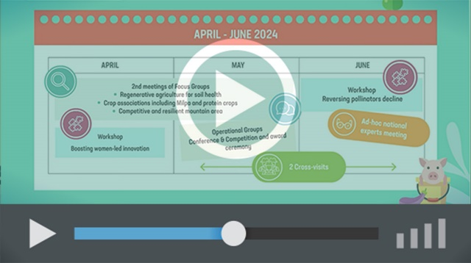
EIP-AGRI Challenge: animal welfare and innovation | EU CAP Network events on Innovation and knowledge exchange | EIP-AGRI - events 2023 - 2024

Innovation, knowledge exchange and EIP-AGRI events 2023-2024
- Brokerage event: Horizon Europe multi-actor approach projects, 19-20 October 2023 - Antwerp, Belgium (Call closed 3/09/2023)
- Focus Group meetings on:
  - Regenerative agriculture for soil health
  - Crop associations, including Milpa and protein crops
  - Competitive and resilient mountain areas
- (Focus Group call for experts closed 11/09/2023)
- Workshop: National networking for innovation, 30 November-01 December 2023.
- Workshop: Circular water management (March 2024)
- Workshop: Boosting women-led innovation (April 2024)
- Workshop: Reversing the decline in pollinators (June 2024)
- Seminar: Skills and lifelong learning (February 2024)
- Conference & Competition and award ceremony focusing on Operational Groups (May 2024)
- Ad hoc national experts meeting (June 2024)
- Cross-visits (May/June 2024)

The Common Agricultural Policy 2023-27
Common Agricultural Policy 2023-27

Innovation, knowledge exchange and EIP-AGRI in the EU CAP Network

Since 6 October 2022, the EIP-AGRI network has joined forces with the European Network for Rural Development, merging into the new European CAP Network. The ‘Support Facility for Innovation & Knowledge exchange | EIP-AGRI’ continues to act as a mediator, enhancing communication and cooperation between everyone with a keen interest in innovation and sharing knowledge for sustainable agriculture, forestry and rural areas.

The European Innovation Partnership 'Agricultural Productivity and Sustainability' (EIP-AGRI) was launched in 2013 by the European Commission in a bid to promote rapid modernisation of the sectors concerned by stepping up innovation efforts. The EIP-AGRI aims to foster innovation in the agricultural and forestry sectors and in rural areas by bringing research and practice closer together – in innovation projects as well as via the European CAP Network and the national CAP Networks. Also, grassroots ideas from farmers are developed into concrete innovative solutions through Operational Group innovation projects. The EIP-AGRI aims to streamline, simplify and better coordinate existing instruments and initiatives, and complement them with actions where necessary.

More information on Innovation, knowledge exchange and EIP-AGRI on the EU CAP Network website.

EIP-AGRI Operational Groups

EIP-AGRI Operational Groups are groups of people who work together on an innovation project. They bring together partners with complementary knowledge. The composition of the group will vary according to the theme and specific objectives of each project. Farmers, advisors, scientists, businesses and other relevant partners work together to find practical solutions for specific problems or opportunities for European farmers and foresters. Farmers and foresters need to cooperate throughout the project to ensure that the innovative solutions are practical and likely to be quickly applied in the field. Read the basic principles. Innovation support services (including advisors with a focus on innovation) and, in particular, innovation brokering can therefore play a crucial role in getting worthwhile projects off the ground by facilitating contacts.

Operational Groups funded under Rural Development Programmes 2014-2022

- 98 Rural Development Programmes 2014-2020 (RDPs) provide support to innovative EIP-AGRI Operational Group projects.
- More than 3 200 Operational Group projects have been notified in the common EU data repository and are currently ongoing (or already finished). Member States will still start more Operational Group projects, which may run until 2025 (under current transitional rules for EU Rural Development Programmes). The EIP-AGRI project database contains information on all these projects.

Operational Groups funded under CAP Strategic Plans 2023-2027

Within the Common Agricultural Policy (CAP) 2023-27, EU Member States have designed national CAP Strategic Plans combining funding for income support, rural development and market measures. All CAP Strategic Plans have been adopted and their implementation started on 1 January 2023.

26 CAP Strategic Plans include support for innovative EIP-AGRI Operational Groups. In total, 6 600 EIP-AGRI Operational Group projects have been planned.

May 2023

