Modernising agriculture through more efficient and effective Agricultural Knowledge and Innovation Systems (AKIS)

Horizon Europe project launched to strengthen AKIS in Europe

November 2023

Modernising agriculture through more efficient and effective Agricultural Knowledge and Innovation Systems (AKIS)

Horizon Europe project launched to strengthen AKIS in Europe
Knowledge and innovation play a crucial role in helping farmers, foresters, and rural communities meet current and future challenges. Effective Agricultural Knowledge and Innovation Systems (AKIS) can ensure that knowledge is shared between everyone who uses and produces it and that people are connected. ModernAKIS is a multi-actor Horizon Europe project that aims to strengthen AKIS by providing a European platform for exchanging good practices and capacity building to AKIS coordination bodies (those responsible within Member States for the improvement of the organisation of their AKIS) and others involved in AKIS.

It is essential to build better AKIS, covering all people and organisations that generate, share, and use knowledge and innovation for agriculture and interrelated fields (value chains, environment, society, consumers, etc.) in the Member States (MS) and their regions. In order to face the challenges of today and tomorrow, all MS can improve the knowledge flows between the various parts of their current AKIS and learn from one another. The EU has an interest in ensuring that well-functioning AKIS exist throughout its territory to avoid duplication of efforts, save costs, increase the impact of EU and national/regional funding and speed up innovation.

This is why modernAKIS started in September 2022 and will be supporting key AKIS players from all 27 EU Member States in their pursuit of implementing the AKIS part of their CAP Strategic Plans 2023-2027. It will continue to build and foster a European network of at least 1 000 key AKIS actors from all EU MS to help the transformation of the AKIS systems towards more effective interaction and the modernisation of the European agri-food sector.

"The project will shape and prioritise its activities according to the practical needs of key AKIS actors, including AKIS coordination bodies, through co-creation," says Elena-Teodora Miron, modernAKIS project coordinator.

ModernAKIS has already organised the first General Assembly for AKIS Coordination Bodies, a forum for key AKIS decision-makers supporting peer-to-peer learning and exchange of experiences on AKIS approaches. The project partners built a methodology to involve key AKIS actors in Transformational AKIS Journeys and created a summary of good practices on how to involve advisers in the AKIS. In the future, the project will develop learning modules on AKIS basics and systems thinking (3 modules in all EU languages), set up a Community of Practice in each Member State to support the AKIS coordination body and prepare the 2nd edition of the AKIS Coordination Body General Assembly in November 2023.

ModernAKIS, along with two other CAP AKIS supportive projects ATTRACTISS and EU-Farmbook, aim to empower the rural sector and its actors to better deal with emerging challenges.

Background information
- https://modernakis.eu

The Common Agricultural Policy (CAP) includes the cross-cutting objective 'modernisation of the sector by fostering knowledge, innovation and digitalisation of agriculture and rural areas' (Article 6 of the CAP Strategic Plan regulation). AKIS strategies in CAP Strategic Plans will incentivise the structuring and organisation of the national innovation ecosystem (Article 114). The CAP modernisation will provide this enabling framework for the transition pathways towards resilient, sustainable and climate-friendly farming systems and value chains, including attention to the social aspects.

The AKIS coordination bodies are contact points for AKIS-related issues between Member States and the European Commission. They will cooperate with AKIS multi-actor platforms and networks across the geographical levels in the country. They will follow up on day-to-day AKIS interventions and actions and can ask for modification of the CAP plan if needed while continuously supporting interaction and implementation of the MS' AKIS plan. The AKIS coordination bodies will keep an overview of the progress of the AKIS strategy as foreseen in the CAP plan, using a dedicated framework for monitoring and evaluation, in particular those related to the CAP indicators.

The EU CAP Network seminar entitled 'Fostering an effective and integrated AKIS in Member States', held in Vilnius on 14-15 June, supported EU Member States in the implementation of their AKIS Strategic Plans, namely by clarifying basic concepts and presenting how efficient knowledge and innovation flows will be organised by MS. The event focused on exchanging experiences and inspiring examples to help organise and support effective knowledge creation and knowledge exchange between all AKIS actors.

Project information
✆ EIP-AGRI contact

Ina Van Hoye
ina.vanhoye@eucapnetwork.eu
+32 486 90 77 43

Communication manager
‘Support Facility for Innovation &
Knowledge exchange | EIP-AGRI’
✆ Project contact

Elena-Teodora Miron
e.miron@lk-oe.at
+43 699 14035497

Project photos
Click on the pictures to download the high-resolution versions. The pictures are free for use; please mention the copyright.

Chanelle Malambo/peopleimages.com – Adobe Stock

Please feel free to use this press article and the pictures in your own publications and to inform your colleagues.
If you would like to receive all EIP-AGRI press articles directly, please fill in the subscription form.

More information on AKIS

EU CAP Network ‘Innovation & knowledge exchange | EIP-AGRI’ activities

Events

- EU CAP Network Seminar' Fostering an effective and integrated AKIS in Member States' (June 2023)
- EIP-AGRI Seminar' CAP Strategic Plans: the key role of AKIS in Member States' (September 2020)
- EIP-AGRI Workshop 'Enabling farmers for the digital age: the role of AKIS' (April 2018)
- EIP-AGRI Seminar 'Promoting creativity and learning through agricultural knowledge systems and interactive innovation' (December 2015)

Videos & publications

- VIDEO: AKIS: Building effective knowledge flows across Europe
- VIDEO: EIP-AGRI - Innovation Support Services
- EIP-AGRI Brochure' Agricultural Knowledge and Innovation Systems (AKIS) - Boosting innovation and knowledge flows across Europe'
- EIP-AGRI Brochure' Agricultural Knowledge and Innovation Systems - Stimulating creativity and learning'
- EIP-AGRI Infographic from the 8th edition of Agrinnovation magazine: Spotlight on AKIS

Inspirational ideas from the network

- Awareness raising campaign on AKIS in the Netherlands (The Netherlands)
- Slovenia integrates advisors in its national Agricultural Knowledge and Innovation System (Slovenia)
Read the EIP-AGRI newsletter from July 2022 which focused on the theme of AKIS: Newsletter 105 July 2022: Languages EN FR DE SK

And check out the AKIS spotlight page

Horizon multi-actor projects working on AKIS

- EUREKA – European Knowledge repository for best agricultural practices: CORDIS (01/2020 – 12/2021)
- FAIRshare – Farm Advisory digital Innovation tools Realised and Shared: CORDIS (11/2018 – 10/2023)
- I2connect – Connecting advisers to boost interactive innovation in agriculture and forestry: CORDIS (11/2019 – 10/2024)
- AgriDemo-F2F - Building an interactive AgriDemo-Hub community: enhancing farmer to farmer learning: CORDIS (01/2017-06/2019)
- 4D4F - Data Driven Dairy Decisions 4 Farmers: CORDIS (03/2016-02/2019)
- EURAKNOS – Connecting Thematic Networks as Knowledge Reservoirs: towards a European Agricultural Knowledge Innovation Open Source System: CORDIS (01/2019 – 12/2020)
- PLAID - Peer-to-Peer Learning: Accessing Innovation through Demonstration: CORDIS (01/2017-06/2019)
- NEFERTITI - Networking European Farms to Enhance Cross Fertilisation and Innovation Uptake through Demonstration: CORDIS (01/2018-12/2021)
- ClieNFarms - Climate Neutral Farms: CORDIS (01/01/2022-31/12/2025)
- AGRISPIN - Space for Agricultural Innovation: CORDIS (03/2015-08/2017)
- AgriLink - Agricultural Knowledge: Linking farmers, advisors and researchers to boost innovation: CORDIS (06/2017-05/2021)
- BOND - Bringing Organisations and Network Development to higher levels in the farming sector in Europe: CORDIS (11/2017-10/2020)
- NEXTFOOD - Educating the next generation of professionals in the agrifood system: CORDIS (05/2018-04/2022)
- LIAISON - Better Rural Innovation: Linking Actors, Instruments and Policies through Networks: CORDIS (06/2018-11/2021)
- ZeroW - Systemic Innovations Towards a Zero Food Waste Supply Chain: CORDIS (01/2022-12/2025)
- ModernAKIS - Modernisation of Agriculture through more efficient and effective Agricultural Knowledge and Innovation Systems website – CORDIS (09/2022 – 08/2029)

Multi-actor projects are research projects in which end users and multipliers of research results, such as farmers and farmers' groups, advisors, enterprises and others, closely cooperate throughout the whole project. Operational Groups are strongly encouraged to participate in this type of research project.

Thematic networks are multi-actor projects which collect existing knowledge and best practices on a given theme to make it available in easily understandable formats for end-users such as farmers, foresters, advisors, etc.

Operational Groups working on AKIS

Many Operational Groups working on AKIS are available in the EIP-AGRI Operational Groups database. You can find some examples here.

The Common Agricultural Policy 2023-27
Find information on the Common Agricultural Policy 2023-27 on the European Commission's website.

Innovation, knowledge exchange and EIP-AGRI in the EU CAP Network

Since 6 October 2022, the EIP-AGRI network has joined forces with the European Network for Rural Development, merging into the new European CAP Network. The 'Support Facility for Innovation & Knowledge exchange | EIP-AGRI' continues to act as a mediator, enhancing communication and cooperation between everyone with a keen interest in innovation and sharing knowledge for sustainable agriculture, forestry and rural areas.

The European Innovation Partnership' Agricultural Productivity and Sustainability' (EIP-AGRI) was launched in 2013 by the European Commission in a bid to promote rapid modernisation of the sectors concerned by stepping up innovation efforts. The EIP-AGRI aims to foster innovation in the agricultural and forestry sectors and in rural areas by bringing research and practice closer together – in innovation projects as well as via the European CAP Network and the national CAP Networks. Also, grassroots ideas from farmers are developed into concrete innovative solutions through 'Operational Group' innovation projects. The EIP-AGRI aims to streamline, simplify and better coordinate existing instruments and initiatives and complement them with actions where necessary.

More information on Innovation, knowledge exchange and EIP-AGRI on the EU CAP Network website.

EIP-AGRI Operational Groups

EIP-AGRI Operational Groups are groups of people who work together on an innovation project. They bring together partners with complementary knowledge. The composition of the group will vary according to the theme and specific objectives of each project. Farmers, advisors, scientists, businesses or other relevant partners work together to find practical solutions for specific problems or opportunities for European farmers and foresters. Farmers and foresters need to cooperate throughout the project to ensure that the innovative solutions are practical and likely to be quickly applied in the field. Read the basic principles. Innovation support services (including advisors with a focus on innovation), and in particular innovation brokering, can therefore play a crucial role in getting worthwhile projects off the ground by facilitating contacts.

Operational Groups funded under Rural Development Programmes 2014 – 2022

- 98 Rural Development Programmes 2014-2020 (RDPs) provide support to innovative EIP-AGRI Operational Group projects
- Over 3 200 Operational Groups are planned to be established under the approved RDPs
- More than 2 900 Operational Group projects have been notified in the common EU data repository and are currently ongoing (or already finished). Member States will still start more Operational Group projects, which may run until 2025 (under current transitional rules for EU Rural Development Programmes). Find information on all of these projects in the EIP-AGRI database.

Operational Groups funded under CAP Strategic Plans 2023 – 2027

Within the Common Agricultural Policy 2023-27 (CAP), the EU Member States have designed national CAP Strategic Plans combining funding for income support, rural development, and market measures. All CAP Strategic Plans have been adopted, and their implementation started on 1 January 2023.

26 CAP Strategic Plans include support for innovative EIP-AGRI Operational Groups. In total, 6 600 EIP-AGRI Operational Group projects have been planned.

Related videos
 | 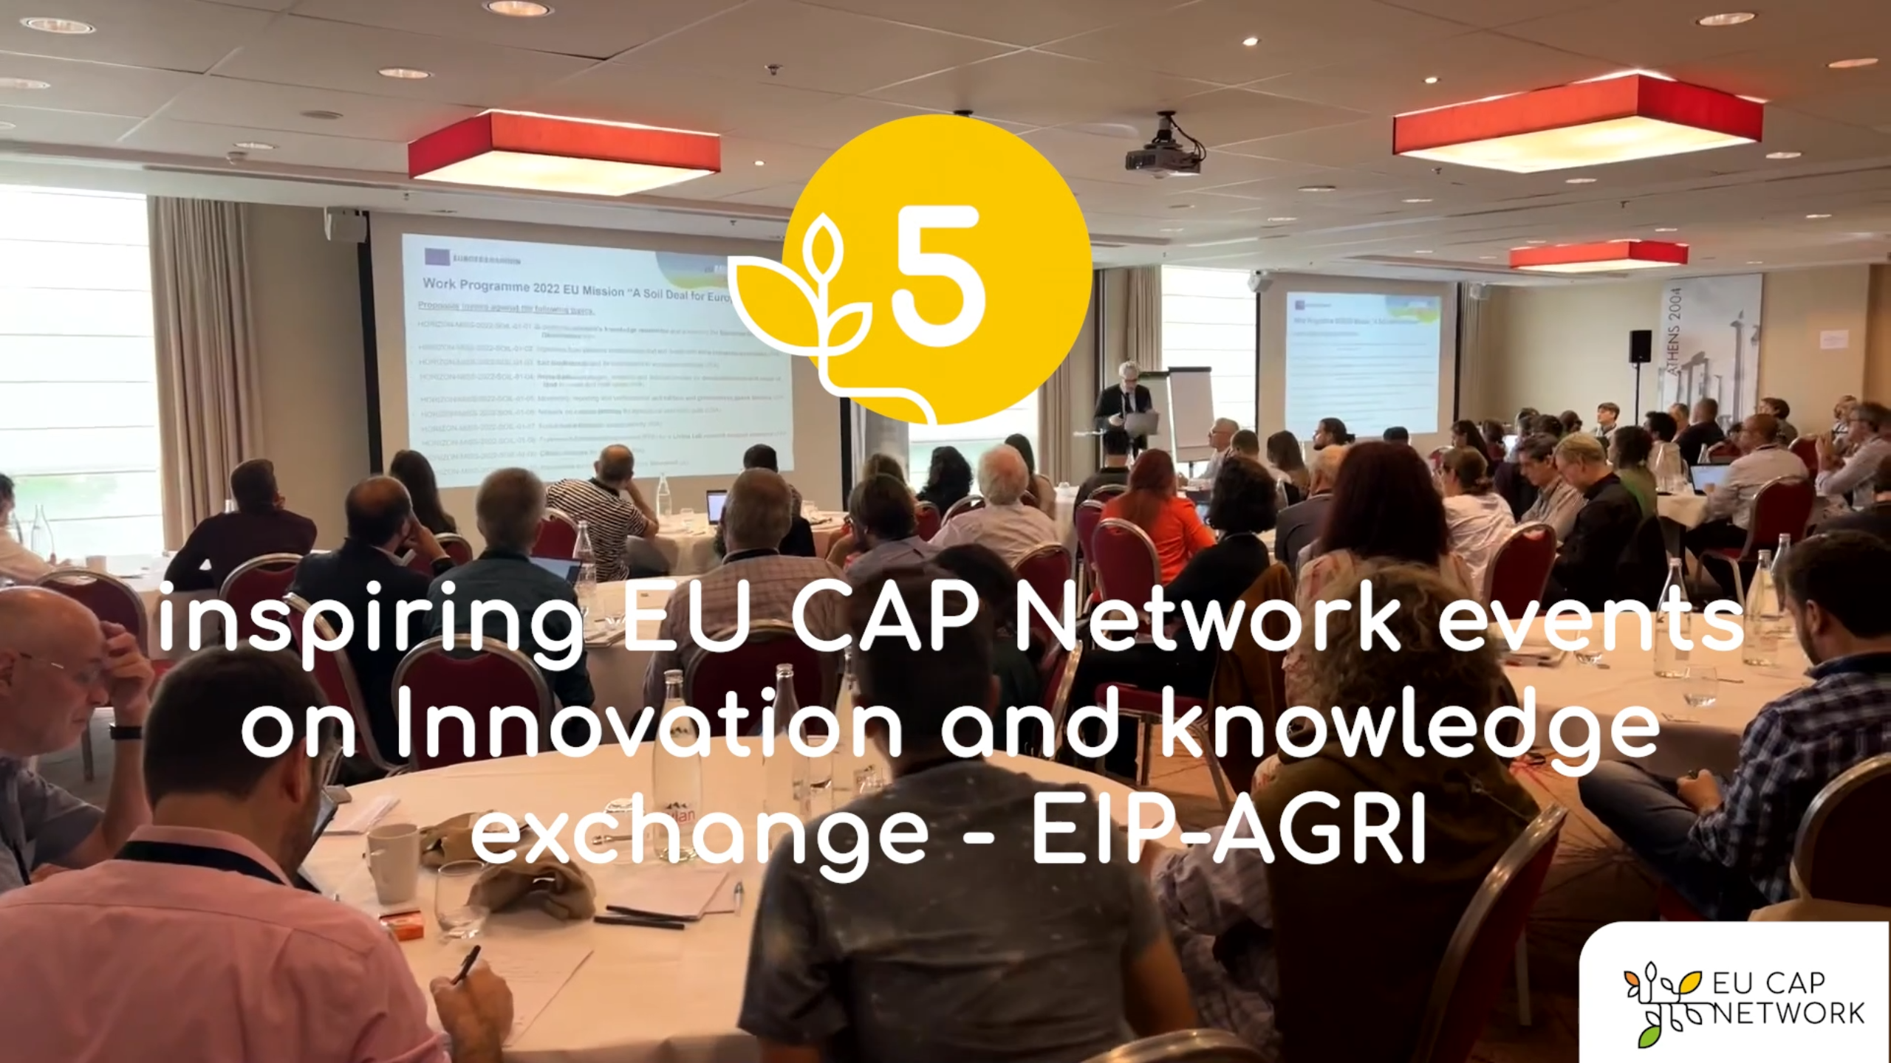
AKIS: building effective knowledge flows across Europe | EU CAP Network events on Innovation and knowledge  exchange – EIP-AGRI – Spring events 2023

EIP-AGRI, 9 years of innovation
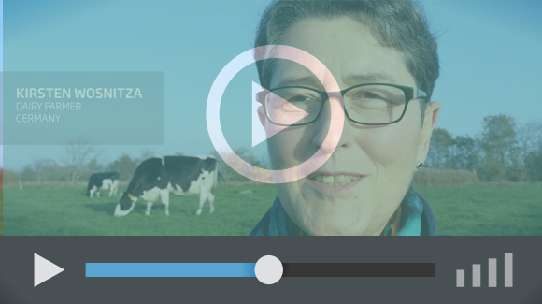 | Enthusiasm is essential for the success of the EIP-AGRI, and to ensure that everyone can benefit. Watch this EIP-AGRI video to hear researchers, farmers, advisors, Managing Authorities and National Rural Networks explain how the EIP-AGRI has helped them over the past 9 years.

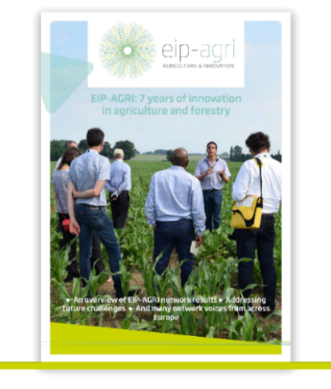 | Since 2013, the EIP-AGRI has been promoting interactive innovation to make EU agriculture and forestry more sustainable, productive, and fit for the future. This report shows how EIP-AGRI has grown. Read the report.

May 2023

