Using digital tools to promote sustainable and productive organic agriculture

Digital tools to support management processes in viticulture

October 2023

Using digital tools to promote sustainable and productive organic agriculture

Digital tools to support management processes in viticulture
For a Portuguese agricultural company producing organic grapes, digitalisation has become crucial to their decision-making processes. In order to achieve the sustainability goals they have identified, they use digital-based management of all processes and operations, both for technical tasks in the field as well as for the management of the team and the whole operation.

The company Esporão S.A. grows organic grapes on around 702 ha of vineyards and olive groves on 92 ha. It is located in the south of Portugal in the Alentejo area, one of the hottest, driest parts of the country. Agricultural Manager Rui Flores tells us: "Sustainability and being in balance with nature is our main aim". But this can be difficult to achieve in such a climate, and this is why they chose to turn to digital tools as a solution.

Alentejo experiences extreme temperatures, and it has poor and varied soils. However, it houses a significant range of biodiversity, which the company strives to protect in order to work with and benefit from the surrounding environment.

Rui continues: "Digitalisation, as a fundamental part of precision agriculture, aims to increase knowledge and maintain better control over the production system, which enables us to work in collaboration with the natural environment." They use drones, probes and sensors in the fields as well as digital management programmes. "Collecting a lot of information means we have more consistent and sustainable practices on the farm. We can increase crop yields whilst reducing the impact on ecosystems."
Soil characteristics, variability, climate and topography are essential factors influencing the yield/quality of grapes produced in a vineyard. Rui Flores continues: "Therefore, it is very important to use all the tools (sensors and digitalisation) that we have at our disposal, to have a good knowledge of the soil before planting the crop, and thus respect the spatial variability of each of the plots."

In the daily management of activities, the company has developed a system which allows computerised management of all operations, facilitating decision-making and productive evaluation of all the different processes on the farm. It is based on agricultural management and planning software, which is accessible online.

They map the production plots with a Geographic Information System (GIS) module that synthesises the spatial representation collected from production land in the form of detailed thematic maps (organised by sector, type of grape variety/crop, production line, type of soil, etc.). The software also allows for the scheduling of agricultural operations in the field, providing workers with information on the tasks they should perform and recording information as they achieve them. It also helps manage and plan activities as it has a module to aggregate the data collected by operators and other key indicators.
"At the moment, this system allows us to plan and record both manual and mechanical operations, evaluate the performance of work teams, make productivity reports and field notebooks, monitor the course and costs of ongoing activities, and control the efficiency of the treatments, and these are just a few of the functionalities," said Rui.
The company intends to develop further software that combines a GIS that brings together geospatial information on agricultural land with a system for managing human and material resources related to agricultural activities. According to Rui, "This tool will allow us to do a detailed resource management also adapted to our sustainability goals."

Background information
- Website: https://www.esporao.com/en/products/#alentejo-herdade-do-esporao
  - Video: https://youtu.be/0VQQKR3WBow

Project information
✆ EIP-AGRI contact

Ina Van Hoye
ina.vanhoye@eucapnetwork.eu
+32 486 90 77 43

Communication manager
‘Support Facility for Innovation &
Knowledge exchange | EIP-AGRI’
✆ Project contact

Rui Flores
+351 913 804 819 agricola@esporao.com

Agricultural Manager at Esporao S.A.

Project photos
Click on the pictures to download the high-resolution versions. The pictures are free for use; please mention the copyright.

Rui Flores, Esporão S.A., in the vineyard | Rui Flores, Esporão S.A., in the vineyard using the drone
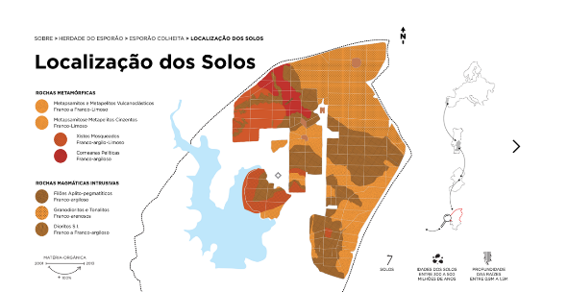 | 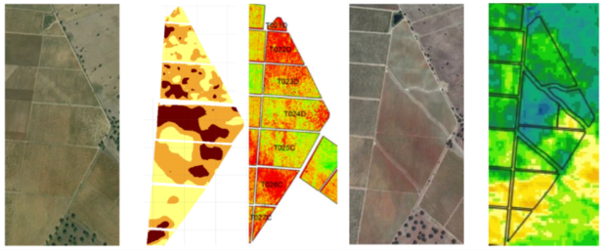
Geological Map of Herdade do Esporão – copyright Esporao S.A. | Redefinition of plots and irrigation sectors in restructuring a vineyard, after using Precision Agriculture tools – copyright Esporao S.A.

Please feel free to use this press article and the pictures in your own publications and to inform your colleagues.
If you would like to receive all EIP-AGRI press articles directly, please fill in the subscription form.

More information on digitalisation

EU CAP Network ‘Innovation & knowledge exchange | EIP-AGRI’ activities

Focus Groups
  - Digital tools for sustainable nutrient management
  - Mainstreaming precision farming

Events
- EU CAP Network Seminar' Smart circular farming to address high energy and fertiliser prices'
- EIP-AGRI seminar: New skills for digital farming

Publications & videos
- EIP-AGRI Brochure Shaping the digital (r)evolution in agriculture
- AGRI challenge: farm data

Inspirational ideas from the network
- Inspirational ideas: Everything you need to know about sheep on one digital platform (Bulgaria)
- Inspirational idea: Certification of Pesticide residue free fruit & veg (Poland)
- Inspirational idea: Using data to manage environmental impact of livestock farming (France)
- Inspirational ideas: A hive of digital activity (Bulgaria)
- Inspirational ideas: Digital tool to building up a picture of soil fertility (Ireland)
- Inspirational ideas: A Smart Label to Build Trust with Consumers (Italy)
- Inspirational ideas: Smart sensors to better understand plant growth (Serbia/the Netherlands)
- Inspirational ideas: Where have ewe moo-ved to? (UK)

Read the EIP-AGRI newsletter from February 2020 which focused on the theme of digitalisation:
Newsletter 78 - February 2020: languages - EN FR EE RO SK

Horizon multi-actor projects working on digitalisation

- 4D4F - Data Driven Dairy Decisions 4 Farmers: CORDIS (Thematic network- 03/2016-02/2019)
- agRoBofood - The agRoBofood project aims to accelerate the digital transformation of the European agri-food sector through the adoption of robotic technologies. Its main objective is to establish a sustainable network of Digital Innovation Hubs that will boost the uptake of robotic solutions by the agri-food sector, with the goal of maximising the return on European investments and transforming the sector.
- DESIRA - Digitisation: Economic and Social Impacts in Rural Areas: CORDIS (06/2019-05/2023)
- Ploutos - Data-driven sustainable agri-food value chains: CORDIS (01/10/2020-30/09/2023)
- DiTECT - DIgital TEChnologies as an enabler for a conTinuous transformation of food safety system: CORDIS (01/11/2020-31/10/2023)
- DECIDE - Data-driven control and prioritisation of non-EU-regulated contagious animal diseases: CORDIS (01/07/2021-30/06/2026)
- Demeter - The H2020 DEMETER project is a large-scale deployment of farmer-driven, interoperable smart farming-IoT (Internet of Things) based platforms, delivered through a series of 20 pilots across 18 countries (15 EU countries). Involving 60 partners, DEMETER adopts a multi-actor approach across the value chain (demand and supply), with 25 deployment sites, 6 000 farmers and over 38 000 devices and sensors being deployed.
- mEATquality - Linking extensive husbandry practices to the intrinsic quality of pork and broiler meat: CORDIS (01/10/2021-30/09/2025)
- PestNu - Field-testing and demonstration of digital and space-based technologies with agro-ecological and organic practices in systemic innovation: CORDIS (01/10/2021-30/09/2024)
- IoF2020 - Internet of Food and Farm 2020: CORDIS (01/2017-12/2020)
- Pantheon - The Pantheon project aims to develop a new way to monitor plant health to detect plant physiology and make corrective interventions. Its main objective is to establish approaches with unprecedented precision and sensitivity for constant monitoring of plant health, focusing on Brassicaceae and Grapevine, which are important annual and perennial species for the EU economy, with the goal of reducing yield losses and facilitating effective management practices.
- Romi - The Romi project aimed to develop an open and lightweight robotics platform for microfarms to reduce manual labour, increase productivity, and monitor crop development. Its main objective was to develop an affordable, multi-purpose, land-based robot that is adapted for organic microfarms and to integrate advanced 3D plant analysis and modelling techniques to improve sensorimotor control of the plant monitoring app.
- SMART-AKIS - European Agricultural Knowledge and Innovation Systems (AKIS) towards innovation-driven research in Smart Farming Technology: CORDIS (Thematic network – 03/2016-08/2018)
- SmartAgriHubs - Connecting the dots to unleash the innovation potential for digital transformation of the European agri-food sector: CORDIS (11/2018-10/2022)

Multi-actor projects are research projects in which end users and multipliers of research results such as farmers and farmers' groups, advisors, enterprises, and others, closely cooperate throughout the whole project. Operational Groups are strongly encouraged to participate in this type of research project.

Thematic networks are multi-actor projects which collect existing knowledge and best practices on a given theme to make it available in easily understandable formats for end-users such as farmers, foresters, advisors etc.

Operational Groups working on digitalisation

Many Operational Groups working on digitalisation are available in the EIP-AGRI Operational Groups database.

The Common Agricultural Policy 2023-27
Find information on the Common Agricultural Policy 2023-27 on the European Commission's website.

Innovation, knowledge exchange and EIP-AGRI in the EU CAP Network

Since 6 October 2022, the EIP-AGRI network has joined forces with the European Network for Rural Development, merging into the new European CAP Network. The 'Support Facility for Innovation & Knowledge exchange | EIP-AGRI' continues to act as a mediator, enhancing communication and cooperation between everyone with a keen interest in innovation and sharing knowledge for sustainable agriculture, forestry and rural areas.

The European Innovation Partnership' Agricultural Productivity and Sustainability' (EIP-AGRI) was launched in 2013 by the European Commission in a bid to promote rapid modernisation of the sectors concerned by stepping up innovation efforts. The EIP-AGRI aims to foster innovation in the agricultural and forestry sectors and in rural areas by bringing research and practice closer together – in innovation projects as well as via the European CAP Network and the national CAP Networks. Also, grassroots ideas from farmers are developed into concrete innovative solutions through 'Operational Group' innovation projects. The EIP-AGRI aims to streamline, simplify and better coordinate existing instruments and initiatives, and complement them with actions where necessary.

More information on Innovation, knowledge exchange and EIP-AGRI on the EU CAP Network website.

EIP-AGRI Operational Groups

EIP-AGRI Operational Groups are groups of people who work together on an innovation project. They bring together partners with complementary knowledge. The group's composition will vary according to each project's theme and specific objectives. Farmers, advisors, scientists, businesses or other relevant partners work together to find practical solutions for specific problems or opportunities for European farmers and foresters. Farmers and foresters must cooperate throughout the project to ensure that the innovative solutions are practical and likely to be quickly applied in the field. Read the basic principles. Innovation support services (including advisors with a focus on innovation), and in particular innovation brokering, can therefore play a crucial role in getting worthwhile projects off the ground by facilitating contacts.

Operational Groups funded under Rural Development Programmes 2014 – 2022

- 98 Rural Development Programmes 2014-2020 (RDPs) provide support to innovative EIP-AGRI Operational Group projects
- Over 3 200 Operational Groups are planned to be established under the approved RDPs

- More than 2 900 Operational Group projects have been selected for funding and are currently ongoing (or already finished). Member States will still start more Operational Group projects, which may run until 2025 (under current transitional rules for EU Rural Development Programmes). Find information on all of these projects in the EIP-AGRI database.

Operational Groups funded under CAP Strategic Plans 2023 – 2027

Within the Common Agricultural Policy 2023-27 (CAP), the EU Member States have designed national CAP Strategic Plans combining funding for income support, rural development, and market measures. All CAP Strategic Plans have been adopted, and their implementation started on 1 January 2023.

26 CAP Strategic Plans include support for innovative EIP-AGRI Operational Groups. In total, 6 600 EIP-AGRI Operational Group projects have been planned.

Related videos
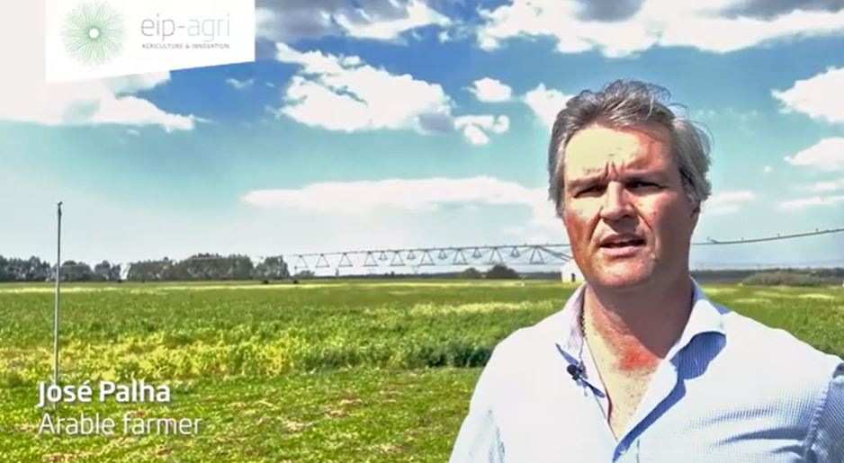 | 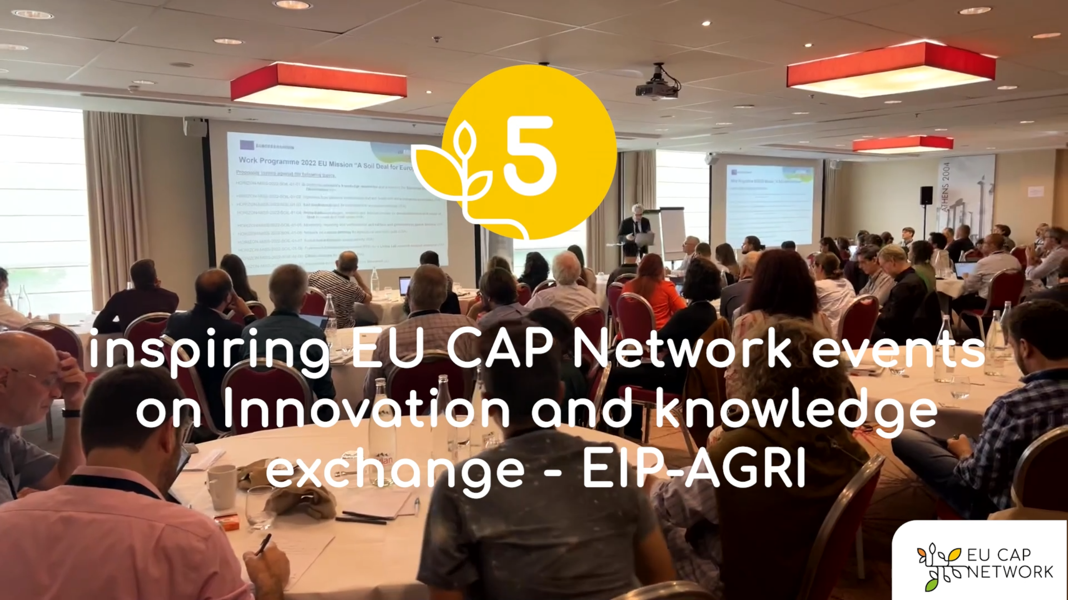
AGRI challenge: farm data | EU CAP Network events on Innovation and knowledge  exchange – EIP-AGRI – Spring events 2023

EIP-AGRI, 9 years of innovation
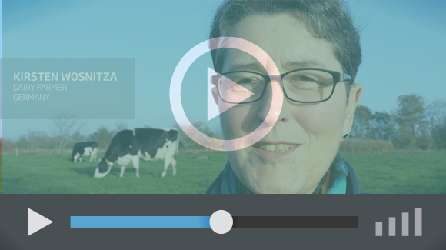 | Enthusiasm is essential for the success of the EIP-AGRI, and to ensure that everyone can benefit. Watch this EIP-AGRI video to hear researchers, farmers, advisors, Managing Authorities and National Rural Networks explain how the EIP-AGRI has helped them over the past 9 years.

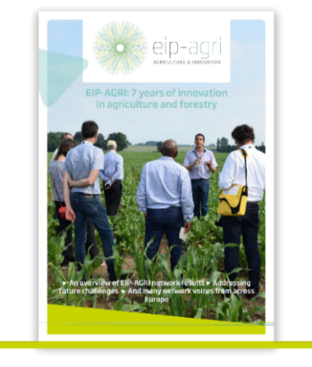 | Since 2013, the EIP-AGRI has been promoting interactive innovation to make EU agriculture and forestry more sustainable, productive, and fit for the future. This report shows how EIP-AGRI has grown. Read the report.

Information officially submitted to the European Commission by RDP Managing Authorities (May 2023).

