Smart barn makes for happy pigs

Innovative barn infrastructure and real-time monitoring to improve animal welfare
and reduce ammonia emissions

July 2023

Smart barn makes for happy pigs

Innovative barn infrastructure and real-time monitoring to improve animal welfare and reduce ammonia emissions
Consumers are calling for more affordable, sustainable pork which is produced in improved animal welfare systems. This was the context identified by the Dutch Operational Group ‘Data driven project’. The partners have developed a pilot barn concept in which the pigs are monitored in real time using ear-tag sensors so that their surroundings can be adapted to their needs.

Frank Wind, Het Familievarken - the organisation leading the project, explains “Ensuring the pigs are happy is at the core of our project. But what makes a pig happy? Pigs love rooting, they like to build their own nest and to be in group. They are neat creatures and they like cleanliness.”

This Operational Group designed a new barn concept which would be able to cater to these needs. The partners built a pilot barn for 48 sows, each providing 29 pigs to slaughter per year. Frank Wind says: “The barn offers a healthy and pleasant living environment”. For example, food is scattered from above at regular intervals onto the sandy floor. This means the pigs can be constantly searching for food and they never get bored. The farmers provide straw to the pigs and other materials so that they can build their own nests. In terms of hygiene, the barn even features two different types of toilet, one for urinating and one for defecating. “We made use of the natural behaviour of the pigs. They need a safe place to go to the toilet in terms of posture and they prefer to be as far as possible from where the food is provided. We have noticed that this barn feature reduces stress for the pigs.” Frank Wind says. This separate collecting also prevents the forming of ammonia.

Another important part of the system is that pregnant sows are put into small groups of four, “The sows support each other, teaching their young to root, eat, and go to the toilet.” Frank explains, “Pigs are naturally social creatures and are much happier living in a supportive group.”

On top of these barn features, the pigs each have a digital ear-tag so that the farmers can follow their behaviour. The barn environment is based on ‘a data-driven self-learning system’ meaning the farmer can adjust certain elements according to the results of data collection and analysis. The ear-tags quantify the position, speed and direction of the animal inside the barn. This data is labelled with expert observations and an algorithm predicts the behaviour of the pigs in real-time. A separate system monitors the climate and other contextual data and the farmer can check animal and health information through a smartphone application. Feed, slaughter, genetic data, and energy usage is also gathered.

This farm is a test version, started in 2019, in Venhorst in the Netherlands. Societal demands are more and more in favour of increasing animal welfare standards, requesting stricter indicators as well as new certification systems. The EU is moving towards phasing out caged farm animals, through a proposal for revised legislation to be made by the end of 2023 as part of the Green Deal and Farm to Fork Strategy. “This Operational Group was designed with this context in mind. The project, which is the pilot phase, has now ended and plans are made to build a second farm this year, [...] we would like to share our results as widely as possible so that they may be taken up across the country, and beyond”, concludes Frank.

Background information
The EU CAP network Innovation & knowledge exchange | EIP-AGRI supports animal health and welfare:

  - From 9-11 May 2023 the EU CAP Network Workshop 'Animal welfare and innovation' took place in Hanover, Germany.
  - The EIP-AGRI Newsletter from July 2020 was dedicated to animal health and welfare.
  - Take a look at the EIP-AGRI spotlight page on animal welfare.

Project information
Het Familievarken is leading the Operational Group, it is an agricultural organisation (pig industry) which focuses on improving animal welfare and costs and profit for the farmer. They teamed up with researchers from Adaptation Physiology Group Wageningen University, who are working on animal welfare as well as with technology specialists, an animal breeding company, an animal nutrition company and a consultant in animal behaviour IT. They also involved architects and construction experts.

  - Website: https://www.hetfamilievarken.nl/
  - Link to page on Operational Group database: https://ec.europa.eu/eip/agriculture/en/find-connect/projects/data-driven-farming

✆ Project contact

Tjacko Sijpkens
tjacko@hetfamilievarken.nl

✆ EIP-AGRI contact

Ina Van Hoye
ina.vanhoye@eucapnetwork.eu
+32 486 90 77 43

Communication manager
‘Support Facility Innovation &
Knowledge exchange | EIP-AGRI’

Project photos
Click on the pictures to download the high resolution versions. The pictures are free for use, please mention the copyright.

Sows and piglets in the pilot barn - Copyright Familievarken | Pigs rooting in the pilot barn - Copyright Familievarken

Feel free to use this press article and the pictures in your own publications and to inform your colleagues.
If you would like to receive all EIP-AGRI press articles directly, please fill in the subscription form.

More information on animal welfare
EU CAP Network ‘Innovation & knowledge exchange | EIP-AGRI’ activities

Focus Groups
- Animal husbandry - Reduction of antibiotic use in the pig sector
- Robust and resilient dairy production systems
- Bee health and sustainable beekeeping
- Reducing antimicrobial use in poultry farming
- Sustainable beef production systems

Events
- EU CAP Network Workshop 'Animal welfare and innovation'
- EIP-AGRI workshop 'Organic is Operational'
- EIP-AGRI workshop 'Innovative solutions for small farms and forest holdings and access of small farms and forest holdings to new technologies '

Publications & videos
  - EIP-AGRI Brochure Reducing antibiotics in pig farming
  - EIP-AGRI Brochure Organic farming: Innovative approaches to support conversion
  - EIP-AGRI Brochure Organic is operational
  - EIP-AGRI Brochure Sustainable livestock farming
  - AGRI challenge video: crop diversification in grassland
  - AGRI challenge video: monitoring bee health through beehive sensors
  - AGRI challenge video: reducing antimicrobials in poultry

Inspirational ideas from the network
- Smart barn makes for happy pigs (The Netherlands)
- Everything you need to know about sheep in one digital platform (Bulgaria)
- A hive of digital activity (Bulgaria)
- Improving welfare for cows…and farmers (Denmark)
- Concrete solutions for sustainability and animal welfare (The Netherlands)
- Working on resilient dairy farming (Germany)
- Alternatives for expensive protein feed for laying hens (Germany)
- Goats in good company (Italy)
- Sustainable egg production (EU, the Netherlands)
- Automatic cleaning for pigs (Sweden)
- Improving chicken value chains- an Operational Group in Germany (Germany)
- A network to improve health management in pigs (Germany)
- Cutting antibiotic use in pig farming (the Netherlands)
- Adding a touch of spice to improve animal health (Greece)

Horizon multi-actor projects working on animal welfare

Some examples:
- DISARM - Disseminating Innovative Solutions for Antibiotic Resistance Management: website - CORDIS (01/2019-12/2021)
- EuroSheep - European Network for interactive and innovative knowledge exchange on animal health and nutrition between the sheep industry actors and stakeholders: CORDIS (01/2020-12/2022)
- aWISH - Animal Welfare Indicators at the Slaughterhouse - website (11/2022-2026)
- PPILOW - Poultry and Pig Low-input and Organic production systems' Welfare - website (9/2019 – 8/2024)
- TechCare - Integrating innovative technologies along the value chain to improve small ruminant welfare management - website (9/2020 – 8/2024)
- EU PiG - EU Pig Innovation Group: website - CORDIS - videos on pig health & welfare (11/2016-10/2020)

Multi-actor projects are research projects in which end users and multipliers of research results such as farmers and farmers’ groups, advisors, enterprises and others, closely cooperate throughout the whole project. Operational Groups are strongly encouraged to participate in this type of research project.

Thematic networks are multi-actor projects which collect existing knowledge and best practices on a given theme to make it available in easily understandable formats for end-users such as farmers, foresters, advisors etc.

Operational Groups working on animal welfare

Many Operational Groups working on animal welfare are available in the EIP-AGRI Operational Groups database.

The common agricultural policy 2023-2027
Find information on the common agricultural policy 2023-27 on the European Commission’s website.

Innovation & knowledge exchange | EIP-AGRI in the EU CAP Network
Since 6 October 2022, the EIP-AGRI network has joined forces with the European Network for Rural Development, merging into the new European CAP Network. The ‘Support Facility for Innovation & Knowledge exchange | EIP-AGRI’ continues to act as a mediator, enhancing communication and cooperation between everyone with a keen interest in innovation and sharing knowledge for sustainable agriculture, forestry and rural areas.

The European Innovation Partnership 'Agricultural Productivity and Sustainability' (EIP-AGRI) was launched in 2013 by the European Commission in a bid to promote rapid modernisation of the sectors concerned by stepping up innovation efforts. The EIP-AGRI aims to foster innovation in the agricultural and forestry sectors and in rural areas by bringing research and practice closer together – in innovation projects as well as via the European CAP Network and the national CAP Networks. Also, grassroots ideas from farmers are developed into concrete innovative solutions through ‘Operational Group’ innovation projects. The EIP-AGRI aims to streamline, simplify and better coordinate existing instruments and initiatives, and complement them with actions where necessary.

More information on Innovation, knowledge exchange and EIP-AGRI on the EU CAP Network website.

EIP-AGRI Operational Groups
EIP-AGRI Operational Groups are groups of people who work together in an innovation project. They bring together partners with complementary knowledge. The composition of the group will vary according to the theme and specific objectives of each project. Farmers, advisors, scientists, businesses or other relevant partners work together to find practical solutions for specific problems or opportunities for European farmers and foresters. Farmers and foresters need to cooperate throughout the project to ensure that the innovative solutions are practical and likely to be quickly applied in the field. Read the basic principles. Innovation support services (including advisors with a focus on innovation), and in particular innovation brokering, can therefore play a crucial role in getting worthwhile projects off the ground by facilitating contacts.

Operational Groups funded under Rural Development Programmes 2014 – 2022

- 98 Rural Development Programmes 2014-2020 (RDPs) provide support to innovative EIP-AGRI Operational Group projects
- Over 3200 Operational Groups are planned to be established under the approved RDPs
- More than 2900 Operational Group projects have been selected for funding and are currently ongoing (or already finished)*. Member States will still start more Operational Group projects which may run until 2025 (under current transitional rules for EU Rural Development Programmes). Find information on all of these projects in the EIP-AGRI database.
*Information officially submitted to the European Commission by RDP Managing Authorities (May 2023)

Operational Groups funded under CAP Strategic Plans 2023 – 2027

Within the common agricultural policy 2023-27 (CAP), the EU Member States have designed national CAP Strategic Plans combining funding for income support, rural development, and market measures. All CAP Strategic Plans have been adopted and their implementation started on 1 January 2023.

26 CAP Strategic Plans include support for innovative EIP-AGRI Operational Groups. In total, 6600 EIP-AGRI Operational Group projects have been planned.

Related videos
AKIS: building effective knowledge flows across Europe | Operational Groups – collaborate to innovate
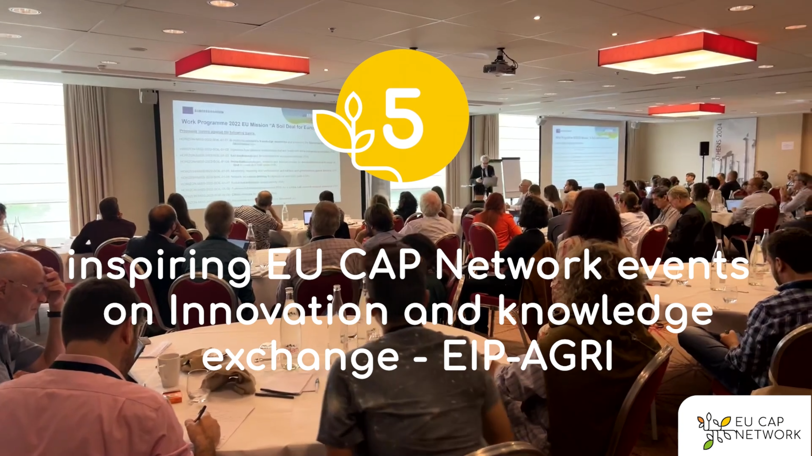 | 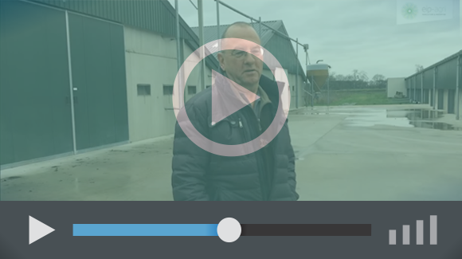
Spring events 2023 | AGRI Challenge - Reducing antimicrobial use in poultry farming

EIP-AGRI, 9 years of innovation
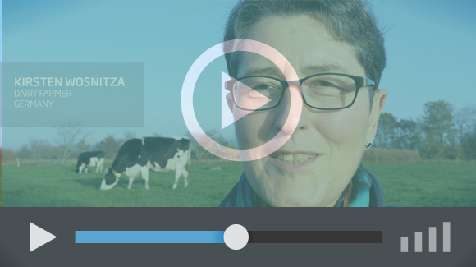 | The enthusiasm is essential for the success of the EIP-AGRI, and in ensuring that everyone can benefit. Watch this EIP-AGRI video to hear researchers, farmers, advisors, Managing Authorities and National Rural Networks explain how the EIP-AGRI has helped them over the past 9 years.

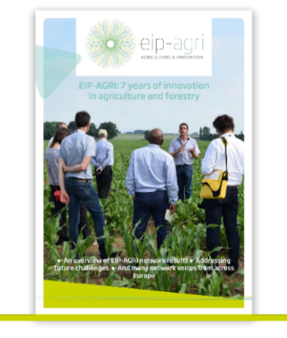 | Since 2013, the EIP-AGRI has been promoting interactive innovation to make EU agriculture and forestry more sustainable, productive, and fit for the future. This report shows how EIP-AGRI has grown. Read the report.

