Circular Economy
Smart circular farming in Malta
Recycling nutrients in manure and using as fertilisers
June 2023

Circular economy

Smart circular farming in Malta

Recycling nutrients in manure and using as fertilisers

The Farmers Central Cooperative Society (FCCS) has teamed up with the pig breeders cooperative (KIM) and the milk producers cooperative (KPH) to work on a new project to recycle the nutrients in manure from animal breeding and use them as fertiliser in the fruit and vegetable sector. “We will even go beyond this to achieve a full circular economy, making full use of the resources in raw pig and cow slurry. On top of fertiliser: water, energy and carbon as soil improver, biochar, or fuel,” Christopher Ciantar, project coordinator tells us.

According to the project, 300,000 tons of slurry is discarded in Malta every year. There are currently very few solutions for dairy and pig producers, and so it is wasted. At the same time, fruit and vegetable farmers are paying high prices for fertilisers. Furthermore, as droughts become more and more common in this Mediterranean country, water is becoming more and more sought-after.

Christopher, who works for FCCS explains “Collaboration between farmers in Malta is very limited, there are just not many opportunities for this. So along with the other cooperatives, we believe that bridging this gap and encouraging more connections and synergies across sectors can have many benefits, not only for the farmers themselves and their livelihoods, but also for the environment.”

The idea is that when several farms are in close proximity, a small biogas facility will be installed on site. As well as producing energy, the remaining substance – the digestate – can also be put to good use. Once processed, the digestate will be treated further (on-farm) using a mobile technology that is concurrently being developed through the project. This device can move from one farm to another. It is able to recover 80% as clean water which can be added to the reservoirs on the farm, and the rest as solid and liquid fertiliser which can be used directly on-farm or sold to other producers. On smaller, individual farms the mobile technology, without a biogas plant, can still be used to separate the slurry into water and nutrients (without the energy element).

A pilot of both the biogas and the mobile plant was built as a showcase. Partners are currently executing field analyses to prove the concept. Christopher explains “We already had a lab-scale facility in 2018, where we recovered water and nutrients, but in this project we have upscaled. We have to ensure the technology is efficient and is able to handle the higher volumes of slurry. We also need to make it cost-effective for the farmers; targeting a solution that makes good manure management, fertilisation with manure and recovery of other by-products, a preferred solution for Maltese farmers.”

The second part of the project is the application of the fertiliser. Farmers need training and support. So the project has developed an app called the “Crop Manager app” which is capable of producing a fertiliser plan. Moreover, all fruit and vegetable farmers using the organic fertilisers will get a certificate which they can use in the cooperative for marketing purposes.

Christopher adds “As part of the project, we are also working on a calibrated economic model to quantify the total financial, social and environmental costs and benefits over a number of years and compare these impacts to the current situation under different scenarios.”

Christopher is currently working closely with FCCS members to trial the organic fertilisation in practice. Through the showcases, demonstrations and open days, the project hopes to convince more farmers as the project produces results and progresses. “SYNECO makes the farmer a protagonist to help shape the future agricultural economic model, taking on the challenge of climate and environmental issues more forcefully and directly”, concludes Christopher.

Background information
More information

On 6-7 December 2022 the EU CAP Network Seminar ‘Smart circular farming to address high energy and fertiliser prices’ was organised. The seminar report has recently been published, all information at a glance can be found in the factsheet. The June 2023 newsletter focused on high energy and fertiliser prices.

Project information
SYNECO, which is financed by the European Union (Rural Development Programme for Malta 2014-2020), helps livestock farms to turn manure from being a complicated and costly waste into being a valuable plant nutrient, reducing the need for storage and transport and so reducing emissions and eliminating odours and noise. The fact that the technology is partially mobile also means that planning permission is also avoided.
The partnership intends to work along with the legislation, as the whole island of Malta is a nitrates vulnerable zone. Therefore, the application of nutrients originating from manure will have to be carefully controlled, planned and monitored, so as to respect the Nitrates Directive.

✆ Project contact

Christopher Ciantar chris.syneco@outlook.com
✆ EIP-AGRI contact

Ina Van Hoye
ina.vanhoye@eucapnetwork.eu
+32 486 90 77 43

Communication manager
Support Facility ‘Innovation &
Knowledge exchange | EIP-AGRI’

More information
- Website
- Facebook

Project photos
Click on the pictures to download the high resolution versions. The pictures are free for use, please mention the copyright.
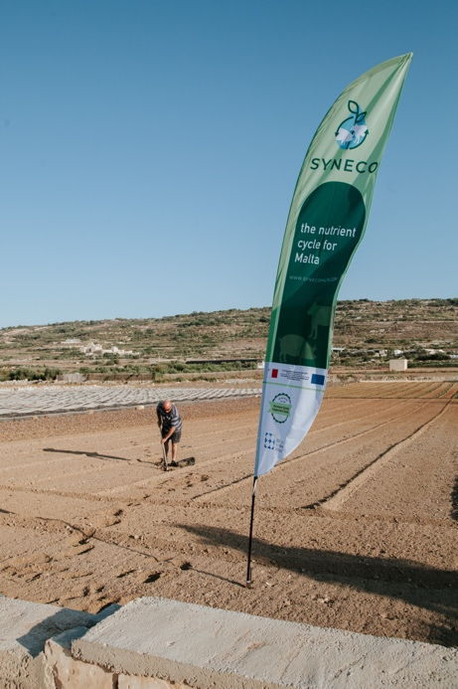
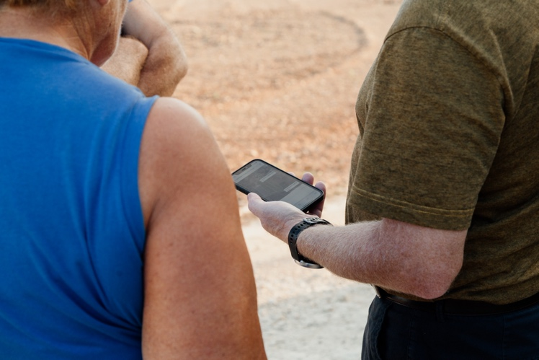
Farmers being given hands-on training on the use of the app – © Syneco project

Soil sampling for analysis prior to generating fertiliser plans – © Syneco project

More information on circular economy

EU CAP Network ‘Innovation & knowledge exchange | EIP-AGRI’ activities

Focus Groups
- EIP-AGRI Focus Group: Agroforestry: introducing woody vegetation into specialised crop and livestock systems
- EIP-AGRI Focus Group: Enhancing production and use of renewable energy on the farm
- EIP-AGRI Focus Group: Circular Horticulture
- EIP-AGRI Focus Group: Enhancing production and use of renewable energy on the farm
- EIP-AGRI Focus Group: Fertiliser efficiency - Focus on horticulture in open field
- EIP-AGRI Focus Group: Mixed Farming Systems: Livestock/Cash crops
- EIP-AGRI Focus Group: New forest practices and tools for adaptation and mitigation of climate change
- EIP-AGRI Focus Group: Nutrient Recycling
- EIP-AGRI Focus Group: Reducing food loss on the farm
- EIP-AGRI Focus Group: Sustainable industrial crops in Europe: new market opportunities and business models which do not replace food production
- EIP-AGRI Focus Group: Sustainable mobilisation of forest biomass

Events
- EU CAP Network Seminar ‘Smart circular farming to address high energy and fertiliser prices’
- EIP-AGRI Workshop Building new biomass supply chains for the bio-based economy
- EIP-AGRI Workhop Opportunities for farm diversification in the circular bio-economy
- EIP-AGRI workshop ‘New value chains from multifunctional forests’
- EIP-AGRI Workshop: Innovation in the supply chain: creating value together
- EIP-AGRI Workshop "Small is smart" - Innovative solutions for small agricultural and forestry holdings

Publications
- EIP-AGRI Factsheet Bioeconomy
- EIP-AGRI brochure: Collaboration in the supply chain
- EIP-AGRI Brochure on Creating diverse forests with multiple benefits
- EIP-AGRI Brochure Innovation for European forestry
- The sixth edition EIP-AGRI’s Agrinnovation magazine focuses on opportunities in the circular bioeconomy

EIP-AGRI Videos
- VIDEO Soil fertility through carbon storage

Inspirational ideas from the network
- French farmers establish local value chain with wood from hedgerows – FR
- Biostimulants for sustainable agriculture - IT
- A grain dryer which is both energy and time efficient - FI
- Agreegreen: Models for managing woody biomass - IT
- Aquaculture + hydroponics = aquaponics - EU
- Biovakka, Manure management to produce biogas and nutrients in Finland - FI
- Birch sap tapping in Finland - FI
- Cork for 3D printing - ES
- Farmers grow high-yield energy grass near Amsterdam Schiphol Airport - NL
- Farming for energy - IT
- Fertile circularity - EU
- Improving forestry value chains in Finland - FI
- Irish potato company prevents food loss on the farm - IE
- Italian farmers develop circular economy for clean electricity - IT
- Plant-based bioproducts to boost regional development - IT
- Setting up short wood supply chains using hedgerows - FR
- The Platform for Knowledge Based Bio-Economy relevant ERA-NETs - EU
- Tomato grower and fish farmer create profits through water re-use and energy exchange - BE
- Towards a circular horticulture system - NL
- Turning waste into a resource – FR

The EU CAP network Innovation & knowledge exchange | EIP-AGRI supports the circular economy by promoting and sharing innovative practices. Read the EIP-AGRI Newsletter from June 2023 which is dedicated to circular economy and high energy and fertiliser prices.

Horizon projects working on circular economy
- Circular Agronomics - Efficient Carbon, Nitrogen and Phosphorus cycling in the European Agri-food System and related up- and down-stream processes to mitigate emissions: website - CORDIS (09/2018-08/2022)
- GO-GRASS – Grass-based circular business models for rural agri-food value chains: website - CORDIS (10/2019 – 09/2023)
- AGRIFORVALOR - Bringing added value to agriculture and forest sectors by closing the research and innovation divide to valorize and exploit sidestream biomass resources from agriculture and forestry: website - CORDIS (03/2016-08/2018)
- PANACEA - A thematic network to design the penetration PAth of Non-food Agricultural Crops into European Agriculture - website - CORDIS (11/2017-10/2020)
- ENABLING - Enhance New Approaches in BioBased Local Innovation Networks for Growth - website - CORDIS (12/2017-11/2020)

Multi-actor projects are projects in which end users and multipliers of research results such as farmers and farmers’ groups, advisers, enterprises and others, are closely cooperating throughout the whole research project period.

Thematic networks are multi-actor projects which collect existing knowledge and best practices on a given theme to make it available in easily understandable formats for end-users such as farmers, foresters, advisers etc.

Operational Groups working on circular economy

71 Operational Groups working on circular economy are available in the EIP-AGRI Operational Groups database (update February 2023)
- France: 1
- Germany: 2
- Ireland: 3
- Italy: 22
- Latvia: 2
- The Netherlands: 12
- Portugal: 10
- Slovenia: 1
- Spain: 16
- Sweden: 2

The common agricultural policy 2023-2027
The reform of the Common Agricultural Policy (2023-2027) was formally approved end November 2021. Find all information on the new CAP on the European Commission website.

Innovation & knowledge exchange | EIP-AGRI in the EU CAP Network
Since 6 October 2022, the EIP-AGRI network has joined forces with the European Network for Rural Development, merging into the new European CAP Network. The ‘Support Facility for Innovation and Knowledge exchange, including EIP-AGRI’ continues to act as a mediator, enhancing communication and cooperation between everyone who has a keen interest in sharing knowledge and innovating agriculture, forestry and rural areas.

The European Innovation Partnership 'Agricultural Productivity and Sustainability' (EIP-AGRI) was launched in 2013 by the European Commission in a bid to promote rapid modernisation of the sectors concerned by stepping up innovation efforts. The EIP-AGRI aims to foster innovation in the agricultural and forestry sectors and in rural areas by bringing research and practice closer together – in innovation projects as well as via the European CAP Network and the national CAP Networks. Also grassroots ideas from farmers get developed into innovations through the so-called Operational Group innovation projects. The EIP-AGRI aims to streamline, simplify and better coordinate existing instruments and initiatives, and complement them with actions where necessary. More information on Innovation, Knowledge Exchange |EIP-AGRI on the EU CAP Network website.

EIP-AGRI Operational Groups
EIP-AGRI Operational Groups are groups of people who work together in an innovation project. They bring together partners with complementary knowledge. The composition of the group will vary according to the theme and specific objectives of each project. Farmers, advisors, scientists, businesses or other relevant partners work together to find practical solutions for specific problems or opportunities for European farmers and foresters. Farmers and foresters need to cooperate throughout the project to ensure that the innovative solutions are practical and likely to be quickly applied in the field. Read the basic principles. Innovation support services (including advisors with a focus on innovation), and in particular innovation brokering, can therefore play a crucial role in getting worthwhile projects off the ground by facilitating contacts.

Operational Groups funded under Rural Development Programmes 2014 - 2022
  - 98 Rural Development Programmes provide support to innovative EIP Operational Group projects
  - Over 3200 Operational Groups are planned to be established under the approved RDPs (2014 – 2020)
  - More than 2700 Operational Groups projects have been selected for funding and are currently ongoing (or already finished)*. Member States will still start more Operational Group projects which may run until 2025 (under current transitional rules for EU rural development programmes). Find information on all of them in the EIP-AGRI database.

*Information officially submitted to the European Commission by RDP Managing Authorities (March 2023).

Operational Groups funded under CAP Strategic Plans 2023 – 2027

Within the new common agricultural policy the EU Member States designed national CAP Strategic Plans combining funding for income support, rural development, and market measures. All CAP Strategic Plans have been adopted and their implementation started on 1 January 2023. 26 CAP Strategic Plans provide support to innovative EIP-AGRI Operational Groups’ projects.

EIP-AGRI videos
AKIS: building effective knowledge flows across Europe | Operational Groups – collaborate to innovate

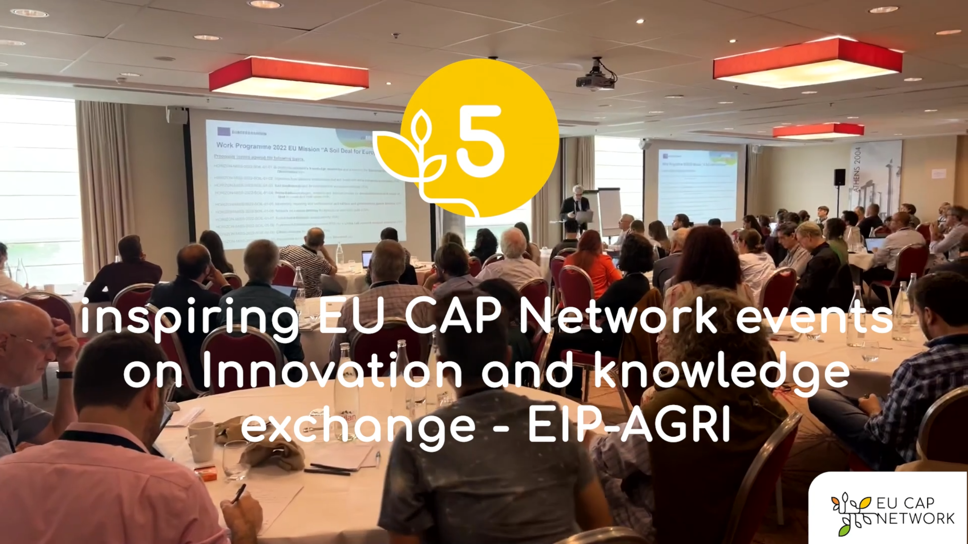

EU CAP Network events on Innovation and knowledge
exchange – EIP-AGRI – Spring events 2023

EIP-AGRI, 9 years of innovation
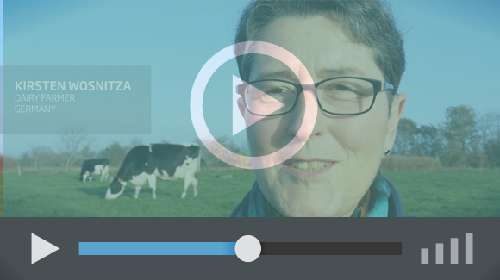 | The enthusiasm is essential for the success of the EIP-AGRI, and in ensuring that everyone can benefit. Watch this EIP-AGRI video to hear researchers, farmers, advisors, Managing Authorities and National Rural Networks explain how the EIP-AGRI has helped them over the past 9 years.

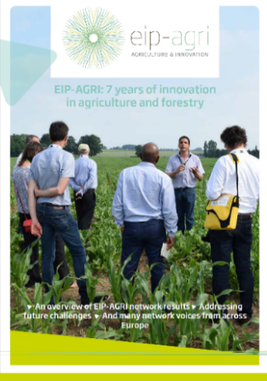 | Since 2013, the EIP-AGRI has been promoting interactive innovation to make EU agriculture and forestry more sustainable, productive, and fit for the future. This report shows how EIP-AGRI has grown. Read the report.

