Soil health
Strip-till and strip-plant methods to improve soil fertility
May 2023

Strip-till and strip-plant methods to improve soil fertility
The effects of climate change mean that soil is under extreme pressure. The Operational Group BioStripPlant in Germany is testing the use of strip-till and strip-plant methods to improve the fertility of soils in organic market gardening. This project is running trials on the combination of these techniques with other organic and ecological practices and adapting methods to the regional conditions.

There is an increasing demand for organic vegetables in Brandenburg, north-eastern Germany. However, in recent years, higher water consumption and nutrient requirements, combined with a shorter cultivation period and worsening weather conditions are challenges being brought about by climate change. The naturally sandy soils have become less fertile. Measures for improving this are often costly, and farmers in the area are also limited in terms of personnel capacity. So this Operational Group set out to identify targeted innovations to regenerate the soils, to improve the economic situation of vegetable farms and at the same time contribute to environmental protection. It aims to transfer the strip-till and strip-plant methods that are already successfully used in arable farming to market gardening. These methods have been shown to reduce weed pressure, increase soil moisture and fight against soil erosion.

The project brings together an innovation company, several farms, an organic farming association and an agricultural institute. Over the 3 years, the farms involved will run field trials, testing combinations of vegetable crops, mulched cereal/legumes and living mulch, strip-till and strip-plant methods, adapting all of this to regional conditions.
Specifically, there are 3 areas on each of the field trials: one field mulched rye, one field with clover as a living mulch and one fallow field. In all three they create planting furrows (strips) with the strip till machine, fertilising at the same time, later in these furrows, the vegetables are planted. The crops do not rotate. For the following year the whole field is cultivated and intercrops are sown on the whole field.

The project is just starting its second year of trials and the partners are currently evaluating the yield of the crops. Isabell Szallies from the lead partner Agrathaer explains that they did encounter some challenges in the first year “We had an issue with the strip-till machine as organic manure blocks the pipes. So we found a solution by making some technical modifications to the machine itself and using very small 100% sheep’s wool pellets. The machine has since been working very well.”

As well as outcompeting weeds, growing mulch keeps water in the plants, water that would otherwise be lost faster, and this is particularly important in sandy, porous soils when temperatures are high and the evaporation is exacerbated. Mulch can improve a bit the microclimate and is important during droughts. “We sowed the living mulch Trifolium subterraneum in Spring 2022. The plant developed well later in the year, but at the beginning of the season, it did not meet our expectations. So for the second year of trials, we already sowed it in the Autumn to give it more time to develop. We are hoping for better results already in May or June.”

After a year, the project partners have been able to identify some opportunities for improvement in the second year. Isabell continues, “We will adjust the sowing time and the composition of the intercrops. For example, instead of pure green rye, a mixture of cereals and legumes will be sown for a better mulch. The seeds for next year’s mulch and living mulch have already been sown and have started sprouting.”

Background information
- Page on EIP-AGRI database
- Website

Project information
✆ EIP-AGRI contact

Ina Van Hoye
ina.vanhoye@eucapnetwork.eu
+32 486 90 77 43

Communication manager
Support Facility ‘Innovation &
Knowledge exchange | EIP-AGRI’
✆ Project contact

Isabell Szallies isabell.szallies@agrathaer.de
+49 3343282299

Project photos
Click on the pictures to download the high resolution versions. The pictures are free for use, please mention the copyright.
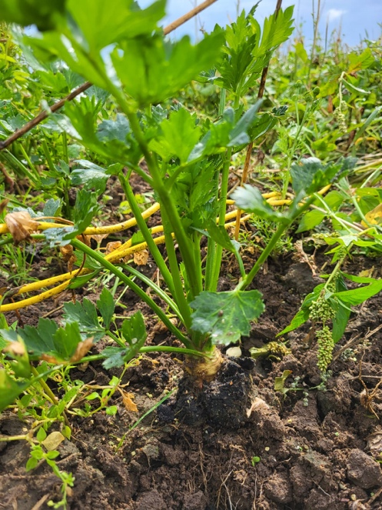
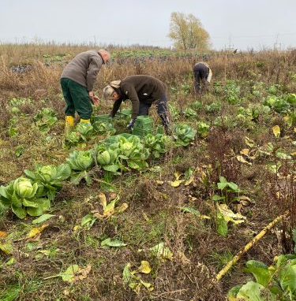
Harvesting the white cabbage, November 2022. © Isabell Szallies, Agrathaer GmbH
Celery root at growth. © Max Liebrich, Bio-Gärtnerei Watzkendorf GmbH

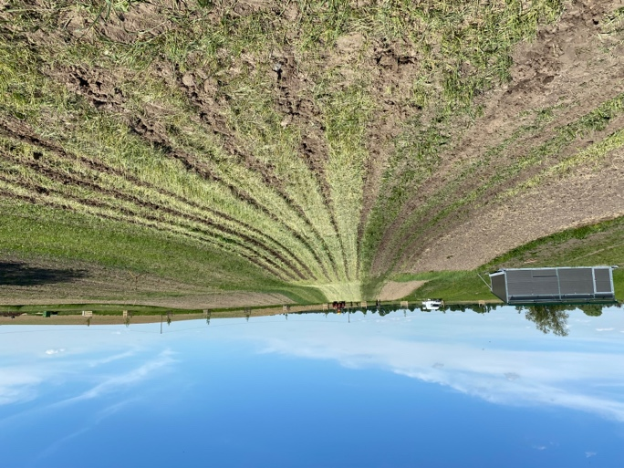
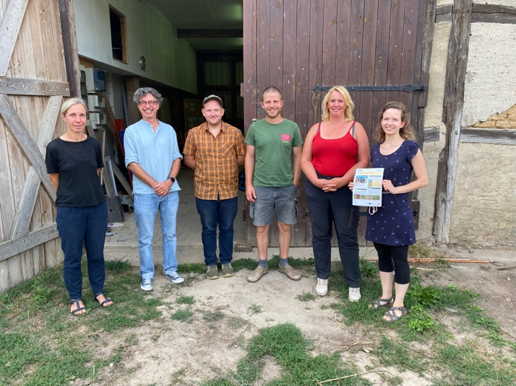
Operational Group meeting to discuss next steps. © Företagaren Plan B

Picture of the Operational Group at Weggun farm. © Gunilla Lissek-Wolf, IDL

More information on soil health

Mission ‘A Soil Deal for Europe’: M€ 126 funding for 2023
The Mission ‘A Soil Deal for Europe’ offers M€ 126 of funding for 2023. Topics include the setting up of 3 Living Labs on soil health (HORIZON-MISS-2023-SOIL-01-08) and 1 Living Lab on carbon farming (HORIZON-MISS-2023-SOIL-01-09). All 9 topics under the call “Research and Innovation and other actions to support the implementation of mission A Soil Deal for Europe” here HORIZON-MISS-2023-SOIL-01. Deadline is 20 September 2023.

The Horizon Europe NATI00NS project supports stakeholders at national and transnational level to develop high quality applications for Living Labs Open Calls funded by the Mission through National Engagement Events, a matchmaking platform, national mentors, capacity-building webinars and e-learning materials. Learn more

Horizon Europe supports EU Missions as a new way to deliver practical solutions to some of our greatest challenges. The Mission ‘A Soil Deal for Europe’ aims to establish a network of 100 living labs and lighthouses in rural and urban areas, to lead the transition to healthy soils by 2030. This network will co-create knowledge, test solutions and demonstrate their value in real-life conditions, to address key soil health challenges such as desertification, soil carbon preservation, pollution, erosion, biodiversity loss or soil sealing.

EU CAP Network ‘Innovation & knowledge exchange | EIP-AGRI’ activities on soil health
- EIP-AGRI Focus Group: EIP-AGRI Focus Group: Fertiliser efficiency - Focus on horticulture in open field
- EIP-AGRI Focus Group: Grazing for Carbon
- EIP-AGRI Focus Group: IPM practices for soil-borne diseases suppression in vegetables and arable crops
- EIP-AGRI Focus Group: Mainstreaming precision farming
- EIP-AGRI Focus Group: Moving from source to sink in arable farming
- EIP-AGRI Focus Group: Nutrient recycling
- EIP-AGRI Focus Group: Organic farming - Optimising arable yields
- EIP-AGRI Focus Group: Profitability of permanent grassland
- EIP-AGRI Focus Group: Protecting agricultural soils from contamination
- EIP-AGRI Focus Group: Soil organic matter content in Mediterranean regions
- EIP-AGRI Focus Group: Soil salinisation
- EIP-AGRI Focus Group: Water & agriculture: adaptive strategies at farm level
- EIP-AGRI Focus Group: Digital tools for sustainable nutrient management
- EIP-AGRI Focus Group: Non-chemical weed management in arable cropping systems
- EIP-AGRI Focus Group: Reducing plastic footprint of agriculture
- EU CAP Network Focus Group: Enhancing the biodiversity on farmland through high-diversity landscape features
- EU CAP Network Focus Group: Recovery of abandoned agricultural lands

Events

- EU CAP Network Workshop: ‘Enhancing food security under changing weather patterns: farm adaptation’
- EU CAP Network Seminar: ‘Smart circular farming to address high energy and fertiliser prices’
- EIP-AGRI Workshop: ‘Tools for environmental farm performance’
- EIP-AGRI Workshop: ‘Towards carbon neutral agriculture’
- EIP-AGRI Workshop: ‘Small is smart’ - Innovative solutions for small agricultural and forestry holdings
- EIP-AGRI Workshop: ‘Shaping the EU mission 'Caring for soil is caring for life'
- EIP-AGRI Seminar: ‘Healthy soils for Europe: sustainable management through knowledge and practice’
- EIP-AGRI Workshop: 'Organic is Operational'
- EIP-AGRI Workshop: Connecting innovative projects: Water & Agriculture
- EIP-AGRI Workshop: Cropping for the future: networking for crop rotation and crop diversification
- Agri-Innovation summit 2019

Publications
- EIP-AGRI Brochure Climate-smart agriculture: Solutions for resilient farming and forestry
- EIP-AGRI Brochure Sustainable and resilient farming: Inspiration from agro-ecology
- EIP-AGRI Brochure Innovation for European forestry
- EIP-AGRI Brochure Sustainable livestock farming
- EIP-AGRI Brochure Organic is operational
- EIP-AGRI Brochure Water and Agriculture
- EIP-AGRI Brochure Soil organic matter matters
- EIP-AGRI Brochure IPM for Brassica
- EIP-AGRI Brochure on Innovative solutions for organic farmers in the EU - Optimising arable yields
- Agrinnovation magazine - Issue n° 7 - September 2020 – Focus on soils
- Agrinnovation magazine - Issue n° 6 - June 2019 (and previous magazines)

Videos

- AGRI challenge: reducing the plastic footprint of agriculture
- New ways to deal with soil salinisation in farming
- AGRI challenge: protecting soils from contamination
- AGRI challenge: soil fertility through carbon storage
- AGRI challenge: crop diversification in grassland
- AGRI challenge: soil salinisation
- AGRI challenge: organic farming
- Agroecology clip
- AGRI challenge: Digital tools for nutrient management

Inspirational ideas from the network

- Improving soil biodiversity to reduce inputs (Spain)
- Farmers tackling drought and flooding (Belgium)
- Farm data for water management of soils (Italy)
- Restoration of degraded forest areas (France)
- Recovering abandoned land in the Rioja Valley (Spain)
- Added value for agriculture and nature (Germany)
- Farmers collaborating for Living Soils (France)
- Arable cropping systems adapted to climate change (Germany)
- Improving soils in Montado ecosystems (Portugal)
- The Soil Box (Germany)
- Cover crops for quality soil in the Po river valley (Italy)
- Mycorrhiza fungi as green alternative for mineral fertilisers (Germany)
- Inishowen Upland Farmers project (Ireland)
- Market gardening (Austria)
- Italian table grape farmers cooperate to improve soil quality (Italy)
- Making rice cultivation resistant to soil salinisation (Spain)
- German Operational Group investigates effective application of Mycorrhiza as green alternative for mineral fertilisers (Germany)
- Looking after the soil to bring life and carbon back (Austria)
- Preserving soil organic matter and protecting water sources (Portugal)
- Inspirational ideas: Increasing farm profitability while cutting carbon emissions, a toolkit developed by farmers for farmers
- Agroecology for sustainable soils (France)
- A kit to improve soil biological activity (France)
- Cutting atmospheric carbon: a central role for soils (France)
- From great soil comes great food – a farmers’ story (France)
- Agroforestry- a win-win for nature and the farmer (Germany)
- Agro-industrial waste put to good use as biofertiliser (Italy)
- Biofertilisers to improve soil fertility (Italy)
- Nutrient spill overs for valuable fertiliser (Italy)
- Fertile Circularity (Netherlands)
- Crop diversification - multiple benefits for dairy farm (Netherlands)
- Precision farming- the right technology and sharing knowledge are key (Netherlands)
- Protecting soil organic carbon in Poland (Poland)
- A passion for permanent pasture (Portugal)
- A nature-based approach for Mediterranean ecosystems (Portugal)
- Finding new in the old, reviving former links between forest and agricultural land (Spain)
- Grazing management with a heart for soil health (UK)
- Digital tool to building up a picture of soil fertility (Ireland)
- Biostimulants for sustainable agriculture (Italy)
- Farmers tackling drought and flooding (Belgium)
- Farm data for water management of soils (Hungary)
- From deserted area to oasis of biodiversity (Greece)
- Walloon farmers test pesticide and tillage reduction strategies (Belgium)
- New machinery for soil health in arable crop production (Italy)
- Strip-till and strip-plant methods to improve soil fertility (Germany)

The EU CAP network Innovation & knowledge exchange | EIP-AGRI supports soil health by promoting and sharing innovative practices. Read the Thematic Newsletter from December 2022 which was dedicated to soil health.

Horizon 2020 multi-actor projects working on soil health

- iSQAPER - Interactive Soil Quality Assessment in Europe and China for Agricultural Productivity and Environmental Resilience: website - CORDIS
- LANDMARK - LAND Management: Assessment, Research, Knowledge base: website - CORDIS
- SOILCARE - Soil Care for profitable and sustainable crop production in Europe: website - CORDIS
- Diverfarming - Crop diversification and low-input farming across Europe: from practitioners engagement and ecosystems services to increased revenues and chain organisation: website - CORDIS

- DiverIMPACTS - Diversification through Rotation, Intercropping, Multiple cropping, Promoted with Actors and value-Chains Towards Sustainability: website - CORDIS
- FAirWAY - Farm systems that produce good Water quality for drinking water supplies: website - CORDIS
- WATERPROTECT - Innovative tools enabling drinking WATER PROTECTion in rural and urban environments: website - CORDIS
- BEST4SOILS - Boosting 4 BEST practices for SOIL health in Europe: website CORDIS other info (Thematic network)
- EXCALIBUR - Exploiting the multifunctional potential of belowground biodiversity in horticultural farming: website - CORDIS
- SoildiverAgro - Soil biodiversity enhancement in European agroecosystems to promote their stability and resilience by external inputs reduction and crop performance increase: CORDIS
- CIRCASA – Developing international synergies concerning research and knowledge exchange in the field of carbon sequestration in agricultural soils at European Union and global levels, with the active engagement of all relevant stakeholders: website - CORDIS
- NUTRIMAN – Developing an online Farmer Platform presenting novel technologies and solutions to facilitate the switch from chemical-processed mineral fertilisers to safe biofertilisers at lower cost: website - CORDIS
- EU Marie Skłodowska-Curie Actions programme - AGG-REST-WEB project and IDESoWa project
- European Research Council (ERC) project DormantMicrobes
- Horizon 2020 Research & Innovation project SIEUSOIL: Sino-EU Soil Observatory for intelligent Land Use Management: website - EIP-AGRI database

Further relevant multi-actor projects and thematic networks here.

Multi-actor projects are projects in which end users and multipliers of research results such as farmers and farmers’ groups, advisers, enterprises and others, are closely cooperating throughout the whole research project period.

Thematic networks are multi-actor projects which collect existing knowledge and best practices on a given theme to make it available in easily understandable formats for end-users such as farmers, foresters, advisers etc.

Operational Groups working on soil health
373 Operational Groups working on soil health are available in the EIP-AGRI Operational Groups database (update February 2023)
- Austria: 9
- Belgium: 3
- Croatia: 2
- Finland: 2
- France: 31
- Germany: 39
- Hungary: 17
- Ireland: 14
- Italy: 77
- Latvia: 6
- Lithuania: 4
- The Netherlands: 77
- Poland: 1
- Portugal: 9
- Spain: 56
- Sweden: 2
- UK: 7

The common agricultural policy 2023-2027
Find all information on the new CAP on the European Commission website.

Innovation & knowledge exchange | EIP-AGRI in the EU CAP Network

The reform of the Common Agricultural Policy (2023-2027) was formally approved end November 2021. Find all information on the new CAP on the European Commission website.

Innovation & knowledge exchange | EIP-AGRI in the EU CAP Network
Since 6 October 2022, the EIP-AGRI network has joined forces with the European Network for Rural Development, merging into the new European CAP Network. The ‘Support Facility for Innovation and Knowledge exchange, including EIP-AGRI’ continues to act as a mediator, enhancing communication and cooperation between everyone who has a keen interest in sharing knowledge and innovating agriculture, forestry and rural areas.

The European Innovation Partnership 'Agricultural Productivity and Sustainability' (EIP-AGRI) was launched in 2013 by the European Commission in a bid to promote rapid modernisation of the sectors concerned by stepping up innovation efforts. The EIP-AGRI aims to foster innovation in the agricultural and forestry sectors and in rural areas by bringing research and practice closer together – in innovation projects as well as via the European CAP Network and the national CAP Networks. Also grassroots ideas from farmers get developed into innovations through the so-called Operational Group innovation projects. The EIP-AGRI aims to streamline, simplify and better coordinate existing instruments and initiatives, and complement them with actions where necessary. More information on Innovation, Knowledge Exchange |EIP-AGRI on the EU CAP Network website.

EIP-AGRI Operational Groups
EIP-AGRI Operational Groups are groups of people who work together in an innovation project. They bring together partners with complementary knowledge. The composition of the group will vary according to the theme and specific objectives of each project. Farmers, advisors, scientists, businesses or other relevant partners work together to find practical solutions for specific problems or opportunities for European farmers and foresters. Farmers and foresters need to cooperate throughout the project to ensure that the innovative solutions are practical and likely to be quickly applied in the field. Read the basic principles. Innovation support services (including advisors with a focus on innovation), and in particular innovation brokering, can therefore play a crucial role in getting worthwhile projects off the ground by facilitating contacts.

- Operational Groups funded under Rural Development Programmes 2014 - 2022
  - 98 Rural Development Programmes provide support to innovative EIP Operational Group projects
  - Over 3200 Operational Groups are planned to be established under the approved RDPs (2014 – 2020)
  - More than 2700 Operational Groups projects have been selected for funding and are currently ongoing (or already finished)*. Member States will still start more Operational Group projects which may run until 2025 (under current transitional rules for EU rural development programmes). Find information on all of them in the EIP-AGRI database.

*Information officially submitted to the European Commission by RDP Managing Authorities (March 2023).

- Operational Groups funded under CAP Strategic Plans 2023 – 2027

Within the new common agricultural policy the EU Member States designed national CAP Strategic Plans combining funding for income support, rural development, and market measures. All CAP Strategic Plans have been adopted and their implementation started on 1 January 2023. 26 CAP Strategic Plans provide support to innovative EIP-AGRI Operational Groups’ projects.

EIP-AGRI videos
AKIS: building effective knowledge flows across Europe | Operational Groups – collaborate to innovate

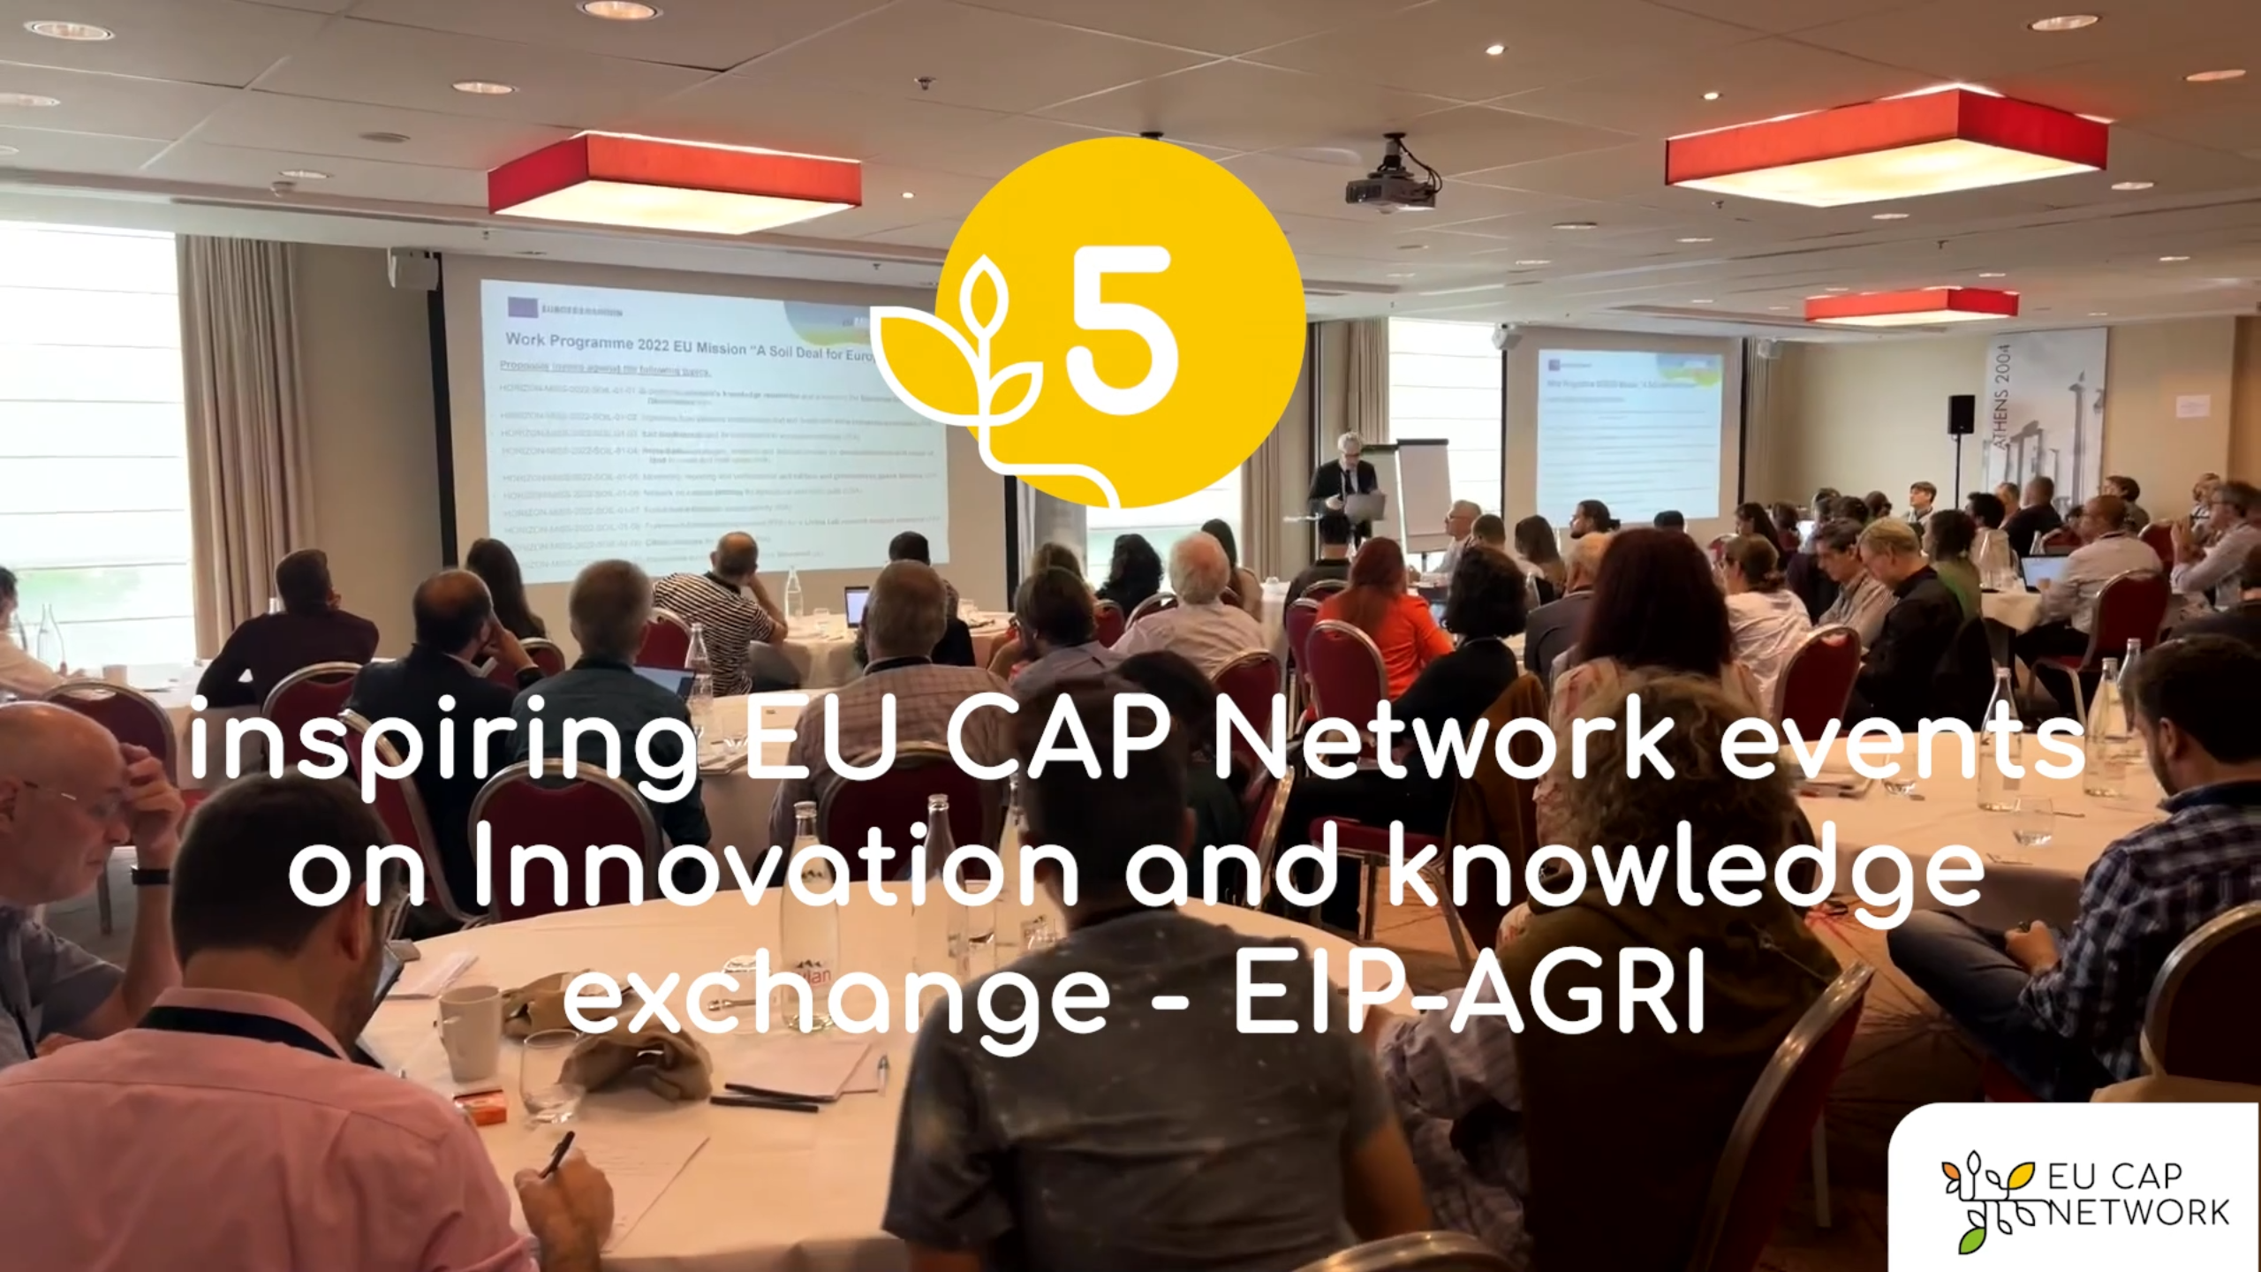

EU CAP Network events on Innovation and knowledge
exchange – EIP-AGRI – Spring events 2023

EIP-AGRI, 9 years of innovation
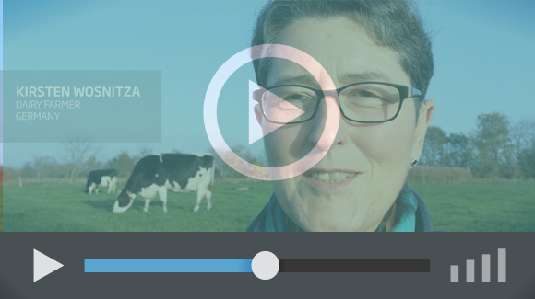 | The enthusiasm is essential for the success of the EIP-AGRI, and in ensuring that everyone can benefit. Watch this EIP-AGRI video to hear researchers, farmers, advisors, Managing Authorities and National Rural Networks explain how the EIP-AGRI has helped them over the past 9 years.

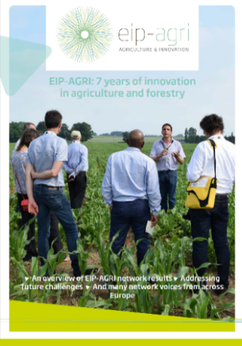 | Since 2013, the EIP-AGRI has been promoting interactive innovation to make EU agriculture and forestry more sustainable, productive, and fit for the future. This report shows how the EIP-AGRI has grown. Read the report.

