Food security & climate change
Climate-adaptive soil moisture management
May 2023

Climate-adaptive soil moisture management
Hoeksche Waard is an island located to the south of Rotterdam in the Netherlands. This rural area lies below sea level and regulating water on agricultural fields is a major issue, especially in the case of heavy rainfall. As part of a longer term project which looks into water management and farm resilience, an Operational Group was set up to test and optimise a sub-soil system to control soil moisture levels from underground.

Soil compaction and its consequences is a significant soil threat in the whole of the Netherlands. It strongly influences the soil moisture balance and leads to a greater sensitivity to precipitation surplus and deficit, which is exacerbated by climate change. Novifarm is a cooperation of 6 family farms growing mainly arable crops in Hoeksche Waard. In 2016 Novifarm started a project called HW20 to face these ever-changing climatic conditions, and the Operational Group is part of this project.

Even though Hoeksche Waard is surrounded by freshwater, the area still has real problems with drought. Farmers tackle the dry conditions by irrigating the surface of the fields, however they encounter high rates of evaporation and energy costs. After a long dry period, heavy rains can occur and cause flooded fields. A solution is needed. Leon Noordam from Novifarm, explains “With this in mind, we decided to try out getting the water from underneath. This way, the crops use what they need and water isn’t wasted and upper soil structure remains intact.”

HW20 aimed to build a 3-pillar integrated water management approach designed to protect the soil and crops. The first pillar is about soil compaction – carrying out the farm work without heavy machinery. The second is about controlling water quantity – how to remove water when there is too much rain, or apply more when it’s too dry. The third pillar is on soil health – getting the soil into better shape. Leon explains “The system is like a tripod, often farmers are already implementing 1 or 2 pillars, but farms need the 3 pillars to stand and be successful.” Novifarm teamed up with 4 other farms in the area to form the Operational Group which worked from 2019-2022 specifically on the second pillar ‘Climate-adaptive soil moisture management’.

The aim was to develop a system which enables the farmer to control the ideal soil moisture balance with regards to the needs of the crop as well as biotic soil processes, to be able to make clear decisions in the case of extreme weather, use water and nutrients sparingly by buffering water for re-use and to save energy compared to irrigation.

Underground drainage/irrigation systems were installed on 5 pilot farms, including at Novifarm, covering 60 hectares of agricultural land which have different sub-soil types. As this was also part of the HW20 project, the pilot plots also used lighter machinery and brought organic material to the fields to increase organic matter. The drainpipes are 2 metres below the surface of the ground. Using an existing soil moisture sensor technology (Adaptive Groundwater Level Management System - aGPS©), farmers can control the soil moisture balance on a sub-parcel scale, letting water in and out of the drainage system in a controlled manner. The excess water can quickly be drained away from the parcel or spread evenly to other parts of the field. The system is also capable of holding excess water nearby in case there is subsequent need for irrigation in which case it can be let back into the system.

Since 2020, the farmers have been collecting data and analysing impact on crops. Leon says “We are still learning, but this Operational Group has already given insight on what happens to groundwater levels when there is a heavy shower, or several weeks with no rain. We have identified some crops which yielded much better under this system. It gives farmers much greater control when it comes to unpredictable weather conditions, and increases the farm’s capacity to face climate pressure.”

Background information
On 14 and 15 March 2023, the European Commission’s Directorate-General for Agriculture and Rural Development (DG AGRI) and the Support Facility for Innovation & Knowledge exchange | EIP-AGRI organised the EU CAP Network workshop ‘Enhancing food security under changing weather patterns: farm adaptation’. 80 participants ranging from farmers, representatives of farmers’ associations and cooperatives, advisors, researchers, local authorities to NGO’s shared their knowledge and innovative, inspirational practices and approaches that support farmers in adapting to changing weather patterns.

Project information
✆ EIP-AGRI contact

Ina Van Hoye
ina.vanhoye@eucapnetwork.eu
+32 486 90 77 43

Communication manager
Support Facility ‘Innovation &
Knowledge exchange | EIP-AGRI’
✆ Project contact

Leon Noordam
info@hwodka.nl
+32 486 90 77 43

More information:
- https://novifarm.nl/
- Operational Group page on EIP-AGRI database
- EU CAP Network workshop ‘Enhancing food security under changing weather patterns: farm adaptation’

Project photos
Click on the pictures to download the high resolution versions. The pictures are free for use, please mention the copyright.

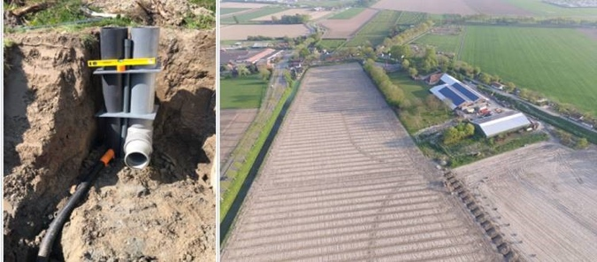
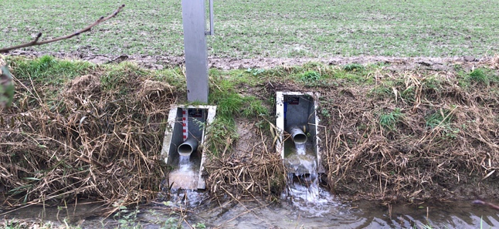
Pilot farm © Novifarm
Evacuating water © Novifarm

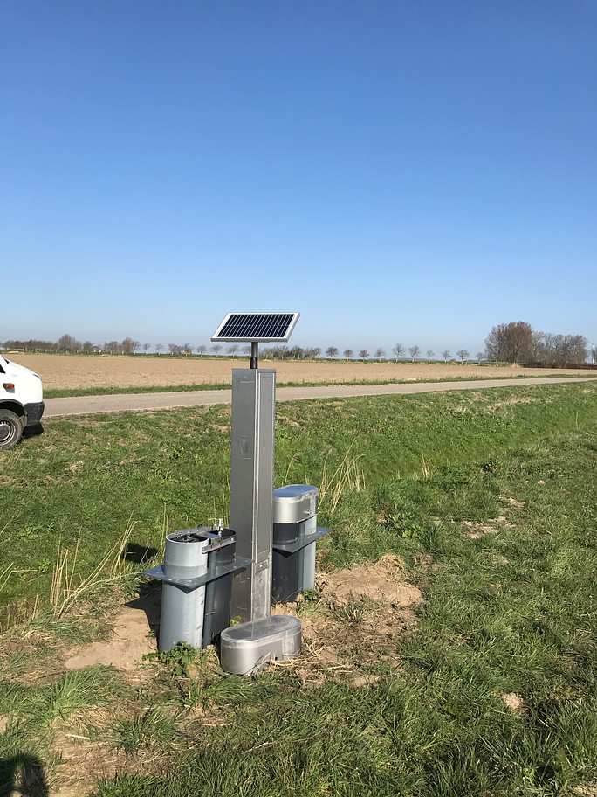
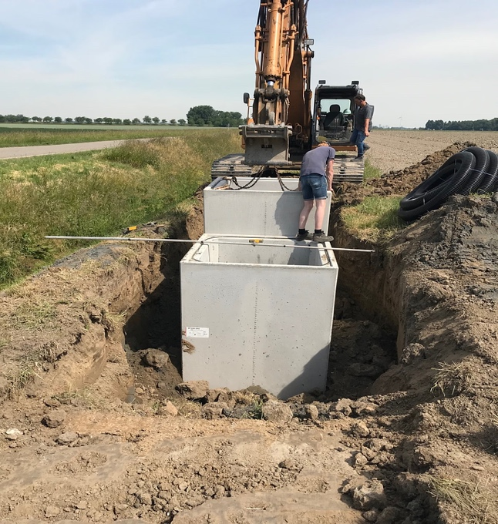
Installing the system © Novifarm
Monitoring © Novifarm

More information on food security & climate change
EU CAP Network ‘Innovation & knowledge exchange | EIP-AGRI’ activities

Focus Groups
- EIP-AGRI Focus Group: New forest practices and tools for adaptation and mitigation of climate change
- EIP-AGRI Focus Group: Nature-Based Solutions for water management under climate change
- EIP-AGRI Focus Group: Water & agriculture: adaptive strategies at farm level
Events
- EIP-AGRI Workshop: Connecting innovative projects: Water & Agriculture
- EIP-AGRI Workshop Tools for environmental farm performance
- EU CAP Network workshop ‘Enhancing food security under changing weather patterns: farm adaptation’
Publications
- EIP-AGRI Brochure Climate-smart agriculture: Solutions for resilient farming and forestry
- EIP-AGRI Brochure Sustainable and resilient farming: Inspiration from agro-ecology
- EIP-AGRI Brochure Water and Agriculture
EIP-AGRI Videos
- AGRI challenge: nature-based solutions for water management - 17 August 2022
Inspirational ideas from the network
- Inspirational ideas: Farmers tackling drought and flooding – BE
- Inspirational ideas: Farm data for water management of soils – HU
- Inspirational ideas: Enhancing water quality – changing mindsets – IE
- Inspirational ideas: Preventing water wastage with wireless technologies – IT
- Inspirational ideas: Efficient and sustainable water use on the farm – SI
- Inspirational ideas: Preserving soil organic matter and protecting water sources – PT

- Inspirational ideas: Dealing with water scarcity – IT/ES
- Inspirational ideas: Arable cropping systems adapted to climate change – DE
- Inspirational ideas: Improving soils in Montado ecosystems – PT
- Inspirational ideas: Climate-friendly practices
- Inspirational ideas: Estonian farmer turns grassland grazing into climate solution - EE

Find out all networking activities, publications and videos under the EU CAP network Innovation & knowledge exchange | EIP-AGRI supports soil health by promoting and sharing innovative practices at the spotlightpages on climate change and water

Horizon multi-actor projects working on food security & climate change
- NEURICE - New commercial EUropean RICE (Oryza sativa) harbouring salt tolerance alleles to protect the rice sector against climate change and apple snail (Pomacea insularum) invasion: website - CORDIS (03/2016-02/2020)
- TomGEM - A holistic multi-actor approach towards the design of new tomato varieties and management practices to improve yield and quality in the face of climate change: website - CORDIS (03/2016-02/2020)
- CROPDIVA - Climate Resilient Orphan croPs for increased DIVersity in Agriculture: website – CORDIS (01/09/2021-31/08/2025)
- STARGATE - reSilienT fARminG by Adaptive microclimaTe managEment: website - CORDIS (10/2019-09/2023)
- ClieNFarms - Climate Neutral Farms: CORDIS (01/01/2022-31/12/2025)
- CONSOLE - CONtract SOLutions for Effective and lasting delivery of agri-environmental-climate public goods by EU agriculture and forestry: website - CORDIS (05/2019-04/2022)
- Contracts2.0 - Co-design of novel contract models for innovative agri-environmental-climate measures and for valorisation of environmental public goods: website - CORDIS (05/2019-04/2023)

There are 31 Horizon projects working on topics related to climate change and food security available in the EIP-AGRI database (update 27 March 2023).

Multi-actor projects are projects in which end users and multipliers of research results such as farmers and farmers’ groups, advisers, enterprises and others, are closely cooperating throughout the whole research project period.
Thematic networks are multi-actor projects which collect existing knowledge and best practices on a given theme to make it available in easily understandable formats for end-users such as farmers, foresters, advisers etc.

Operational Groups working on food security and climate change
375 Operational Groups working on food security and climate change are available in the EIP-AGRI Operational Groups database (update March 2023)
- Austria: 7
- Belgium: 1
- Croatia: 3
- Finland: 3
- France: 31
- Germany: 40
- Hungary: 3
- Ireland: 12
- Italy: 92
- Latvia: 7
- Lithuania: 3
- The Netherlands: 45
- Portugal: 7
- Slovenia: 24
- Spain: 84
- Sweden: 3

Food security & climate change in EU policies
The Farm to Fork Strategy is at the heart of the European Green Deal, and aims to accelerate the transition to a sustainable food system that ensures food security, nutrition, and public health, making sure that everyone has access to sufficient, safe, nutritious and sustainable food.
The EU Strategy on Adaptation to Climate Change sets out how the European Union can adapt to the unavoidable impacts of climate change and become climate resilient by 2050. The strategy seeks a smarter, faster and more systemic adaptation. It includes a European platform for adaptation knowledge (Climate-ADAPT), developing and rolling out adaptation solutions to help reduce climate-related risk, increase climate protection and safeguard the availability of fresh water, and actively mainstream climate resilience considerations in all relevant policy fields.
In addition, the Biodiversity Strategy for 2030 aims to build societies’ resilience to future threats such as impacts of climate change, forest fires, food insecurity and disease outbreaks and will support a green recovery following the COVID-19 pandemic. Events like the pandemic and climate change are putting agriculture all over the world under pressure and the unprovoked Russian invasion of Ukraine and a global commodity price boom are exposing the vulnerabilities of our food system (Safeguarding food security and reinforcing the resilience of food systems).

The common agricultural policy 2023-2027
Find all information on the new CAP on the European Commission website.

Innovation & knowledge exchange | EIP-AGRI in the EU CAP Network
Since 6 October 2022, the EIP-AGRI network has joined forces with the European Network for Rural Development, merging into the new European CAP Network. The ‘Support Facility for Innovation and Knowledge exchange, including EIP-AGRI’ continues to act as a mediator, enhancing communication and cooperation between everyone who has a keen interest in sharing knowledge and innovating agriculture, forestry and rural areas.

The European Innovation Partnership 'Agricultural Productivity and Sustainability' (EIP-AGRI) was launched in 2013 by the European Commission in a bid to promote rapid modernisation of the sectors concerned by stepping up innovation efforts.

The EIP-AGRI aims to foster innovation in the agricultural and forestry sectors and in rural areas by bringing research and practice closer together – in innovation projects as well as via the European CAP Network and the national CAP Networks. Also grassroots ideas from farmers get developed into innovations through the so-called Operational Group innovation projects. The EIP-AGRI aims to streamline, simplify and better coordinate existing instruments and initiatives, and complement them with actions where necessary. More information on Innovation, Knowledge Exchange |EIP-AGRI on the EU CAP Network website.

EIP-AGRI Operational Groups
EIP-AGRI Operational Groups are groups of people who work together in an innovation project. They bring together partners with complementary knowledge. The composition of the group will vary according to the theme and specific objectives of each project. Farmers, advisors, scientists, businesses or other relevant partners work together to find practical solutions for specific problems or opportunities for European farmers and foresters. Farmers and foresters need to cooperate throughout the project to ensure that the innovative solutions are practical and likely to be quickly applied in the field. Read the basic principles. Innovation support services (including advisors with a focus on innovation), and in particular innovation brokering, can therefore play a crucial role in getting worthwhile projects off the ground by facilitating contacts.

Operational Groups funded under Rural Development Programmes 2014 - 2022
- 98 Rural Development Programmes provide support to innovative EIP Operational Group projects
- Over 3200 Operational Groups are planned to be established under the approved RDPs (2014 – 2020)
- More than 2700 Operational Groups projects have been selected for funding and are currently ongoing (or already finished)*. Member States will still start more Operational Group projects which may run until 2025 (under current transitional rules for EU rural development programmes). Find information on all of them in the EIP-AGRI database.

*Information officially submitted to the European Commission by RDP Managing Authorities (March 2023).

- Operational Groups funded under CAP Strategic Plans 2023 – 2027
Within the new common agricultural policy the EU Member States designed national CAP Strategic Plans combining funding for income support, rural development, and market measures. All CAP Strategic Plans have been adopted and their implementation started on 1 January 2023.

26 CAP Strategic Plans provide support to set up 6600 innovative EIP-AGRI Operational Groups.

EIP-AGRI videos
AKIS: building effective knowledge flows across Europe | Operational Groups – collaborate to innovate

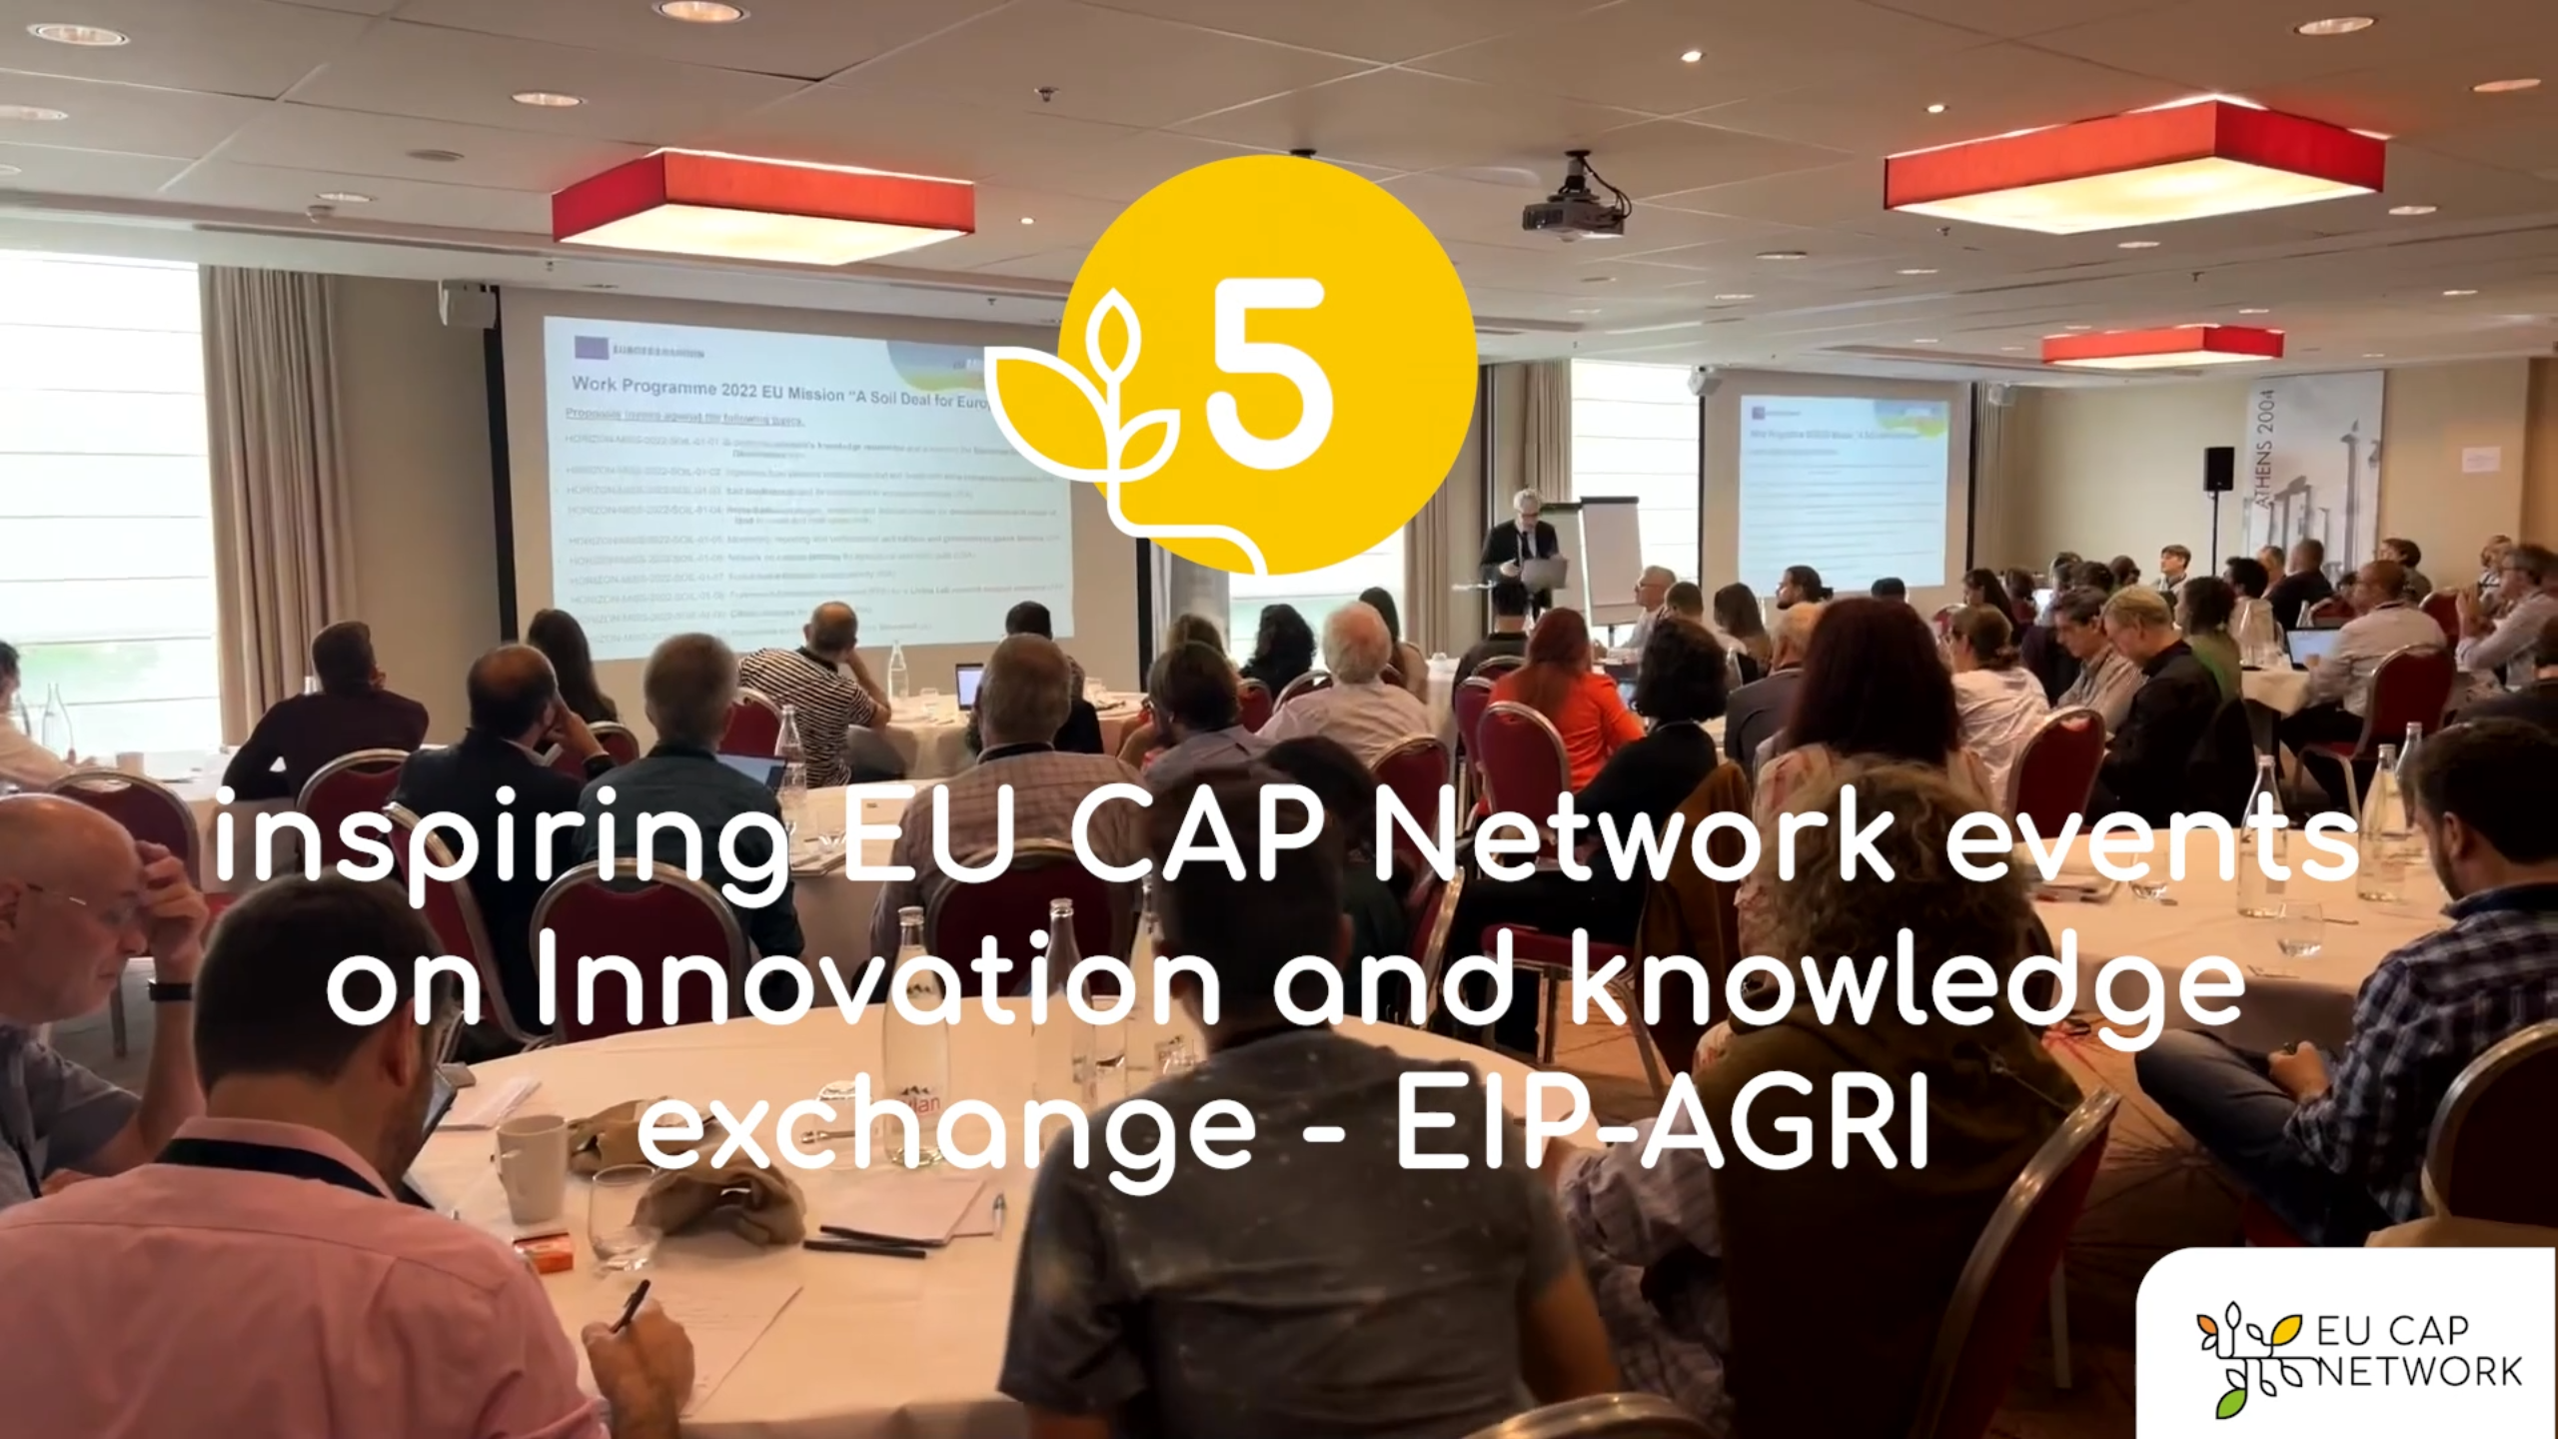

EU CAP Network events on Innovation and knowledge
exchange – EIP-AGRI – Spring events 2023

EIP-AGRI, 9 years of innovation

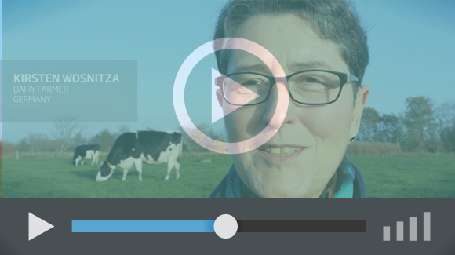 | The enthusiasm is essential for the success of the EIP-AGRI, and in ensuring that everyone can benefit. Watch this EIP-AGRI video to hear researchers, farmers, advisors, Managing Authorities and National Rural Networks explain how the EIP-AGRI has helped them over the past 9 years.

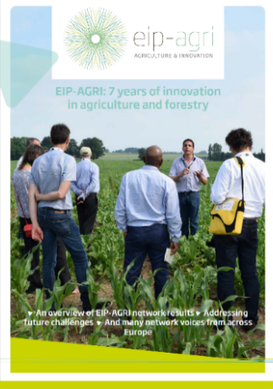 | Since 2013, the EIP-AGRI has been promoting interactive innovation to make EU agriculture and forestry more sustainable, productive, and fit for the future. This report shows how EIP-AGRI has grown. Read the report

