Opportunities for advisors under Horizon Europe

Advisory network COREnet shares tips to set up a successful consortium

March 2023

Opportunities for advisors under Horizon Europe

Advisory network COREnet shares tips to set up a successful consortium
Horizon Europe, the EU’s key funding programme for research and innovation, includes regular calls to set up EU-wide advisory networks. COREnet was the first such network, launched in 2022. Over the next two years, there are five more of these advisory network calls on different topics. Applying to this type of call can be challenging, but there are many useful support tools and information sources available. Patrick Pasgang from the Innovation Support Center of Boerenbond Belgium (Innovatiesteunpunt), one of the partners of COREnet shared his experience and a few useful tips.

The advisory networks call is part of Horizon Europe’s cluster 6 on “Food, bioeconomy, natural resources, agriculture and environment.” The overall objective of this call is to foster exchanges between advisors across all EU Member States in order to facilitate the synthesis and sharing of knowledge, capacity building, as well as identifying innovative solutions and bringing them into practice more quickly. The five calls for advisory networks for 2023-2024 focus on: organic agriculture, reducing the use of pesticides, optimal fertiliser use, forestry and sustainable livestock systems.

COREnet is a successful project from the 2021 edition of the call. It is the EU advisory network on ‘consumer-producer chains’ to facilitate, through advisory systems, the transition towards more inclusive, resilient and sustainable food systems.

The calls for EU advisory networks state that the multi-actor approach is essential and the majority of project partners should be farm advisors with solid field experience. The COREnet project ensured that they could respond to this requirement by involving 14 different organisations, two thirds of which are relevant advisory and training services, and the others include a communication service, a consumer organisation and research centre. Patrick explains “It is also ideal to have all Member States represented in the project, even if they are not formal partners from the start, for example, in COREnet we have a dedicated budget for the involvement of other organisations during the project lifetime.”

The calls also state that the networks should build on existing knowledge developed by the EIP-AGRI and the SCAR-AKIS, and that they should also contribute to Member States’ Agricultural Knowledge and Innovation System (AKIS) plans which are part of the CAP Strategic Plans, helping advisors to become better integrated in AKIS systems. COREnet was able to demonstrate significant experience in this field. Many of the organisations met as members of the EIP-AGRI Focus Group on Innovative Short Food Supply Chain Management as well as during other EIP-AGRI and ENRD events. As a result of this, they set up a first Horizon 2020 Thematic Network (SKIN) which has now ended. Patrick further explains “The partners are also connected to several European networks (Copa-Cogeca, Eufras, CEJA), Operational Groups and AKIS-related Horizon projects”.

When it comes to preparing the application form, starting in good time and organising online meetings with all the potential partners as soon as possible is extremely useful.
If a consortium needs to find other partners, organisations can reach out to their networks and to Horizon National Contact Points or attend events such as EU CAP Network brokerage events. Patrick adds “It is also a good idea to check the project idea in the market by asking relevant stakeholders to write a letter of support to confirm added value”.

Next, the writing of the application form should be distributed according to the knowledge and experiences of the partners. Tasks such as calculating the budget, choosing a project name and proof-reading should not be neglected. Throughout the drafting stage, it is important to continue meeting all partners regularly. Cross-checks back to the call text must be made, as Patrick tells us “Attention must be paid to details such as the expected outcomes and impacts, the project results, the scope... look at it as if you were an evaluator. Ask yourself if all is clear and logical”.

Patrick gave some final tips and tricks: “It is necessary to be critical, to identify risks and look for adequate mitigation measures. Also, keep in mind that an excellent communication and dissemination plan takes time and specific skills. Make sure that the cost/benefit ratio is in line with the expected outcomes. Develop Key Performance Indicators to measure impact”.

The deadline for the Horizon Europe call for EU advisory networks on organic, pesticides, fertilisers is 23 March 2023, for the networks on forestry, livestock systems, the deadline is 28 Feb 2024.

Background information
- More information
  - COREnet information (CORDIS): https://cordis.europa.eu/project/id/101060905
  - EU CAP Network Brokerage event ‘Get involved in Horizon Europe advisory networks’ (Jan 2023)
  - EU CAP Network factsheet: Tips and tricks to apply for Horizon Europe calls
  - EU CAP Network brochure: Funding opportunities under Horizon Europe – Calls 2023

Project information
✆ EIP-AGRI contact

Ina Van Hoye
ina.vanhoye@eucapnetwork.eu
+32 486 90 77 43

Communication manager
Support Facility ‘Innovation &
Knowledge exchange | EIP-AGRI’
✆ Project contact

Patrick Pasgang
pasgang@boerenbond.be
+32 16 28 61 38

Project photos
Click on the pictures to download the high resolution versions. The pictures are free for use, please mention the copyright.

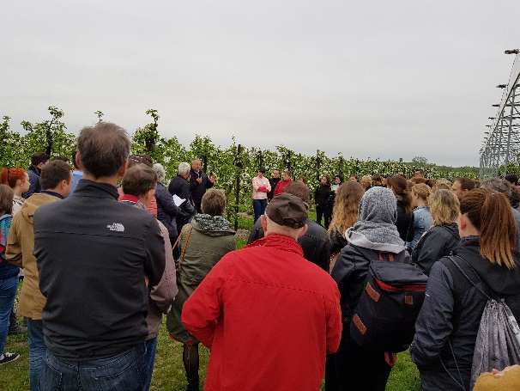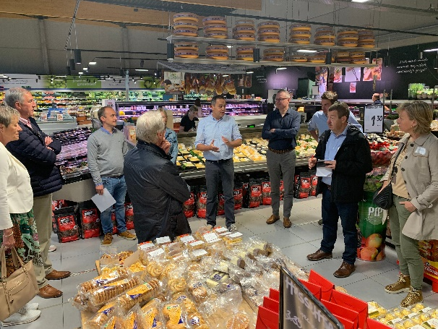

Patrick Pasgang: “It is ideal to have all Member States represented in the project, even if they are not formal partners from the start. For example, in COREnet we have a dedicated budget for the involvement of other organisations during the project lifetime.” ©COREnet

More information on the Horizon Europe calls on EU advisory networks
- Horizon Europe calls 2023
  - HORIZON-CL6-2023-GOVERNANCE-01-20 Developing an EU advisory network on organic agriculture
  - HORIZON-CL6-2023-GOVERNANCE-01-21 Developing EU advisory networks to reduce the use of pesticides
  - HORIZON-CL6-2023-GOVERNANCE-01-22 Developing EU advisory networks on the optimal fertiliser use

- Horizon Europe calls 2024
  - HORIZON-CL6-2024-GOVERNANCE-01-12: Developing EU advisory networks on forestry - All details on Page 572 of the Horizon Europe Work programme (2023-24)
  - HORIZON-CL6-2024-GOVERNANCE-01-13: Developing EU advisory networks on sustainable livestock systems - All details on Page 576 of the Horizon Europe Work programme (2023-24)

The CAP of the Future
The reform of the Common Agricultural Policy (2023-2027) was formally approved end November 2021. Find all information on the new CAP on the European Commission website.

Innovation & knowledge exchange | EIP-AGRI in the EU CAP Network
Since 6 October 2022, the EIP-AGRI Network has joined forces with the European Network for Rural Development, merging into the new European CAP Network. The ‘Support Facility for Innovation and Knowledge exchange, including EIP-AGRI’ continues to act as a mediator, enhancing communication and cooperation between everyone who has a keen interest in sharing knowledge and innovating agriculture, forestry and rural areas.

The European Innovation Partnership 'Agricultural Productivity and Sustainability' (EIP-AGRI) was launched in 2013 by the European Commission in a bid to promote rapid modernisation of the sectors concerned by stepping up innovation efforts. The EIP-AGRI aims to foster innovation in the agricultural and forestry sectors and in rural areas by bringing research and practice closer together – in innovation projects as well as via the European CAP Network and the national CAP Networks. Also grassroots ideas from farmers get developed into innovations through the so-called Operational Group innovation projects. The EIP-AGRI aims to streamline, simplify and better coordinate existing instruments and initiatives, and complement them with actions where necessary. More information on Innovation, Knowledge Exchange | EIP-AGRI on the EU CAP Network website.

EIP-AGRI Operational Groups
EIP-AGRI Operational Groups are groups of people who work together in an innovation project. They bring together partners with complementary knowledge. The composition of the group will vary according to the theme and specific objectives of each project. Farmers, advisors, scientists, businesses or other relevant partners work together to find practical solutions for specific problems or opportunities for European farmers and foresters. Farmers and foresters need to cooperate throughout the project to ensure that the innovative solutions are practical and likely to be quickly applied in the field. Read the basic principles. Innovation support services (including advisors with a focus on innovation), and in particular innovation brokering, can therefore play a crucial role in getting worthwhile projects off the ground by facilitating contacts.

- Operational Groups funded under Rural Development Programmes 2014 - 2022
  - 98 Rural Development Programmes provide support to innovative EIP Operational Group projects. *
  - Over 3200 Operational Groups are planned to be established under the approved RDPs (2014 – 2020).
  - More than 2700 Operational Groups projects have been selected for funding and are currently ongoing (or already finished) *. Member States will still start more Operational Group projects which may run until 2025 (under current transitional rules for the EU rural development programmes). Find information on all of them in the EIP-AGRI database.

*Information officially submitted to the European Commission by RDP Managing Authorities (November 2020).

- Operational Groups funded under CAP Strategic Plans 2023 – 2027

Within the new common agricultural policy the EU Member States designed national CAP Strategic Plans combining funding for income support, rural development, and market measures. All CAP Strategic Plans have been adopted and their implementation started on 1 January 2023. 26 CAP Strategic Plans provide support to innovative EIP-AGRI Operational Groups’ projects.

EIP-AGRI videos
AKIS: building effective knowledge flows across Europe | Innovation Support Services, supporting innovation in EU farming and forestry

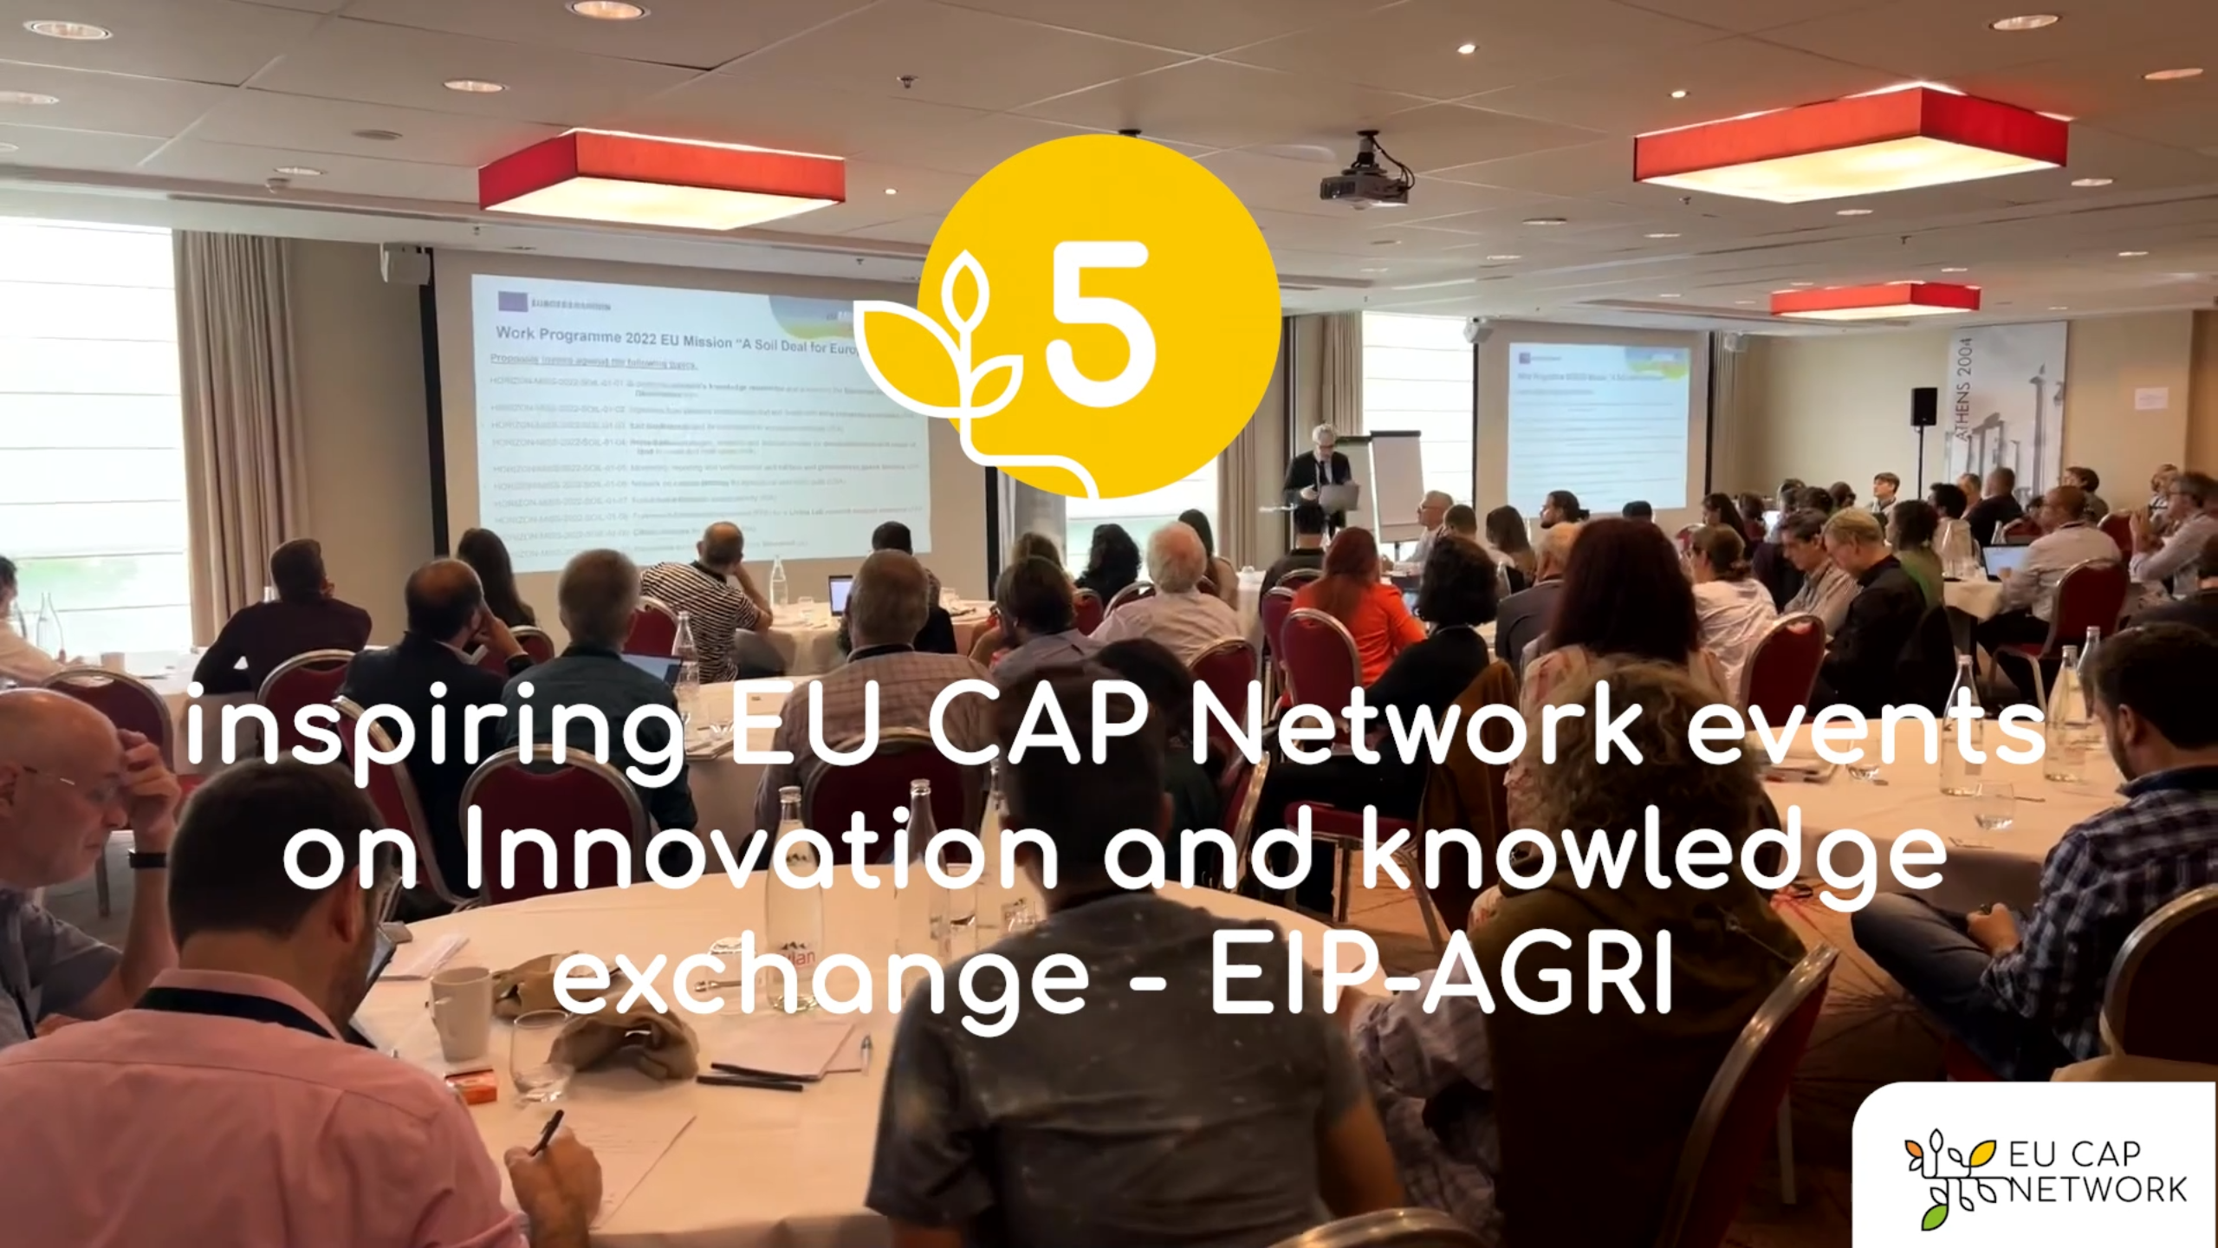

EU CAP Network events on Innovation and knowledge
exchange – EIP-AGRI – Spring events 2023

EIP-AGRI, 9 years of innovation
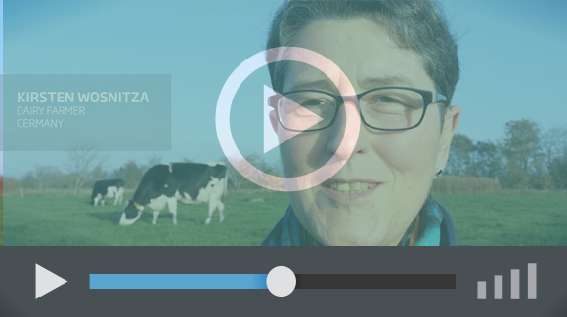 | The enthusiasm is essential for the success of the EIP-AGRI, and in ensuring that everyone can benefit. Watch this EIP-AGRI video to hear researchers, farmers, advisors, Managing Authorities and National Rural Networks explain how the EIP-AGRI has helped them over the past 9 years.

